A Report submitted in partial fulfilment of the regulations governing the award of the Degree of BSc (Honors) Computer Science with Web Development at the University of Northumbria at Newcastle

Project Report

Designing and developing a microservice architecture for an IT help desk system

Nicholas Coyles

2020/21

1. **Abstract:**

The focus of this project revolves around the subject of software architecture. In particularly, the work is centred around the sudden rise in popularity of the microservice architecture.

The report begins with investigating the benefits over existing architectures, such as monolithic architecture which has been the dominant architecture for large scale systems. With reference to the literature, and arguments in support of the new architecture will be assessed and the main reasons why traditional architectural approaches are being seen as less advantageous. But also investigating the perceived drawbacks of the microservice architecture.

The objectives of the project, establish the overall scope. Firstly, to investigating the state of the current literature and congregating current and existing methodologies and patterns. For both design and development of a microservice architecture. Leading into the second objective, which takes understandings from the literature to guide the design and development of an IT Help Desk system.

The motivation behind this choice in system, is because the requirement for a Help Desk is well defined and established. Therefore, it can be used as a vehicle to demonstrate the process of development of the architecture. Once the requirements for the system were clarified, systems diagrams were created to break down the problem at hand, detailing each of the services necessary to meet the requirements.

An agile development was applied to carry out the rapid development, using each service as an iteration cycle. There was no prior knowledge in technology used for development ASP .NET Core. It was chosen due to the power of the .net frameworks and the ability to build services-based web applications. Additionally, many of the tasks such as object persistence can be easily incorporated using tools such as Entity Framework which are supported in the .NET framework. In accordance with Agile methodology unit testing was used extensively on the project so that continual integration could take place.

There were multiple instances where a step back was necessary to re-evaluate the system, to change the design of the services. This was due to the prementioned lack of clarity in the literature, which partially created frustration in the findings across the project. Accompanied with the complexity of what was set out to achieve, the steep learning curve and limited time. A great deal of time and effort was expended to showcase a limited system, but the teachings and evaluation can provide a utilitarian insight to the struggles of adopting microservice in a professional development team. The conclusion is that microservices are still in their infancy and it will take time before there is a consensus among the software engineering community for the best practice in design patterns and development methods. In reflection microservice development is complex and would take more time than was available to become more familiar with the language to a point where a fully functioning system could be created with high level design documentation.

However as already stated the IT help desk was only a vehicle in which to demonstrate this emergent software architecture. Showing the additional complications in establishing the core architecture.

The agile methodology may be a hinderance in the early stages of development because it focuses only on the requirements for the current development iteration and is not helpful in establishing the baseline architecture. However, it was discovered that agile would support refactoring to a microservice as baseline requirements have already been defined, alleviating the burden of early-stage design. Finally, there is an importance of learning the architecture and its features as the current methods in the literature are limited.

**List of Contents:**

1. **Abstract:**4
2. **Introduction:**7

2.1) Background:7

2.2) Project aims:8

2.3) Subject of work: 10

2.4) Plan of work: 10

Analysis:

3)**Literature Review:** 11

3.1) Microservices11

3.2) Microservices and Monolithic 13

3.3) Monolith first 14

3.4) Microservices benefits and concerns 14

3.5) Technology Heterogeneity 15

3.6) Scaling 15

3.7) Security considerations 16

3.8) Designing a microservice 17

3.8.1) Model based 17

3.8.2) Domain Driven model 18

3.8.3) Experimental Model 19

3.9) Containers 20

3.10) REST API 20

3.11) Conclusion20

4)**Requirements Approach** 21

4.1) Requirements Capture Method 21

4.2) Existing IT Help Desk Systems Survey 21

4.2.1) Happy Fox 21

4.2.2) Zoho 22

4.2.3) Fresh service 23

4.2.4) Live Chat 24

4.3) Discussion of Results 25

5)**Requirements** 26

5.1) Requirements Specification 26

5.2) Requirements Justification 26

5.3) Tools and Techniques Justification 27

5.4) Development Methodology 30

5.5) Summary 30

Synthesis:

6)**Design Documentation** 31

6.1) Use case diagrams 31

6.2) Front-end 31 6.3) Back-end Design 32

6.3.1) Entity framework 32

6.3.2) System overview 32

6.3.3) Database 34

6.3.4) System re-evaluation 34

6.3.5) Final System Design 35

7)**Development and implementation** 36

7.1) Build cycle 3 (System modification) 36

7.1.1) Ticket Collection Service (Iteration one) 37

7.1.2) Discussion Service (Iteration two) 43

7.1.3) FAQ Service (Iteration three) 49

7.1.4) API Gateway (Iteration four) 49

7.1.5) Blazor Front-end (Iteration five) 52

8)**Testing** 57

8.1) Testing Results 58

Evaluation Chapter:

9) **Evaluation of the Product** 59

9.1) Strengths and weaknesses 59

9.2) Project Objectives 62

9.3) Evaluation of Tools Used 63

10)**Evaluation of the project process** 64

10.1) The Plan 64

10.2) Project Objectives 67

10.3) Skills gained and lessons learnt 68

11) **Conclusion and future recommendations** 69

**References** 71

**Appendices** 78

Appendix A – Terms of Reference 78

Appendix B – Requirements Specification 88

Appendix C – Use case diagrams 90

Appendix D – Wireframes 94

Appendix E – ERD diagrams 95

Appendix F – Ticket Collection Models 97

Appendix G – Ticket Database Context 97

Appendix H – Repository Interface classes 99

Appendix I – Repository classes 100

Appendix J – Controller classes105

Appendix K – API Gateway Configuration 113

Appendix L – Test plans 115

Appendix M – Build 1 128

Appendix N – Build 2 136

1. **Introduction:**

**2.1) Background**

Software engineering is an ever-evolving field, where technologies are continuously being developed and integrated with the goal of solving the problems with previously technologies to a high technical standard.

We have seen examples of this transition in the past when the software engineering standards shifting from procedural to object orientated programming. A similar transformation is currently being seen with the industrial norms moving from a monolith architecture, towards a microservice architecture. Which is in a fact a hybrid between both a procedural and object orientation. These movements are caused by client needs and is comparable to the wider world. Everything is changing to adapt to the modern needs of people, and this no different to what is happening in software architecture. New methodologies are implemented to better and improve the output for the client. Methodologies underpin the development of systems. Although methodologies may be discussed in this project, the focus is the software architecture and the effects that the architecture bears on the resulting product.

Object orientation provides many programming benefits with the ability to abstract data. A form of encapsulation where unnecessary details are hidden, only exposing the important operations to the user (Harrison, 1993). Each class can have their own capabilities which may be completely different from one another, but all respond to the same protocol operations (Stefik, M. and Bobrow, 1985) showing a rich domain. Not to be mistaken for an anaemic domain which is style of procedural programming, the opposite to what object orientation is trying to achieve (Fowler, 2003)

Object oriented models, aim to be loosely coupled meaning that a class should have one functionality and do too very well. If a class has more than one responsibility it can become tightly coupled. Where a change to one responsibility will inhibit the ability of all the other classes that depend on it, leading to a fragile design (Martin, 2007).

When objects become loosely coupled in this way, the rich domain is essentially lost due to the extreme complexity and is now a hindrance on the system. Systems gain a large codebase and becomes anaemic in fashion and hard to maintain. Constantly having to maintain a monolithic architecture makes it difficult to keep up with development changes (Kalske, 2017).

Even in the early stages of development this can become an issue it is difficult for developers to keep insight of all the system components (Fritzsch, 2018). Which makes it challenging to adapt an agile development because now the monolith requires extensive thought in the design phase. As well as this there is a knock-on effect of a system becoming technology locked because the system is too complex to easy transition to a new technology and would be very cumbersome to move to a new technology and the system is no longer scalable (Fritzsch, 2018).

The pre-existing issue with the monolithic architecture is forcing an evolution of technologies and methods. Introducing the microservice architecture.

It is important to note that a microservice breaks a system down into several distinct services, separated based on business capabilities of the system. Resulting in more flexible scaling and deployment because services run their own processes and can evolve independently (Jin, 2018) without effecting the rest of the system (Rademacher, 2017). Which allows of a major benefit of a service being able to incorporate the most suitable technology for the job (Taibi, 2018) amending the shortcoming of the monolithic architecture. Also, these services are typically responsible for their own functionalities (Jin, 2018). Presenting the question, how far has the microservice come from outdated methods such as procedural programming, because service being self-contained and depending on its functionality is an example of the anaemic domain model. From the findings it seems that the evolution of software architecture has progressed full circle and the methods that being used are modern adaptations of older techniques used to meet new the demands of clients.

However, although there are advantages of the architecture addressed. There is not a great deal of depth in the literature relevant to the practical decomposition of a system into its business capabilities. There is lots of theory but not much in practise. The purpose of the project is to address this and analysis the literature searching for the current best practises for designing a system using the architecture. As well as encapsulating the topic of microservices assessing where its place is in the future of software engineering. The findings demonstrated a lack of both depth and clarity in the current methods in the literature. Which results in a difficulty in producing a complex system and many systems built in a microservice style may fail to live up to expectations.

The project idea stemmed from a meeting with the supervisor where the discussion of current software engineering trends leads to the microservices topic. The challenge plus the relevancy in the current day ultimately led to this project being undertaken.

**2.2) Project aims:**

1. “To investigate and analyse the use of different architectures, and the rise of microservices architecture.”
2. “To design and develop an IT Help Desk System built upon a microservice architecture.”

**Objectives:**

1. Review the literature surrounding microservices, comparing to other architectures and include some real-world examples of microservice systems. As well as common patterns used in their development.

The literature will be used through the project, to provide potential solutions to problems in the development of the project. Reviewing the literature in this way creates a useful discussion of different possibilities when it comes to facing problems.

2. Establish requirements to address the points of focus during each stage of the project.

Requirements capture discusses both functional and non-functional requirements.

3. Create an overall design of the system establishing what microservices are needed and how they will integrate.

A systems diagram that shows how each service plays a role in the system and demonstrates the inter connection between services and databases

4. Create suitable design documentation for each individual element in the system.

Design documentation is the basic groundwork for development and implementation chapters. Discussing all the functionalities of each part of the system.

5. Develop and implement the IT Help Service System with some full functioning applications.

Development and implantation of system, commenting on the multiple solutions to complete the problem and discuss why certain choices are taken. Also discussing how problems are solves.

6. Create system documentation including relevant test plans and cases.

Creating test cases based on each services functionality.

7. Test the system using the documentation as a reference.

Carry out testing of the systems functionality, using the test plans just created as guide, taking note of both successful and unsuccessful tests.

8. Analysis the result of the tests/evaluation.

Summarising the results of the tests, evaluating how the system can be improved and what can happen to make this take place.

9. Evaluate the system.

Evaluate the product created. Including strengths, weaknesses, objects, alternate methods and how what could be done to improve upon the weaknesses

10. Evaluate the project.

Evaluate the project using the requirement specification, to measure success.

11. Evaluate the project process, including a self-reflection.

Evaluate the product process, looking at the initial project plan comparing it with what happened during the product process.

12. Conclude the project and give recommendations.

Finishing the project with an overall conclusion and give recommendations to future work.

**2.3) Subject of work:**

The area of work that is the whole project revolves around is that of the microservices architecture. The first section of the project is the critical research into the current trends in microservices including development and design techniques and the general perception within the software engineering community of microservices. These areas are important to conduct research into because the next section is the development of an IT Help Desk system using the microservice architecture and the patterns discovered through the research can influence the development of this project. The scope is to stay on these areas so the resulting product can demonstrate a functioning microservice architecture, as well as presenting several different methods that can be used to meet the project goals. The final product will be an IT Help Desk system using built on the microservice architecture. The only planned limitation of the project is the timescale, as the methods and techniques used within the project are new and complex. Tied with no prior knowledge from the author the time might cause a potential limitation for implementation of all the desired system features.

**2.4) Plan of work:**

After the literature review, a research survey into existing IT Help desk applications will be conducted to form the requirements specification. Research into tools to develop microservices and selecting the most appropriate technology is crucial at this stage. The synthesis will include two main parts, firstly the design of the system where systems diagrams and other design documentation will be created using findings from the literature review. The second part of the synthesis is where the product itself will be created alongside the subsequent documentation of the process. The main tool for development will be ASP .NET. Once the development has concluding testing will begin where the functionality of the system will be tested using a test plan and methodology where errors can be filtered out, finishing with a final test of the overall system. The project ends with an evaluation of the final product, project process and a closing conclusion including future recommendations.

**Analysis Chapter:**

1. **Literature Review:**

This literature review examines what defines a microservice, along with the characteristics of the architecture and why it is becoming the successor to the monolithic architecture. Looking into the reasons why the rich domain monolithic systems have fallen out of favour as of late in the development community. In contrast, why microservices are seen as the solution to the issues encountered with traditional object-oriented software development. Illustrating both sides of the argument for the benefits of drawbacks of such an emerging technology. The scope of the review is the focus of design and development of a microservice, examining existing literature surrounding the topic and developing an understanding of the current state of accepted techniques and approaches within this area of research. The analysis of the literature will be needed to form an effective solution using microservices.

* 1. **Microservices**

In recent years, there has been a shift in the methods within system architecture development. One of the big causes being the increasing popularity of cloud computing. Microservices is the newest approach towards systems architecture in software development. It can be said that microservice architecture is a branch of service-oriented architecture (SAO) where the fundamentals of SAO have been built upon with a modern twist to create a new technique. With that aim of combatting the shortcoming of traditional software architecture, in particular the monolithic architecture. Companies are already taking steps to adopt microservices by modernizing their legacy monolith applications, refactoring old systems into microservice. This includes companies like Amazon, Netflix, and Uber (Larrucea, X, 2018).

The term “microservice” is relatively new and was first defined in 2012. A year after it was first discussed at a workshop, a group of software architects. They branded it with the name microservices to describe what was seen by participants as a common architectural style (Fowler, 2014). A vague definition has been created by the likes of Fowler and Newman throughout the years and microservices now has a more established definition. A small, autonomous services that works together to create a single application with each service having the capability of running its own process through lightweight and loosely coupled mechanisms (Fowler, 2014) (S. Newman, 2015). The functionality of Microservices however is not a completely new idea, Mike Amundsen believes that the desired properties that are being seen currently with microservices is not particularly new. In fact, these properties can be tied back to the patterns that were seen in SOA. Properties you wish to design for will structure the constraints for the implementation of a system and in ways microservices are the best-practice approach for realizing SOA (Pautasso, 2017). Which brings back the claim made in the introduction that what we are seeing now is the same as what was seen in the past with the development of new technologies taking the best approach from previously existing techniques, and adapting them into a new concept, effectively going full circle. However, it has been put forward by Daya and co that the comparison is more complex and somewhat unfair than what has been stated, because the microservice architecture has never actually claimed to be a modern approach for building distributed systems (Daya, S, 2016). In fact, SOA and Microservices have different aims, the prior aims on reusability, whereas the latter’s main goal is manageability (Daya, S, 2016) The argument for the comparison is valid because even though the aims are different fundamentally, they build off the same premises developing service-based applications (Vural, 2017).

The notion of Microservices being a small autonomous application can be better described as an application which has been divided into services and can be tested, deployed, and scaled independently of each other. Each has a single responsibility in the global scheme of the application (Thönes, 2015). Services function individually in this way, any testing, changes, and deployment made to a service will not have any effect on the other survives keeping the integrity of the system intact. Resulting independence allows a great increase to the scalability, manageability, and updatability of the microservice application (Bao, 2019). The break down into multiple services revolves around the small business capabilities or needs of the application (Daya, S, 2016).

To better understand how a microservice is broken into services can be visually presented in Figure 1 by (Richardson, 2018) In this example of an e-commerce context, the application's functionality has been divided into separate responsibilities. Such as a UI interface communicating directly to the web connected by a REST API to the other services. The other services are the business capabilities, account, inventory, and shipping. This correctly demonstrates the decomposition of services and how the design allows them to interact together via an API.

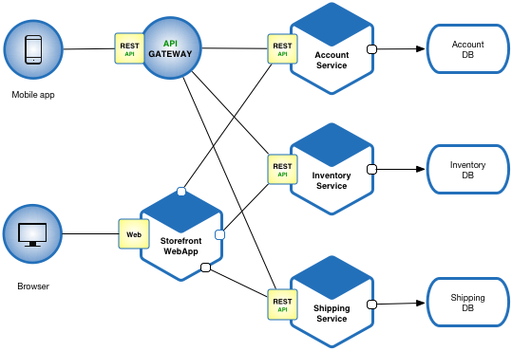

Figure 1: Pattern: Microservice Architecture (Richardson, 2018)

* 1. **Microservices and Monolithic**

Comparing Microservice to Monolithic architecture, there are some major differences in the characteristics and structure of both architectures. Uncovering these differences may support the switch in technologies over the recent years. Monolith architecture is the traditional way to structure. Today microservices are used by world-famous Internet services such as Netflix, Amazon, and eBay, and it advocates encapsulating all functions in one single application. Less complicated monolithic applications have their own strengths, for instance, simple to develop, test and deploy (Chen, 2017). However, this is where the advantages end unfortunately. As this can be an effective software development structure for a very small piece of software it is inevitable that software will go through development changes, because applications are continuously developed, scaled (Villamizar, 2015). Leading to a point where there are more disadvantages than advantages. As it grows a monolith structure becomes more complex with a massive code set and becomes incomprehensible and impractical. The previous team that was managing a small set of code will have to use a tremendous amount of effort to maintain a system that is practically unmaintainable as a single error can cause whole system shutdowns. Resulting in delayed updates, fixes, downtime, and generally slow (Chen, 2017). Now this is where microservices come in. As the new architecture Microservices, promises to address these issues with the monolithic structure (Fritzsch, 2018). Therefore, Microservices has many benefits over monolith because it is actively working to correct monoliths shortcomings. However, it cannot be all positive so, it is necessary to see if there are any drawbacks noted throughout the literature to have a fair discussion of the microservices architecture.

* 1. **Monolith first**

An interesting approach is a monolith first development cycle which is a current trend in the literature starting with a monolithic system and refactoring towards a microservice. It is less risky than completely redeveloping the whole system into microservices and easier to start is a monolith base (Larrucea,2018). Which could suggest that to create a microservice from scratch, potentially the developer could design the system in a monolith approach first, then refactor into a microservice. This viewpoint was also suggested by Martin Fowler he says an argument to start with a monolith then split to microservice when monolith becomes an issue is a reasonable approach (Lewis, J., and Fowler, 2014). As stated in the introduction a monolithic system can suffer from locked in technology, but even if a system is monolithic in nature refactoring even part of it to a microservice can unlock it from this lock and open it up to this idea of technology heterogeneity (Chapter 3.5). For example, current books and papers on the issue, monolith to microservices evolution patterns to transform your monolith from Sam Newman (Newman, S., 2019) and from monolith to microservices (Gouigoux, 2017). The fact that this idea of moving from monolith to microservice is still one of the preferred ways to incorporate a microservice architecture could show that the technology is still immature in nature, and there is not as much literature referencing building from the group up. On the other hand, this literature would be very useful in industry where companies still have legacy monolith systems which seems to be the main target audience of this new architecture.

* 1. **Microservices benefits and concerns**

Monolith structures main issues arise from the difficulty with scaling the structure as this can involve an increasing code set which makes it difficult to make changes and update without causing system breaking errors. Whereas Microservices has the self-contained services approach, which Villamizar describes microservices as allowing for a more practical methodology for managing a large codebase. Applications each have individual small codebases managed by a small independent team managing the development of the code but also the deployment (Villamizar, 2015). Having small teams working individually inherently limits the scope for errors and bugs within the services. Due to the fact developers can directly test and develop the code in separate environments meaning the functionality is isolated from the rest of the system (Dragoni, 2017). Newman believes this characteristic of microservices can better align an organization, reducing the number of developers working on an individual codebase can find the best balance between team size and productivity (S. Newman, 2015). Effectively, creating a level of efficiency that was not possible previously with a single complex codebase in the monolithic structure.

On the other hand, it is impossible for microservices to be perfect in every aspect there are some potential concerns and challenges that should be addressed. Nadareishvili, has suggested that having a system compiled of multiple interconnected services can become a challenge because if part of a system has an error it may have an unforeseen impact on another part of the system making error handling more difficult (Nadareishvili, 2016) Following on from this an increase in inter communication add more ‘chatty’ communication between services can cause a poor performance for the end user as to meet a single business requirement communication between multiple services is necessary. As well as deciding how services are discovered, for example presented through an API gateway (Alshuqayran, 2016). Esposito believes that due to microservices unique complex characteristics, there is a need for research into technical limitations and security vulnerabilities (Esposito, 2016). The security issue is summarised by Sun, the fact that microservices are comprised of many small applications creates a complex network of activity. Which in turn makes monitoring and securing an application very challenging. Which is even more challenging when a system is deployed to the cloud as the admins only have limited access to the applications network (Sun, Y., Nanda, S. and Jaeger, T., 2015).

* 1. **Technology Heterogeneity**

The separation of services comes with another benefit known as Technology Heterogeneity. Which refers to the ability to compose a system of multiple collaborating services using different technologies. Allowing the unique ability to pick a technology based on the type of job the service is required to do (S. Newman, 2015). Working hand in hand with the small independent team structure of microservices. As heterogeneity, let us different programming languages and databases to be used, a team can cater to their needs by picking a familiar coding language, in turn the development time may increase as training developers may not be needed (Villamizar, 2017). However there needs to be a level of caution with technological heterogeneity. Such that it can counteract the main reason microservices are used. The manageability of the system can become overwhelming as the diversity among services increase. Previously mentioned, development teams choose the language a service is created in, the service becomes somewhat dependent on the developers and their skills in the language. Meaning the output of a service is a representation of the developers, and it would be difficult to bring in a new member of the team if they do not have any prior knowledge in the specific language. A way of combating such effects on a system is by introducing basic standardization where teams are encouraged to use technologies with tools and infrastructure support. While still allowing enough heterogeneity to not hinder future innovation (Bogner, J. and Zimmermann, A., 2016).

* 1. **Scaling**

Scaling microservices is also an easier process than scaling monoliths. Monolithic scaling would require major hardware improvements to be able to manage the requirements of scaling. In result it would need a large investment of both time and money (Taibi, 2017). On the other hand, microservices do not face this problem because of the independent deploy ability characteristic allowing for on-demand scaling, where monolith scaling is dependent on hardware requirements if a microservice experiences similar problems it can be re deployed into an environment with more resources (Nadareishvili,2016). The main disadvantage of microservices stems from the newfound complexity of the system. Increasing the number of interactions as the system was broken down into smaller services the systems complexity increases with more and more cross service interactions happening. Which can make testing, security, and data management more difficult with the new level of complexity. To deal with this it would be ideal to keep the interactions as simple as possible to eliminate unnecessary complexity and stick to a robust set of principles (Chen, L., 2018).

* 1. **Security considerations**

The security of any system is not to be taken lightly, and essentially if the system is being designed for the use of users. If a system has vulnerabilities, then there are chances of a security breach, which would then become a concern with users as data can potentially be stolen or intercepted. Which is no different when it comes to a microservice system, security is a concern. Even though there is limited literature in security there are attempts to address potential security concerns and offer solutions. Firstly, the way microservices function raises areas for concern, REST, XML and JSON to handle the transfer of data across the system (Dragoni, 2017). Yuqiong Sun (2015) discusses the security flaws that inherently come with microservice architecture and proposes a method to increase system security. He confirms what Dragoni says about microservices having inherent flaws, referring to the increasing number of small services within an application creates a complex network of activity, as data will be getting sent back and forth between the services making it increasingly difficult to monitor and securing the network (Sun, 2015).

The other major security concern Yuqiong Sun puts forward is to do with the cloud. The cloud is the most popular way to deploy microservice applications, some of the issues with the cloud were presented in the chapter previously mentioned. The main point in the literature here is that cloud platforms lack or have limited ability to monitor the interactions among distributed microservices (Sun, 2015). Due to the diversity of technologies increases the chances for security vulnerabilities in a microservice (Torkura, 2017). Their solutions that are provided is Flow Trap a primitive is designed to be a cloud API that can be invoked by cloud applications essentially the methodology is to forward networks requests to a security monitor which then can redirect the request if it deems it to be a breach to security (Sun, 2015). However, it is among the themes of being a prototype like most of the ideas present for microservices, even though it does show positive results within a case study. It could be argued that when dealing with security a methodology that is more developed would be the practical solution and the idea presented would need more time to develop before it is used in practice.

That is where Yarygina (2018) suggests since the aim of a microservice system is to be lightweight so should its security solution meaning it can be accessible to developers keeping that statement in mind, Netflix’s Token-based authentication is presented, a security token is created on the server side upon the successful validation of the clients’ credentials and given to the client for subsequent use. Security tokens substitute the client’s credentials within a limited timeframe (Yarygina,2018).

Unlike the previous security solutions, token-based authentication is the first solution that has some sort of depth in the literature surrounding the topic. Encryption being a well-developed area of study which provides some backing to the idea of using token-based authentication. In practice tokens would allow for two-way authentication, between the system and the user allowing for data to be sent across the network encrypted reducing the risk of vulnerable data being intercepted, increasing the overall security of the system.

* 1. **Designing a microservice**

After reviewing the literature there are currently two ways that have been found to be used in practice to design microservices. Like any new technology there are many ideas but only some that seem to become industry standard, because with anything new it takes time before ideas turn into reality and over time the ideas will settle down and become more cohesive. But currently this is the start of this cycle and there are still things that are not fully understood, this section will focus on these ideas that are industry standard and briefly discuss other design ideas that can add extra insight to the research that is taking place.

Before the development phase of a microservice project the necessary time should be spent on designing the system to create a fundamental guide to build the microservice. This section will focus on the current design trends and patterns because microservices must be designed in quality and style but that is not always true

Despite microservices’ popularity, research still lacks disciplined understanding of transition and consensus on the principles (Hassan,2020). Due to the lack of refined requirements for microservices, understanding what is necessary for designing such a system could potentially seem a difficult task. However, there are a couple of ways to tackle this issue. Firstly, by looking at one of the most influential books on Microservices by S Newman, the ideas he puts forward can be used as the baseline needs for designing a microservice system. He puts forward a domain driven modelling technique, a domain driven model takes the main focuses of the system, usually the business capabilities and how these different capabilities provide context for the rest of the system (S. Newman, 2015). The evolution of the boundaries between capabilities changes over time, triggered by knowledge updates about the system domain (Hassan,2017) Suggesting that a domain driven model is potentially flexible in design as the initial system that is created can be small and as the problem grows and complexity the model can unison. Also designing a system with boundaries isolates individual capabilities within the microservice, meaning if the system requires to be changed the isolated capabilities can update individually, allowing for quicker development and deployment time (S. Newman, 2015).

**3.8.1) Model based**

A possible method of capturing a reliable design requirements specification is to examine more recent literature that has been released since Newman’s’ initial requirements were published. This should give a broader opinion, hopefully finding similarities between literature can provide adequate requirements to designing/modelling a microservice system. Irakli Nadareishvili (2016) is another influential book in this topic, and he suggests a model-based approach.

Figure 2: Microservice Architecture (Nadareishvili,2016)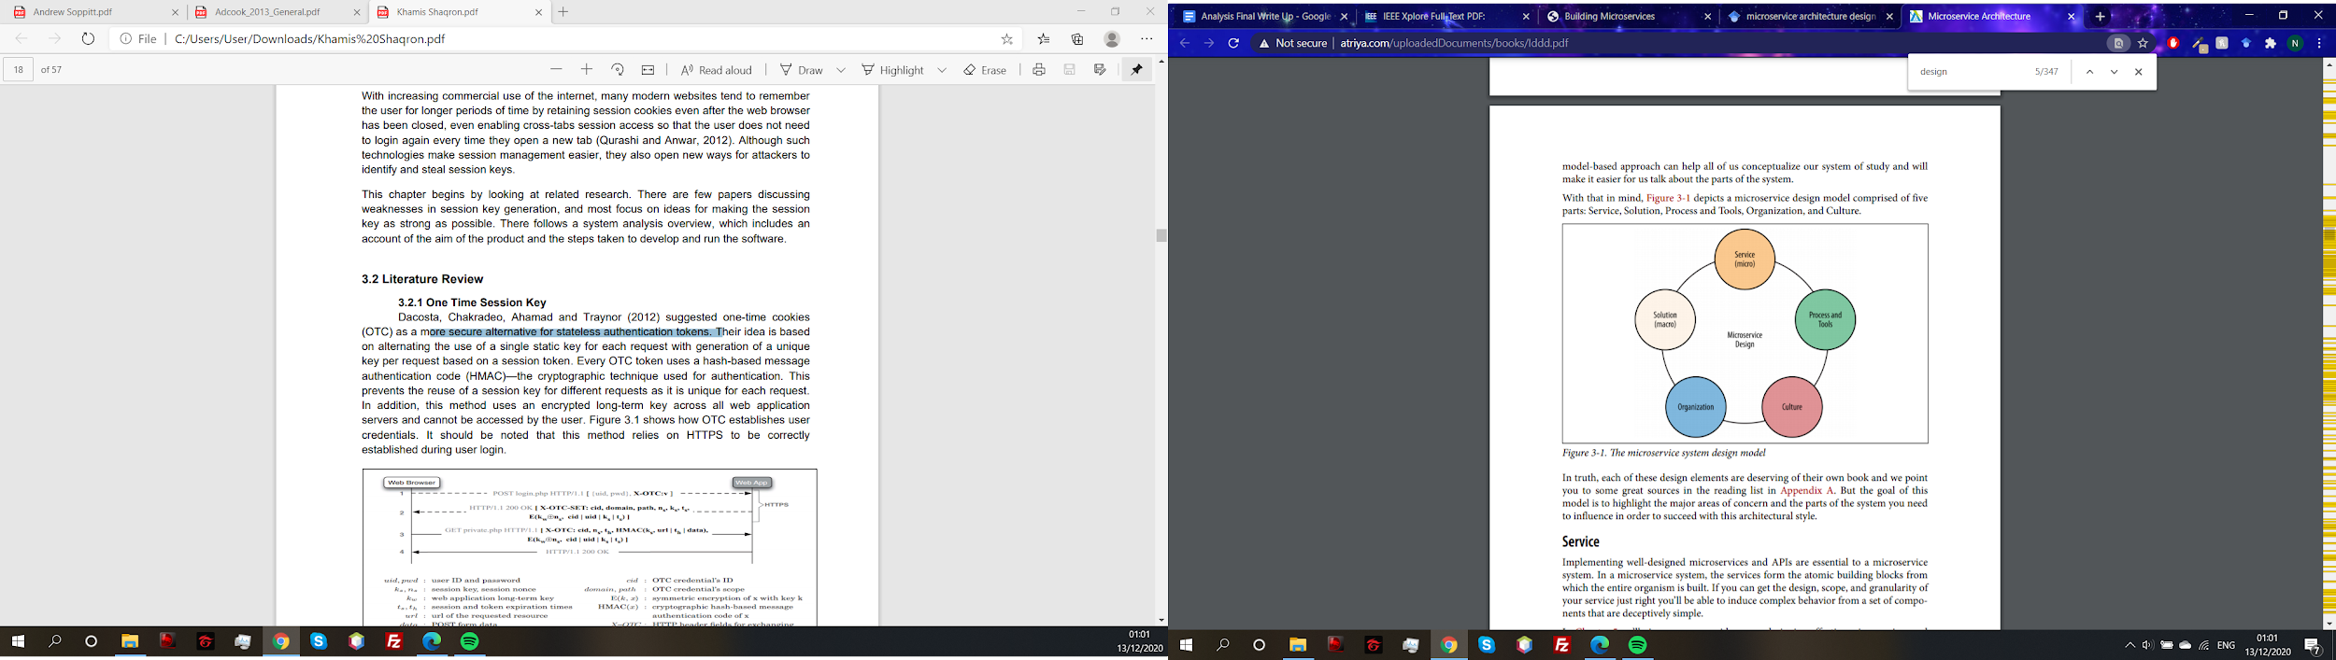

The model takes a microservice and breaks it down into several sections. The intention of the model approach is to visualize how the system connects and helps create a set of principles developers can then use to build a microservice with more structure. This would involve looking at the microservice design as a whole and breaking it down into Services, Process and Tools, Culture, Organization, and solution.

Initially, looking at both proposed methods for modelling a system it may look like they are the opposites of each other. However, in fact they are both very similar methodologies the premise of both is focus a system on a specific problem, breaking the problem into services with the goal of creating a system with a design adaptability into the system as a feature (Nadareishvili,2016) The differences are that the model is less a technical approach than the domain driven as domain driven focus solely on the connection of the capabilities. Whereas the model based is more orientated around creating a good design, instead of working to simply produce a solution (Nadareishvili,2016). Modelling the system is more focused on helping the designer understand the whole process including the tools as previously mentioned, creating a microservice that is adaptive but also well structured.

**3.8.2) Domain Driven model**

Another paper by Hippchen suggests using to use the domain driven model like Newman but since some time has passed between Newman’s study Hippchen is aware of the shortcoming of domain driven model “the approaches focus on the development itself but omit the design and maintenance phases” (Hippchen,2019)

Their intent is to provide design details, like the model-based approach, they have done this by a domain driven context map. The goal of using this method rather than just the domain driven is that it focuses on the macro structure of the domain rather than just the business objects (Hippchen,2019). An issue with this method is the lack of integration in the development process and it may be unclear when to create the context map. However, it does provide a better overview of a microservice architecture including the dependencies that will be beneficial for maintaining a microservice system (Hippchen,2019).

With this newer methodology it seems to cover the flaws of the domain driven model by using a content map. However, the methodology they suggest is a new idea and has only been used in a case study, and not practically. This is a flaw with the idea as without any practical evidence to support the implementation, designing a system would be difficult.

A running theme in the more recent literature is that the design principles that they are suggesting are being presented as prototypes, one again it appears the topic of modelling a microservice is still in its infancy and will take time to develop new methods and principles that have been tested in real world projects and the community will then be able to agree on a set of requirements for designing and models microservice systems. For the current time Model driven development is the most tried and tested development style for microservices and is the most designer friendly as it does not omit these stages of development like domain driven.

**3.8.3) Experimental Model**

The QOC model is experimental re-evaluation by Zdun of a well-known design pattern from MacLean published in 1991. However, Zdun, proposes a use of the model to be used as a design tool for pattern designing microservices. The original suggests, a design space analysis approach to represent design. Essentially is follows a set pattern of questions, identifying key design issues. Options, providing possible solutions to the questions and criteria comparing each of the options (MacLean, 1991). MacLean’s justification for his approach is the bridge between criteria as it can take considerable effort to find the correct criteria when designing and using design space allows the design to phase through the criteria to find the criteria that best meet the desired outcome (MacLean, 1991). Before looking into Zdun’s incorporation of the design methodology, based on the current literature it it’s possible to see why it may be appropriate. One of the main issues with designing microservices is the difficult to know how to manage and define services.

Zdun builds a more abstract design space by using patterns as options and adding an additional mapping between the questions, options, and criteria. (Haselböck, 2018)

It states that the method has been used to API management, even though the model has not been used for modelling the services themselves it has presented an interesting idea and use of a pre-existing design concept such as design space could potentially be used for any kind of design, even microservices. Bringing the idea that because there is not current a solid validated method apart from one of the more popular methods such as model based. That well know methods can be used to try and create a feasible design. In theory MacLean’s methodology could be used alongside the design documentation of a microservice to narrow down a more defined solution.

* 1. **Containers**

Once a system has had a successful design phase, the next step is to the development process. It is believed that the research is still in its infancy phases, and the general focus of the literature is on the general architecture. With a lack of empirical research on the design and development or microservice applications (Aderaldo, 2017). Due to the potential issue of a lack of a validated framework or requirements, could suggest that it is necessary to look at the current trends, compared to the biggest studies in microservice creation Newman and Nadareishvili.

One such growing standard is containers as they enable a microservice to distribute a lightweight infrastructure between the services, supported by technologies such as Docker (Viggiato, 2018). The idea of using a of using containers for microservices is a well-known topic as Newman believes that if a technology such as .NET adding a container for the services will prove beneficial for the system because it becomes easier to manage as a group of clustered services within a container can get support from monitoring tools (S. Newman, 2015). Such monitoring tools could be Consul or Serfnode, these example monitoring tools can be added to an existing container. Which offers robust monitoring and health checking (Stubbs, 2015) With microservice getting more complicated as they grow tools can help keep a system healthy meaning there is a great chance of the system being available, with monitoring a microservice system it would be too time consuming or cause a team a drastic amount of effort to fix a complex system fault.

* 1. **REST API**

So far everything that has been mentioned has been in theory what defines a microservice and how they should function. In practice there needs to be a way to get data in and out of each service (Sill, A., 2016). REST APIs are based on lightweight inter-service communication like HTTP (Terzić, 2018). Making calling resources very convenient, reducing the complexity (Hong, 2018). The main advantage of REST APIs is that they are very flexible with the ability to manage different data formats making them a perfect fit for technology Heterogeneity and suitable for microservices (Hong, 2018).

* 1. **Conclusion**

The future is potentially very positive for microservices, as they continue to grow in popularity more businesses and industries will begin to move away from older technologies like monolith as scaling applications are extremely important in today's day and age. Currently, the state of the research resolves heavily on the migration and refactoring old systems into microservices. Meaning that there is still currently little literature for the creation of a microservice from the ground up, and a lack of information surrounding the design stages. Most studies centred on the structure and technical sides of microservices. However, this was to be expected as the research is still in its infancy stages and it will take time before the research is at a point where the research is at a level where there are validated frameworks and requirements. However, there is a solid base of research that already exists from the likes of Newman and Fowler. The fact that microservices are showing that they can already work in the practical sense with major businesses already using them is encouraging for the future of the technology.

1. **Requirements Approach**

The focus of the development aspects of the project is to create an IT Help Desk application. The following section observes the process of collecting the necessary requirements, including both functional and non-functional subcomponents of the proposed system.

**4.1) Requirements Capture Method**

When selecting a priority for the requirements the MosCow technique will be used. This method takes all the requirement is an example of numerical assignment. There are for priority groups Must, Should, could and wont. All requirement under a particular requirement has the same priority (Vestola, M., 2010). MosCow is probably the best used in the early stages where requirements are not fully specified (Vestola, M., 2010). This method is important is that the priority can be used to show how important requirement should be (Racheva, 2008).

**4.2) Existing IT Help Desk Systems Survey**

Existing IT Help Desk Systems were evaluated with the intent to gather what requirements there are to create this type of system. Several existing software’s were discovered by looking at the top picks of help desk systems for 2020. The research included looked at the list of features listed on the sites.

**4.2.1) Happy Fox**

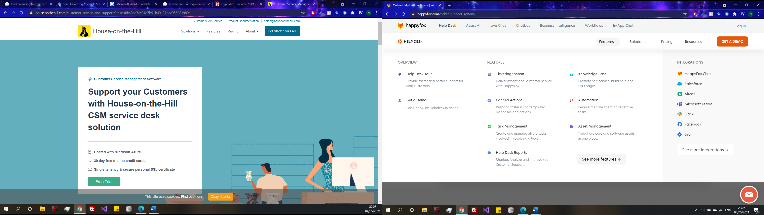

Figure 3

|  |  |
| --- | --- |
| Feature | Description |
| Create Ticket | There are multiple methods of ticket creation, tickets can be created by:   * Email * Web interface * Live chat * Phone * API |
| Staff Dashboard | The staff dashboard has features such as:   * Ticket Overview * Pending Ticket count * Assigned Ticket count * Critical Ticket count * Tickets by status * Tickets by priority * Recent replies |
| Ticket management | * Unique ticket Id * Respond and update ticket |
| Personal Preferences | * Personal information * Ticket page * Landing page |
| Reports | * Status * Priority * Subject * Assignee * Category * Time since ticket created * Updated by * Customer name * Customer email |
| Staff Management | * Create and manage roles * Define role-based access privileges * Add single / multiple staff within a role * Active Staff/Inactive Staff * Two Factor Authentication for Agents. |
| Notifications | * End Users * Setup Auto Responders * System Notifications * Forum Notifications * New Ticket Notification * Private Note Notification * Ticket Assignment Notification |
| End User Interface | * Web interface to create and submit new tickets, view past tickets * View ticket history and agent responses * Customizable profile for each end user * Search and browse Knowledge Base * Create tickets from Knowledge Base Page * Access Knowledge Base, Forums and Tickets from one portal page * Forums * View topics and posts * Post comments |

(Simple Help Desk Features Makes HappyFox The Best Ticketing Software, 2021)

**4.2.2) Zoho**

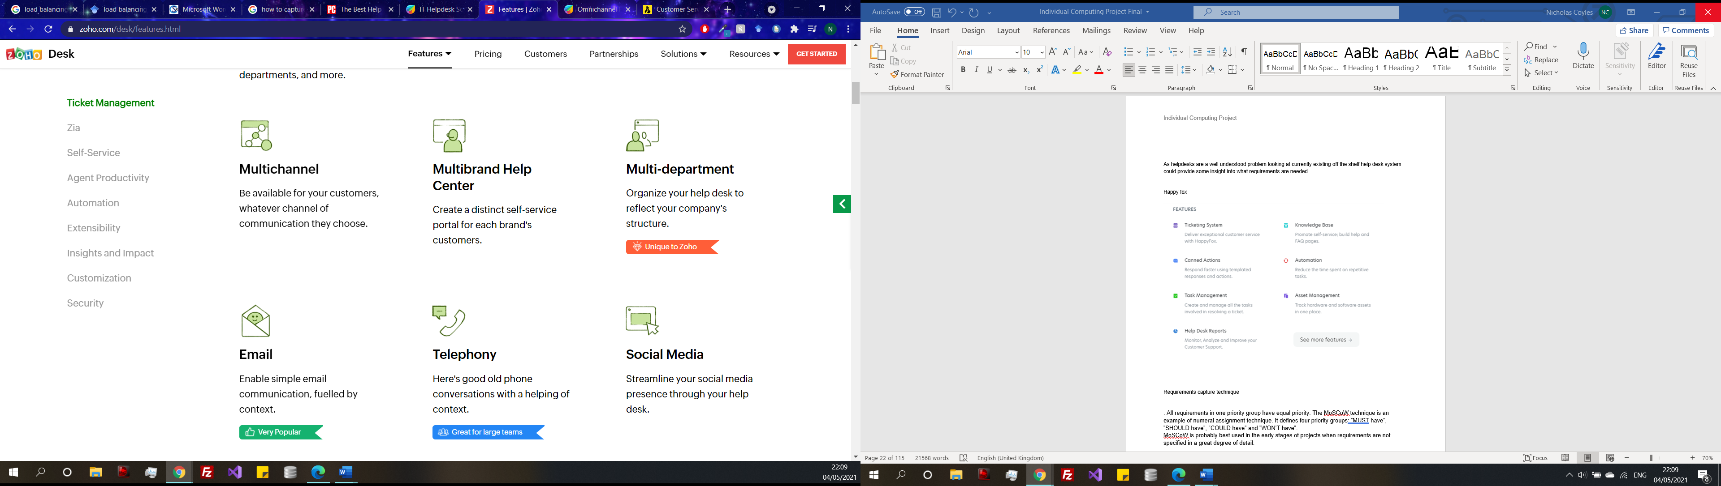

Figure 4

|  |  |
| --- | --- |
| Feature | Description |
| Ticket management | * Multichannel * Help centre * Multi-department (unique to zoho) * Email * Live chat |
| ZIA (Contextual AI) | * Zia voice chat * Ask Zia * Auto tag tickets * Zia notifications * Zia dashboard * Reply Assistant (unique to zoho) |
| Self service | * Embedded self service * Help center * Knowledge base |
| Agents Productivity | * Work Modes (unique to zoho) * Response Editor |
| Automation | * Ticket Assignment * Notification |
| Extensibility | * APIs |
| Insight and Impact | * Reports and dashboard * Time tracking |
| Security | * Roles * Profiles * Data sharing * GDPR |

(Features | Zoho Desk, 2021)

**4.2.3) Fresh service**

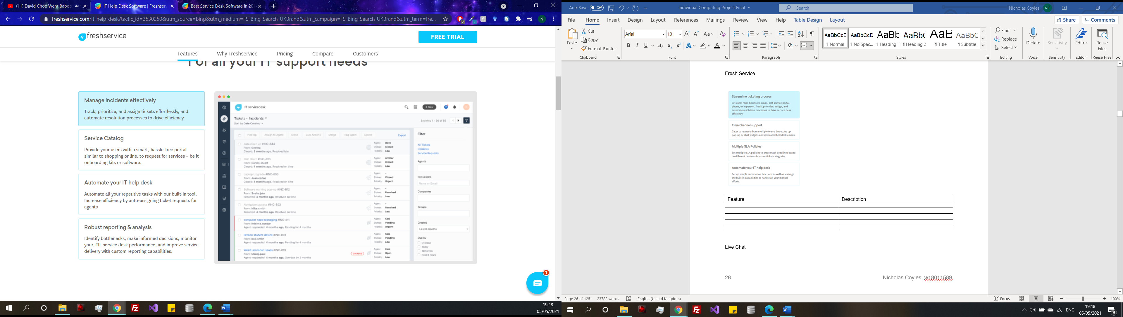

Figure 5

|  |  |
| --- | --- |
| Feature | Description |
| Manage incidents effectively | Track, priorities and assign tickets |
| Service catalogue | Provides users with a smart, hassle free portal |
| Automate your help desk | Automate all your repetitive tasks with built in tool |
| Robust reporting | Identify bottlenecks |
| Incident management | Users raise tickets via email, self-service portal, phone. |
| Self-service portal | users can look up solutions from the knowledge base, and let them raise requests directly from your service desk’s support portal |

(Freshservice ITSM System | ITIL-aligned service desk software, 2021)

**4.2.4) Live Chat**

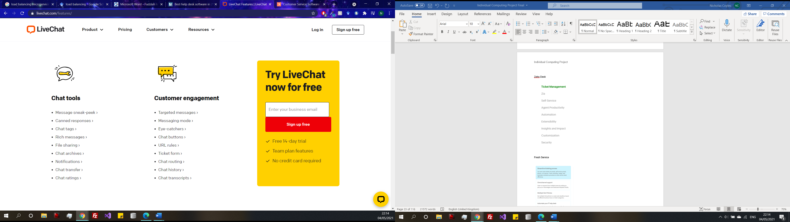

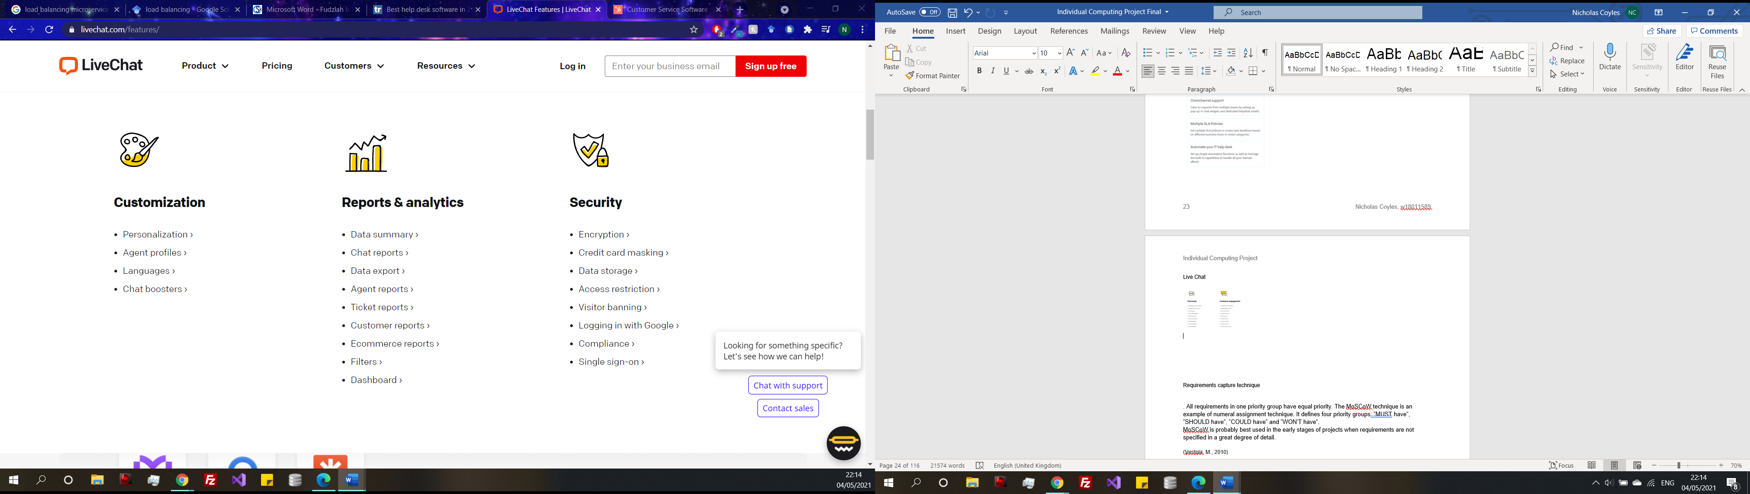

Figure 6

(LiveChat Features | LiveChat, 2021)

(Helpdesk: full list of features, 2021)

**4.3) Discussion of Results**

As shown in the collection of requirements, existing Help desk application have a great number of features, some features are unique to that service like contextual AI that is used by Zoho help desk. When looking for what requirements should be should in this project system it would be appropriate to look for commonalities between the systems to find what are customary Help desk functions as they could be used as the functional requirements for this project. Common features seem to be having a knowledge section or FAQ page, the ability to create a ticket, tickets to be priorities and categories. A chat or blog system, user/admin portal, ticket history and roles.

1. **Requirements**

**5.1) Requirements Specification**

Shown in (Appendix B) are the requirements marked as a HIGH priority using the Moscow method and are the principal requirements when it comes to development in the Synthesis chapter. The remaining requirements can also be seen in Appendix B.

The requirements have been produced because of the findings the literature (Chapter 3) and the systems research (Chapter 4.2). Other functional requirements were considered in the form use case diagrams (Chapter 6.1) and can be seen in (Appendix C) where the core functionalities of the system were visualised in diagrams. The non-functional aspects such as HCI implications are discussed in (Chapter 6.2).

The full requirements specification can be seen in (Appendix B), The list of requirements was created using the prementioned common features above but considering the key findings from the literature. For example, what is necessary for a system to be a microservice? Looking back at the characteristics or a microservice from Fowler (Chapter 3.1), breaking the system into services organized around business capabilities, Scalable, loosely coupled, automated testing (Fowler, 2014). These characteristics are what define a microservice system, therefore it reasonable to include them as non-functional requirements, giving the highest priority because they need to be met to call the system a microservice.

**5.2) Requirements Justification**

The Justification of Requirements section adds support to the requirements specification (Appendix B) to justify the choices made and how influences from the literature review and research into the subject field may have caused some requirements to receive a higher or lower priority than others.

The functional requirements have been selected from the research survey picking the most important feature that create the core of an IT Help Desk, as well listing some other features with a lower priority which would be a suitable inclusion but not a main priority.

Non-functional requirements are also present in the requirements specification, rather than specifying a certain system behaviour like functional requirements. Non-functional requirements are focused on the operation of the system. In the requirements specification scalable, maintainable, and available are all listed with a high priority. The reason for the collective high priority is to do with the definition of a microservice. A microservice is defined by these characteristics therefore they are listed as high priority because for the project to be a success a microservice is to be created with the capability for these requirements.

However, scaling is listed a low priority the reasoning behind this is that scaling a microservice would require the use of a load balancer. Load balancing is the process of improving the performance of a parallel and distributed system by organising horizontal scaling (Sharma, 2008) (Singleton, 2016). To apply this method of scaling to the project would incur significant networking overhead (Niu, 2018) which is not available therefore will be deemed out of scope. Similarly, any sort of Virtual machine testing would fall under the same category because not only are they time consuming to set up, but there is also a potential overhead.

Other requirements that are out of scope are the HCI elements, even though there are wireframes created in (Appendix D), these elements are out of scope because the development is aiming to build a vehicle for the microservice architecture rather than a full operational web application. However, if this were a real project that would be deployed both scaling and HCI would be extremely important. Firstly, scaling so that the system can grow and change over time. Secondly, an IT Help desk customer may be untechnical themselves so thought would have to go into the HCI to make sure that it is accessible and usable to everyone.

All the requirements will be revisited during the evaluation of the project to decide the level of success of the project. The level of success will be determined by how well the strength and weakness of the solution in meeting the requirements and forming a critical analysis of where alternate approaches could have possibly been taken to meet the specification. However, now the most crucial requirements are the ones marked with the highest priority, and the success of the project is according to completion of the core requirements. A method of testing the requirements will come through the form of testing, testing will be covered further in the design chapter. Briefly, good testing is essential for the evaluation of the project so making sure that a high-level test plan and test cases will not only ensure that the system can be tested functionally, but the usability can also be accounted for. The test plan will be documented in the design chapter.

**5.3) Tools and Techniques Justification**

The project revolves around creating an application using a microservice software architecture, and as learned in the literature review. Microservices allow for technology hierarchy (Chapter 3.5) meaning it is up to the developer to choose what language is most suitable because any can be used. The selection of what language will be selected will be based on what benefits certain languages may have when it comes to developing a microservice. Also, some consideration must be made for the requirements because whatever software and language of choice must have the capability to achieve the requirements.

|  |  |
| --- | --- |
| Language | Discussion |
| Java | When creating microservices with Java, it I supported by a framework known as Spring boot which supports MVC and Restful web features.  Dependency injection which can make the development process more convenient.  And a major benefit is the spring can use Aspect Object programming (Suryotrisongko, 2017) which can split an application in  UI, Business layer and the data access layer. Which as a result can make code more abstract and less complex.  For the front-end can be created using the Angular2 framework. (Suryotrisongko, 2017)  Some have argued that Spring is the most matured framework for developing microservices, due to its simple guidelines for development (Ma, 2018)  On the other hand, using the Spring Boot approach come with its challenges. With a Spring-based application its configuration is complex. Although it can be easy to create an application, there is little support for the configuration. Also, it can be difficult to identify the framework dependences and library versions required to create an application (Guntupally, 2018). |
| ASP .NET C# | NET Core has the benefits of the emphasis on security, supports OAuth2, JWT and OpenId. Which allows for the creation of authentication and authorization system. As well as support and documentation from Microsoft (Kostolny, 2019).  .NET Core supports Linux or windows containers, for docker containerization which can make applications cross platform (de la Torre, 2020) |
| Python | The Flask framework supports python, it provides a flexible minimal template to creating microservices, allows for both independent deployment of servers and flexible to administrate each server (Le, 2015). Python can use a heavy framework Django, which provides support for web applications. Python-based API can be used for defining databases, with automated SQL statements (Burch, 2010).  Python has become on the most popular languages for back-end application. However, there is currently no simple solution for monitoring the performance of Flask based web applications (Vogel, 2017). |
| PHP | A survey of professionals who work with microservices. Out of the 122 professions only 8% of use PHP to create microservices (Viggiato, 2018).  Even though there seem to be low number of developers using PHP, there are advantages to using the language. PHP does in fact have a large community that has great documentation, easy to deploy server side, small learning curve so development speed is relatively high and there are lots of frameworks and libraries available to use with PHP like GTK which can be used to create a GUI (Sanchez, 2017).  Although there are some disadvantages, security can become an issue if the developer is experienced, and PHP is open sourced which in turn is unsuitable for large applications (Sanchez, 2017), and would be more suitable for smaller web applications (Kostolny, 2019). |

To summaries .NET would be the most appropriate tool for this project the main reason for this choice is the support and helpful documentation that is provided. The movement of microservices is fronted by Microsoft which lets visual studios be used to develop the service. Also, as the project is creating a web application .NET can also be used to make an ASP web application, unlike the other technologies which are focused on the back-end development of microservices, but they can support front ends in other technologies. None of the languages stand out because there is no prior experience therefore .NET would be the easiest choice to learn through the development process due to the documentation from Microsoft and other literature. The final motivation for picking .NET is for the framework support, the ability to add packages to .NET to add capability to use entity framework and LINQ to the project, which Java currently does not have support for.

One consideration for the language of choice is to pick the language that is most suited to complete the task at hand, which is ASP .NET. However, if this were a real project there would not be just a single language any of these languages would be appropriate, which has already been discussed in section (Chapter 5.3). Also completing this project individually would not allow the time to complete multiple services in different languages as this would require too much time to learn multiple methods. Therefore, singling one on language is most appropriate way to approach the project coming from a place of no prior knowledge. But it is important to note that each language would be appropriate for a particular task as, they all have their own benefits and drawbacks.

**5.4) Development Methodology**

The approach of development is coming from the Agile Manifesto, focusing on “Working software over comprehensive documentation” (Abrahamsson, 2017) meaning that the priority is create functioning software rather than creating comprehensive design documentation. However, this does not mean there will be no design documentation, just making sure the design documentation that is created that provides necessary and relays what is being created in development. Otherwise, time can be wasted creating a plethora of designs that may become irrelevant or not focus on the main scope, and not only can more time be spent ensuring the product is built to a high standard the documentation will also add value to the overall project.

**5.5) Summary**

To briefly summaries this section of the Analysis chapter established the functional and non-functional requirements for the planned system gather from both literature and a research survey. Several tools were evaluated, and ASP .NET was selected as the most appropriate technology to complete this project.

**Synthesis:**

**Introduction**

This chapter is the first of the two main chapters that make up the synthesis. The goal of the project is to design and develop a help desk system using a microservices architecture. The software is to be designed following the agile development methodology where the conclusion was made that a strong design can lead to more coherent development. The system is to be broken down into its structural components which will be discussed in turn with the relevant design documentation referenced.

1. **Design Documentation**

**6.1) Use case diagrams**

Use case diagrams (See Appendix C) are very helpful in the design process as they represent how a user, or another role would interact with the system. Their purpose is to visualize aspects of the system defined in the requirements specification; they can show a representation of what the system should do.

**6.2) Front-end**

One way of gaining an understanding into designing a system with an appropriate font end interface with a design that fits usability needs as well as functional needs is to investigate the world of Human Computer Interface (HCI), especially the work of Nielsen. Nielsen’s creates a method for finding issues with the usability of a user interface by using a set of evaluators, inspects and compares with a broad range of usability principles (Nielsen, J., 1994) The Heuristic principles that Nielsen created in his study, are still relevant today. Therefore, they can be used here as a guide to creating a user interface within minimal to no usability problems. Nielsen’s top ten heuristics achieve the widest cover of usability. For example, this includes heuristics such as consistency keeping things the same way, feedback from user’s input and error recognition (Nielsen, J., 1994).

Also, when designing the look and feel of the application is important for both usability and readability so there should be some consideration. For the background white is the most appropriate It allows all other colours to reflect from it and make all colours except yellow to be very readable. As well as making the site look clean and uncluttered (Cerrato, 2012) blue will be used as the secondary colour for the application because blue listed as the most popular colour trust, reliability, belonging, coolness (Cerrato, 2012) this is important as an IT Help Desk whole purpose is helping users and using a colour scheme that represents these emotions especially trustworthy could potentially build trust between users. The last consideration is to do with the text used on the application Nielsen recommends using font sizes of at least 10 points or 12 points for elderly readers and using a reasonable line height to not hinder the readability of the text (Rello, 2016).

Wireframes (See Appendix D) are helpful in the design process as they show the design layout of the systems interface. The wireframes created are for several the pages that will be in the system. There has been a colour scheme selected that will remain consistent throughout. Following the principles discussed in the HCI considerations using a background colour of white and blue as a secondary colour and a reasonably sided font to ensure that text on the screen is readable.

**6.3) Back-end Design**

**6.3.1) Entity framework**

Firstly, as this project has specified, the entity framework is going to be used during the implementation. The way it works is by using migrations, which update the database schema to keep it in sync with the application's data model within affection the currently existing database (Migrations Overview - EF Core, 2021) By using entity framework there is not a database manually getting created, with a data dictionary.

**Code first approach:**

Code First lets you define your domain model with code. Using a code first approach focuses on creating classes first rather than designing a database first. Once classes have been defined Entity Framework will use the code to generate a database (Lerman, J. and Miller, R., 2011). The major benefit of using a code first approach over other approaches like database first is the increased development process, because time does not need to be spent creating a database. Classes need to be defined and the database will automatically update corresponding to the code. As well as this it makes it easier to maintain the application the database can be updated by using entity framework rather than having to design and re-define a database.

**6.3.2) System overview**

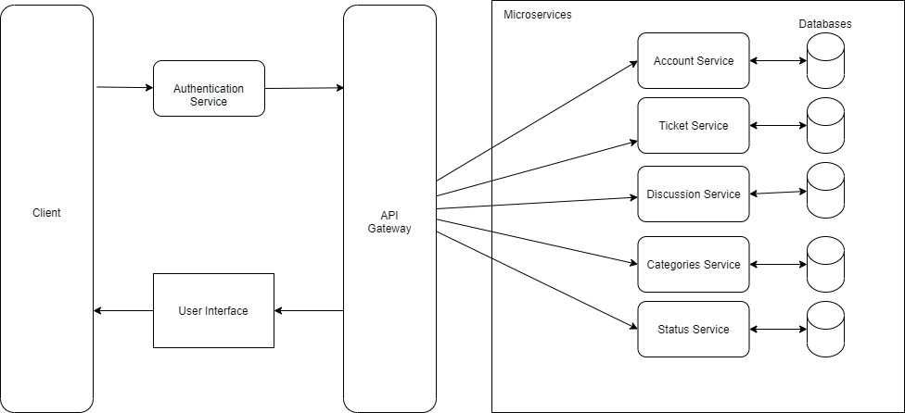

Figure 8

**Structure**

A microservice architecture has been used to design the structure of the application. The design is based on the requirements stated in (Appendix B). Firstly, each service has been broken into its own microservice and connected using a REST API, like the diagram in (Figure 1). However, one of the requirements is that a user needs to log in to have access to the features of the application, therefore a separate service has been created of authentication which will be the gateway between the Client and the services. Once the user has been authenticated against the user credentials in the database, they will have access to the services. The way a user interacts with the services is to send a post or get a request using the front-end user interface, the request is then sent via the API to carry out the request at the desired service and data will be returned.

Each of the services that is shown in the systems diagram in (Figure 3) are self-contained services within the microservice. The system is broken down by capabilities. The first being authentication. Once logged in the user is then able to create a ticket, the ticket service manages the data relevant to the ticket like Id title, description, time created and cross reference to the category and status services.

**Authentication**

The user interacts with the user interface of the site, when they try to enter the site for example through a URL the system checks if they have been authorized if not then they are redirected to the login page. When the user adds their details, it is checked against the user authentication service and its personal database containing user credentials. If valid the user will be directed to the services which they can now interact with via the user interface now they are authorized.

**Front-end design**

As the application requires the user to navigate through the site to login and create a ticket for example and meet some of the other requirements from the requirements specification (Appendix B). To make sure the front-end meets the requirements to the highest level there needs to be some consideration into what is needed to create a functional, usable front end. The next sections will be the building upon this thought adding into the overall design.

**Services**

Figure 8 shows the proposed services. The account, ticket, discussion, category, and status services that all have their own database to store data related to that service. Each service can communicate to each other through REST API requests sent through the API gateway, indicated by the multidirectional arrows on the diagram.

The services are showing the capabilities of a ticket and how a ticket can be broken down into its components to make each service.

**API gateway**

The purpose of the API gateway in the system is to manage the requests and routing of the API communicating across the system.

**6.3.3) Database**

Even though it states in (chapter 6.3.1) that entity framework will be used to automatically create the databases. Creating a simple ERD diagram may prove to be benefit in trying to understand the system.

In (Appendix E) the planned database diagrams show the databases for each service. Iin the table for the discussions database it shows an Id for ticket Id even though there are not directly links. This is an example of the communication that is going to happen, in the discussion database there will be comments stored under a particular ticket Id. The ticket service will call this service when it needs to display comments and when a comment is to be posted the ticket service will call the functionality from the discussion service to create a new comment which will be saved into the discussion database and can now be called when necessary. The ticket database is a regular relational database with foreign keys to the category, status, and priority tables to get the relevant name for a specific Id. The other databases are relatively simple databases which are only to be used by their service independently.

**6.3.4) System re-evaluation**

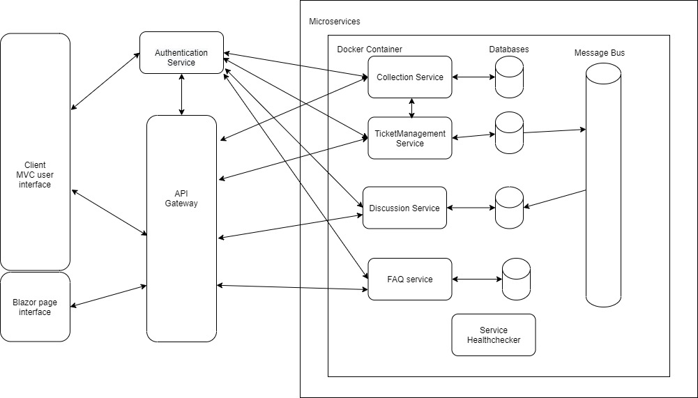

Figure 9

In this new design, which appears to be more appropriate to meet the needs of the project. There has been a re-evaluation of the services.

Firstly, the authentication service will authenticate uses using JWT tokens and role policy. Authorizing access from the front-end interface login portal and restricting access to services dependent on the role accessed with the login credentials.

Now there is a single service for a collection of all the tickets stored in its independent database, this service will communicate directly with the ticket management service which will contain all the functionality for editing and updating tickets. Then this service will communicate with the discussion service using asynchronous messaging over a message bus. The ticket management will be able to message the discussion service to request comments on a ticket and can post new comments. The FAQ service is the same and all services will be wrapped within a docker container. All services will be contained within a docker container and communicate the front end over the API gateway and there will be a single page Blazor page for the admin portal.

**6.3.5) Final System Design**

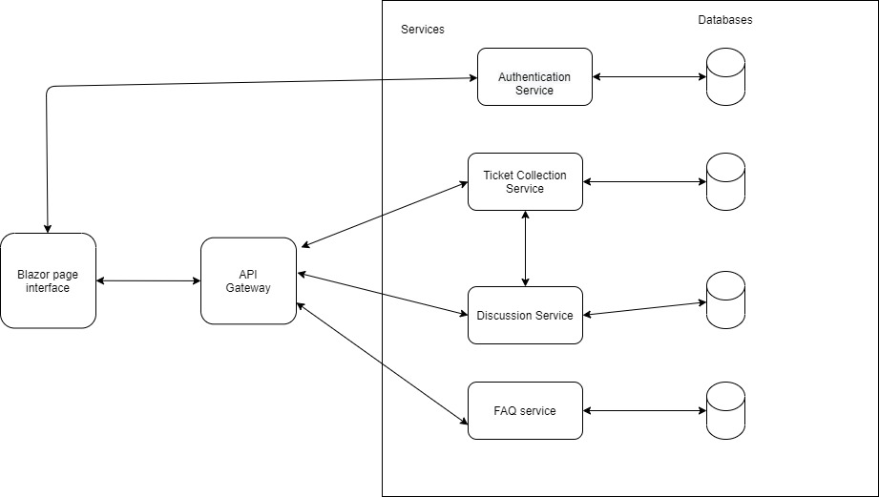

Figure 10

(Figure 10) as discussion in the third build (Chapter 7.1) due to time constraints and the struggles that were encountered with the complexity of the techniques from (Appendix N), required a more simplistic system design that was more possible to implement in the remaining time. The ticket management service was removed and all the functionality for managing tickets is within the collection service. Instead of using asynchronous communication to communicate between the ticket collection service and the discussion service, synchronous communication is used because it is not as complex and easier to implement. Final the front end has changed it is no longer using the traditional MVC application because after practicing with the blazor front end it was easier to use. As well as the added benefit of being able to set up in built authentication, server side was very convenient add would allow some time to be saved. The FAQ service and API gateway remain the same.

1. **Development and implementation**

**Introduction**

This is the second chapter of the synthesis section. Now the design documentation has been created the development and implementation of the IT Help desk using a microservice architecture can begin. The focus of the following chapters is to document the progress of the applications development, key segments of the development including any barrier encountered and solutions are to be discussed. If a decision has been made to take development in a different route this choice should be discussed, the reasons behind making the decision will be addressed as well alternate solutions.

The builds are divided in three building the first two builds were unsuccessful due to the leaning curve and being over ambitious. Both processes for these builds can be seen in Appendix M and N and remain in the report to demonstrate the struggles that were undertaken before the final build was completed and they show the learning that was required to complete this project. The main build of the project follows in chapter (7.1). But builds 1 and 2 shows discussions into other techniques for building microservices that were important for the learning process so they are a necessary to include.

**7.1) Build cycle 3**

Another modification needed to be made to the systems diagram. In (Chapter 6.3.4) there was too much focus on the implementation of a secure authentication system and docker containers, which was too advanced for its own good. This was becoming out of scope for the actual goal of the project which is the demonstrate the microservice architecture. What was made in the previous chapter was drifting towards an industry standard authentication and containerization. Although a good demonstration of how to apply security and containers to the underlying services, time was becoming an issue and there were not any functioning services to demonstrate.

This is what drove this major decision, to rebuild one final time resisting the focus on the end goal of demonstrating the microservice architecture. The previous build provided good practice to .NET skills which can now be applied in the correct way.

Due to the ever-shortening timeframe, the systems diagram (Figure 10) now shows a show a stripped back version of the system. With more confidence in what the system should be another build has been started, with the aim not to overwhelm the development in ideas too complex, rather just the keep components necessary to show case the architecture.

**7.1.1) Ticket Collection Service (Iteration one)**

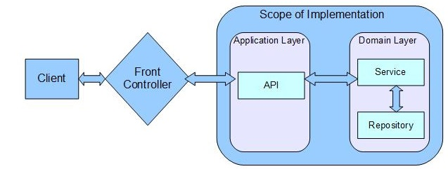

Figure 11: Application layer vs Domain layer? (Application layer vs domain layer? 2019)

This structure of modelling the application is a call back the domain driven model (Chapter 3.8.2) the reason for using a repository is that all the logic can be separated from the domain and then the domain will call the repository when needed. Encapsulating the logic in this way uses object orientation reference (Marinescu, 2007). Unlike how the service have been modelled in the previous builds. In the previous builds the controllers have contained all the logic with the service, making the data procedural and anaemic in nature. Using the domain driven model will add clarity and focus back to the application the repository will acts as a storage place for globally accessible objects (Marinescu, 2007). (Figure 11) shows the flow of data in a data driven model.

To avoid the mistakes encountered in the previous builds this iteration going to be simple following the agile development of each service to then test the functionality at the end of cycle. The first iteration is focused on the tickets collection service.

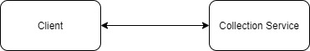

(Figure 12)

(Figure 12) shows how this iteration adds to the overall systems diagram, it is simple so far just the first service and the on way that it can be interacted with so far is directly through the client. This diagram will continue to add to until the system built to represent the systems diagram (Figure 10)

The same initial steps of the over build have been followed in the creation of the classes. Starting with the classes. (Figure 13) shows the structure of the tickets class, the other models used can be seen in (Appendix F) in the other models there is a list of tickets because each of status, category and priority can appear on multiple tickets.

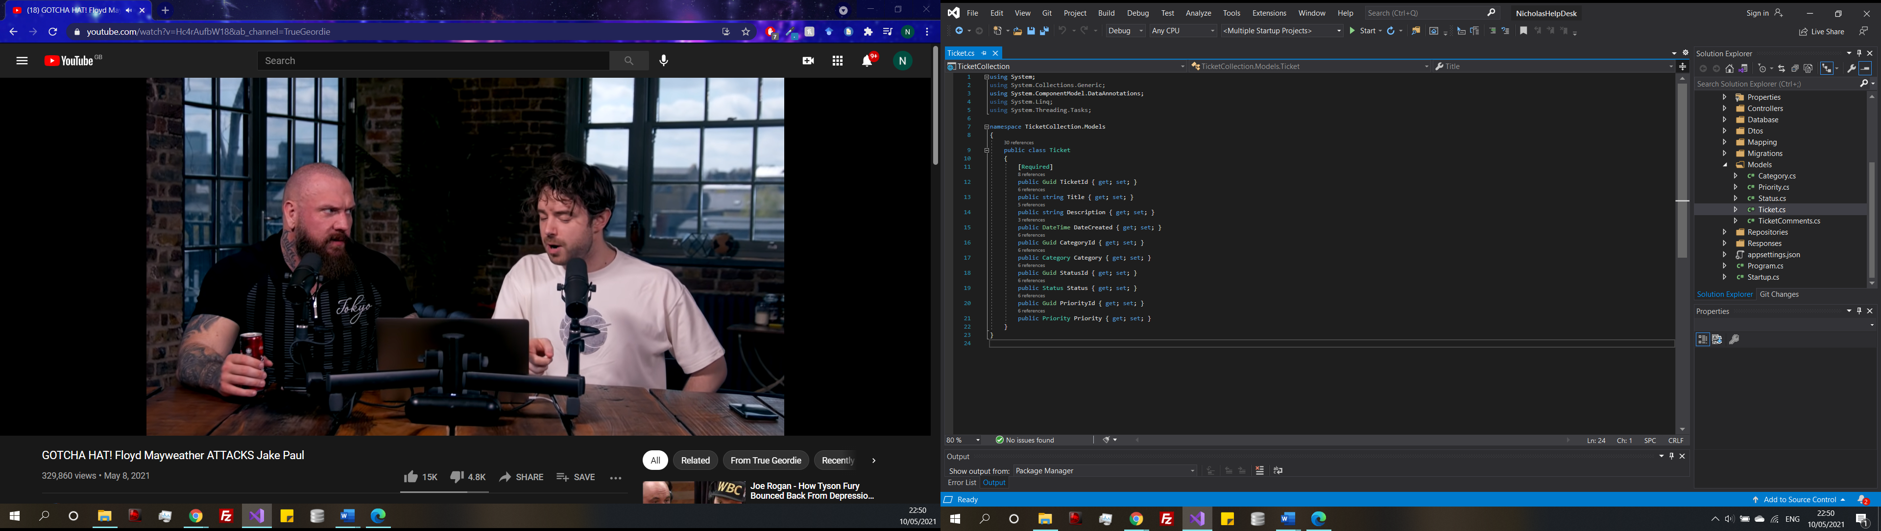

Figure 13

The database context for the ticket is the next thing that is created, the whole class can be seen in (Appendix G), in (Figure 14) shows the structure of the database. Database context is essentially representing the database and will be used to in fact generate the database using entity framework (Chapter 6.3.1) where the database is created to using the models that were just created and is an example of a code first approach. However, this is slightly different to the model builders that were presented in the previous builds, those methods were outdated and were older approaches for an older version of entity framework. The way to do this in the current entity framework is to configure the seed in (Figure 14) and specify the foreign keys and entity framework does the rest automatically. It should be noted that seeding data into the database is only used for testing purposes.

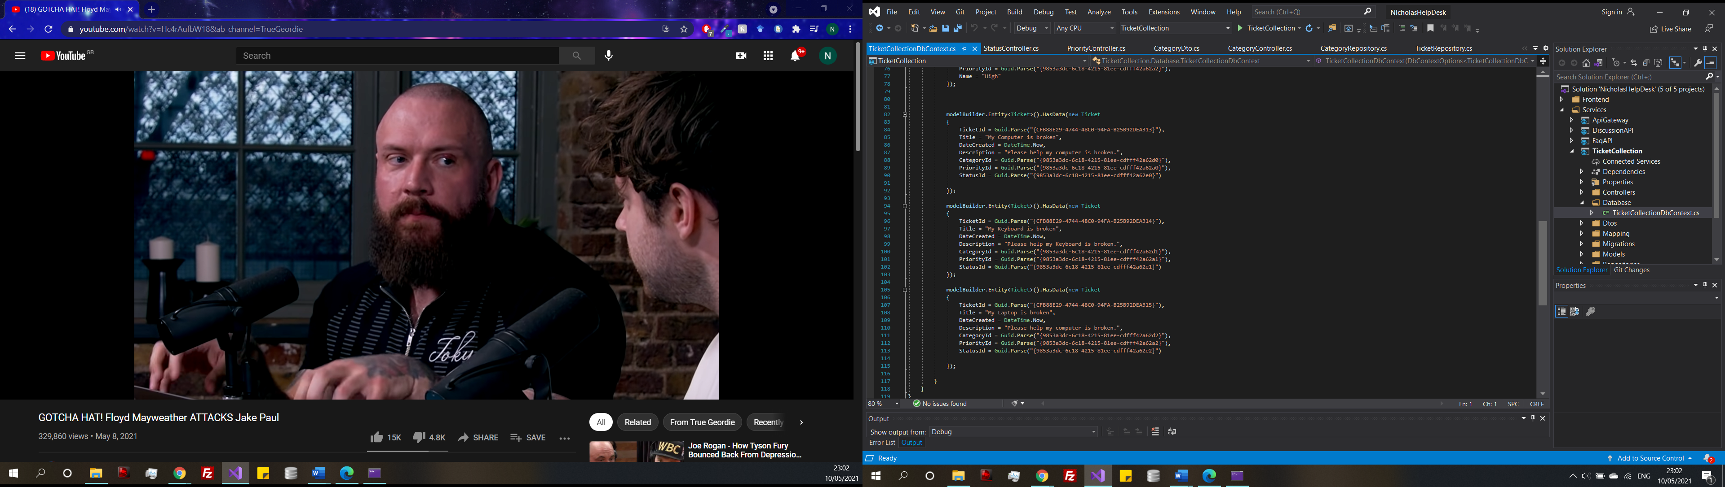

Figure 14

Add migration/ Update database

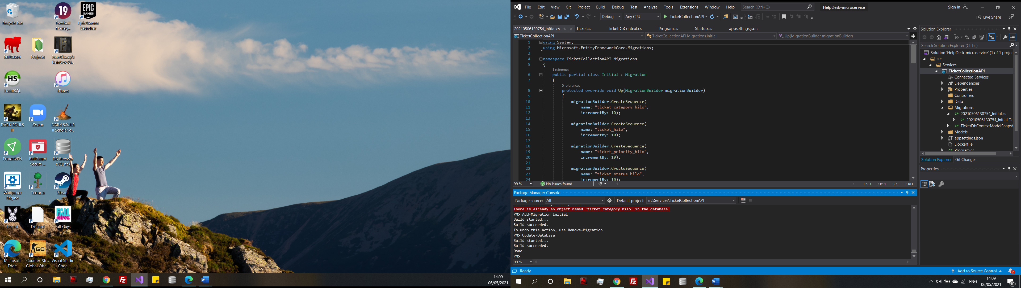

Figure 15

Using the tools imported by the entity framework tools package, an initial migration has been added in (Figure 15), a database schema has been generated based of the database context file, update database hen creates the database itself. Now looking at the database in SQL server under the local host the empty tables can be seen (Figure 16).

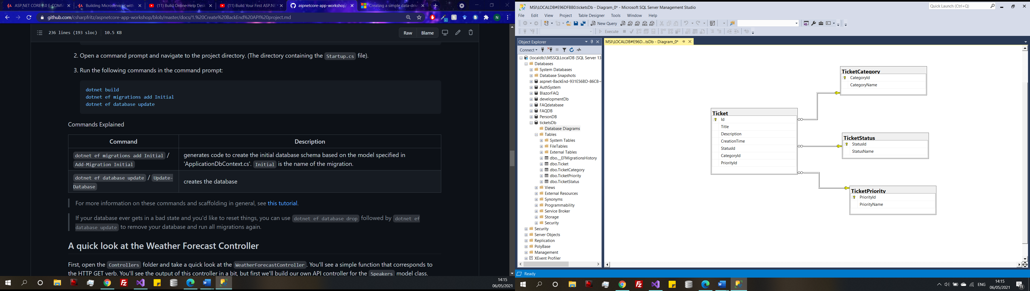

Figure 16

The added benefit of SQL server is that it can automatically create a database diagram based of the models (Figure 17) displays the diagram. So, without coding any SQL, or designing an initial database diagram everything has been made through the powerful Entity Framework tool. Resembling the initial database ERD diagrams (Appendix E)



Figure 17

However, SQL server is not the only way to approach databases in microservices. More recently, a NoSQL approach is becoming popular.

A NoSQL approach is easily scalable, faster, and flexible because there are less schemes and documents are in formats like XML and JSON (Nayak, 2013). A benefit is this flexibility allows for the database to be changed dynamically (Oliveira, 2016) and is often used in the agile approach for quick iterations (When to Use NoSQL Databases, 2021). On the other hand, there is no SQL and is not reliable because there is no support for ACID unlike a relation database that used through SQL Server (Nayak, 2013). For this project SQL server is the most appropriate but for microservices it is clear to see the benefits of NoSQL, as they are easily scalable and flexible works well with the microservice architecture.

One problem experience in a previous build was that the was the ticket was returned the Ids

were returned but the data related to that key in the other tables was not being returned, like in (Figure 17). The way around this was to create a mapping class, where the names are mapped on the Id. Shown in (Figure 18)

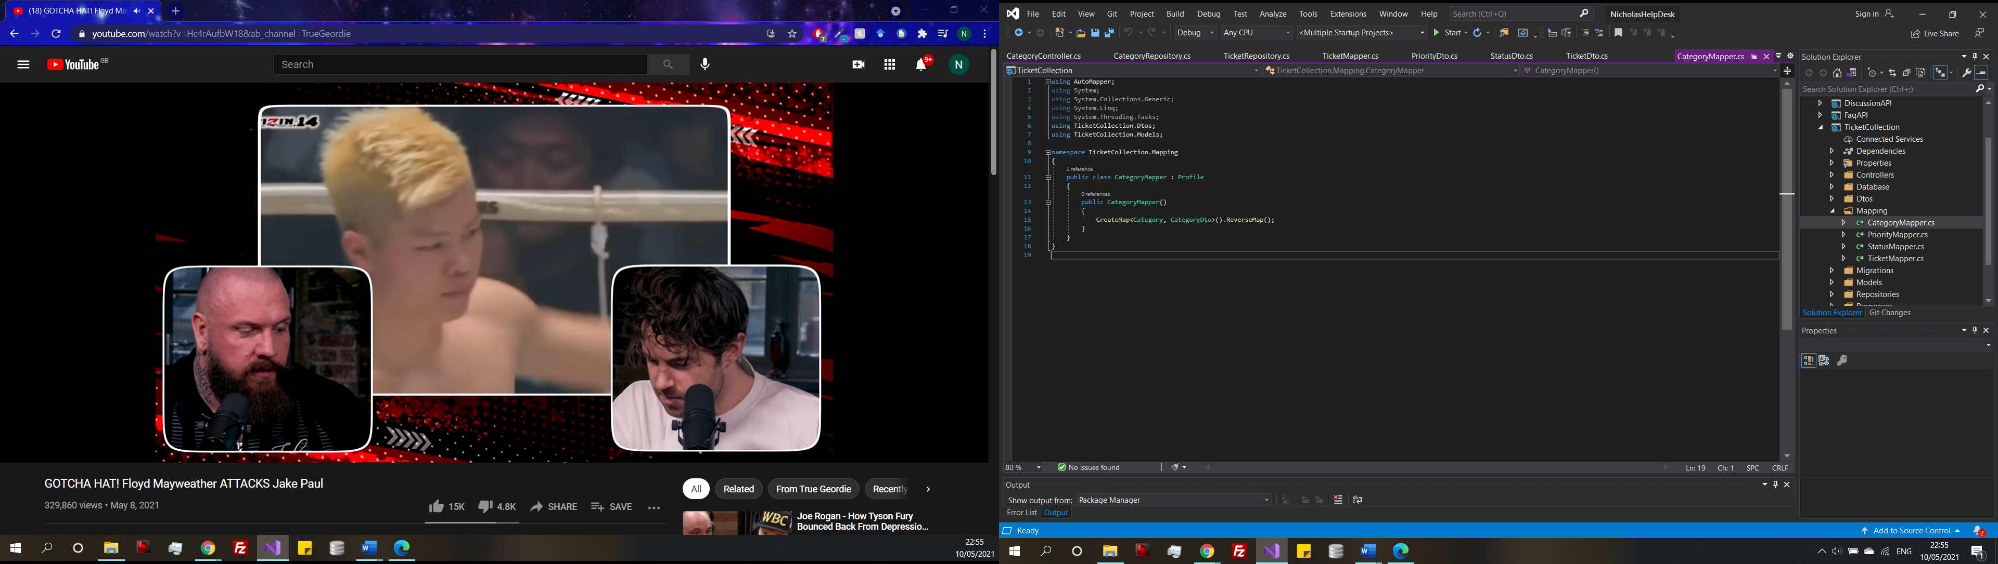

Figure 18

The models and the database have been created now it is time to bridge the gap between the data-access layer and the domain and create the repositories. (Figure 19) shows the interface category repository the repository contains the methods to be used by the repository. All the interface classes can be seen in (Appendix H).



Figure 19



Figure 20

The interface themselves implemented in (Figure 20) injects the repository methods from the interface classes. Then the database contest for the table is saved as a variable to be used through the class. The methods defined in the interface have been created here, once the methods are called the database is queried and the response is returned. All the interface repositories as stated are in (Appendix H) and the associated repositories can be seen in (Appendix I).



Figure 21

In the ticket repository it calls the ticket table in the database, and includes the mapping for the status, category, and priority where the status is equal to the inputted status to get the ticket by a particular status seen in (Figure 21).



Figure 22

Now that the other tables have been mapped the controllers for each are implemented to create the application layer. In the controller is where the REST APIs discussed (Chapter 3.10) are created. All the different CRUD (Create, Read, Update and Delete) methods are put here. (Figure 22) shows a get request, which returns all the tickets in the database. It calls the get all tickets method in the repository and the response is mapped. It is all in a try catch block to catch any error returning the data.

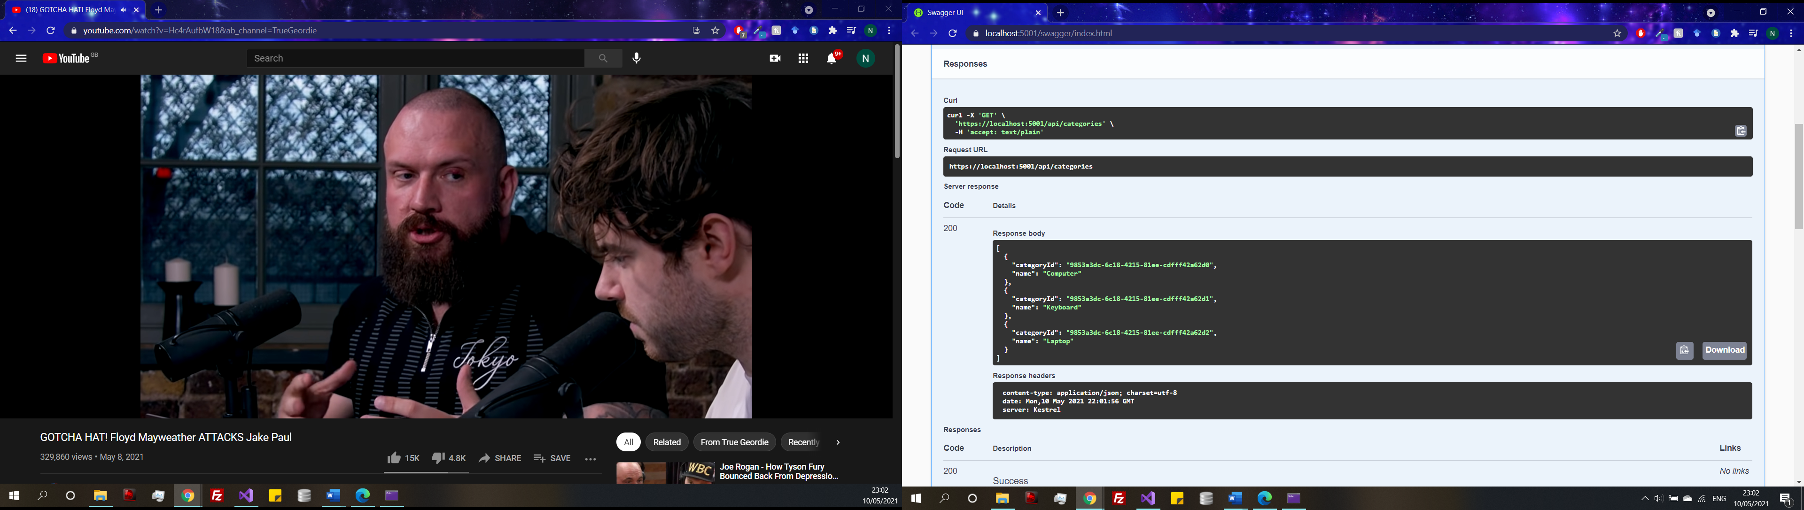

Figure 23

(Figure 23) shows what the response of the (Figure 20) method in the repository, which is a list of all the categories.

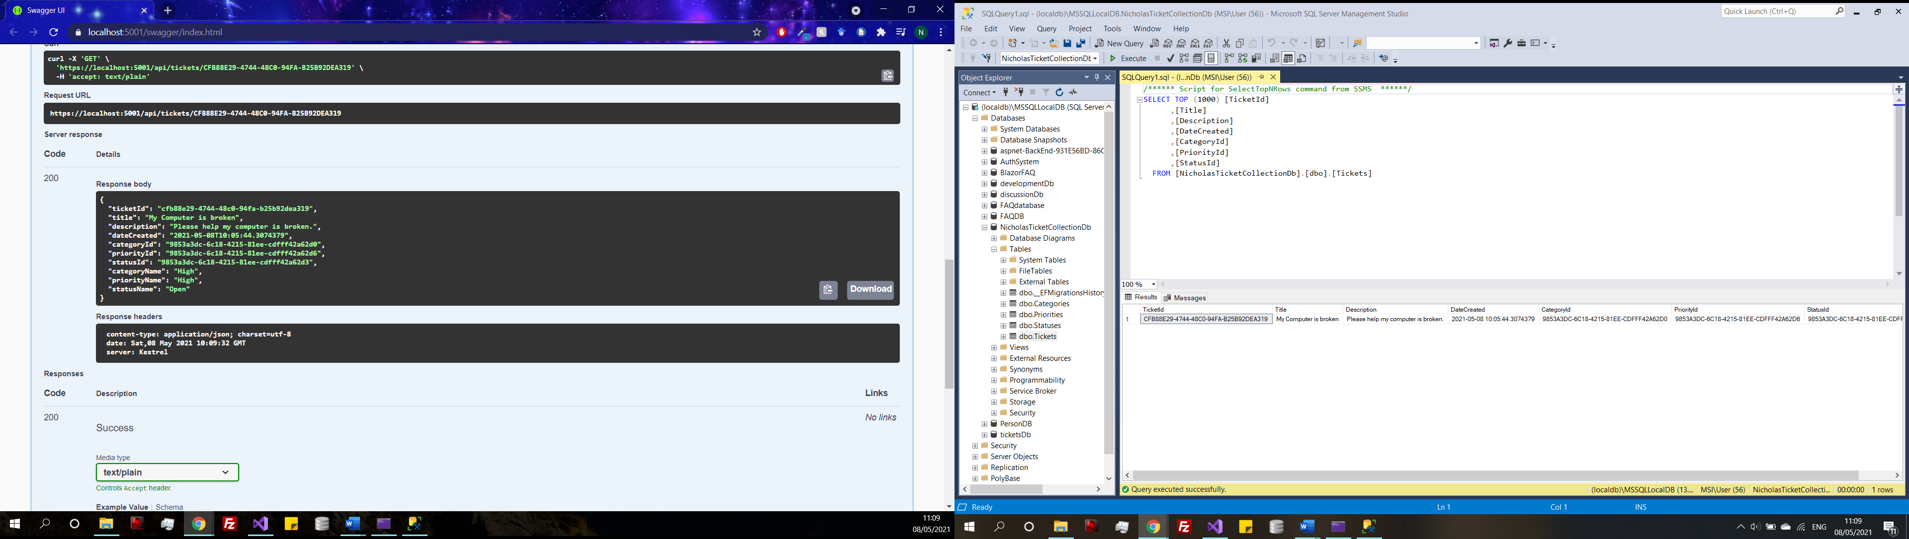

Figure 24

The response to get all al ticket is shown in (Figure 24), the response has all the data for tickets, and it shows that the mapping is a success. However, this did not work at first because the DTO for tickets was missing, therefore was unable to get all because nothing existed.

Add Remaining Controller features

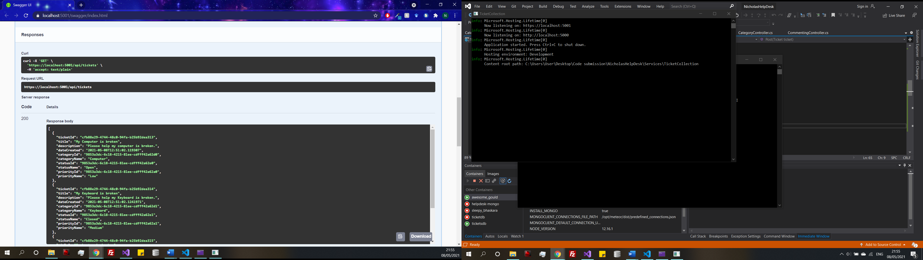

Figure 25

Remaining features are added to the controller. Such as create ticket, get all ticket, update ticket, and remove ticket which can be seen in (Appendix J). Figure 25 shows the result of get all tickets.

The functionality of the standalone ticket collection service has been completed and now testing will take place for this service and any changes will be discussed in (chapter 8.1)

**7.1.2) Discussion Service (Iteration two)**

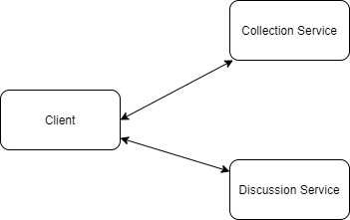

Figure 27

The goal for this iteration is to add the discussion service to the solution (Figure 27). As discussed in (Chapter 6.3.2). The discussion service not only needs to be able to post and save comments it needs to be able to communicate directly with the ticket collection service, do that the ticket service can call the discussion service when comments on a particular ticket need to be displayed and then send a comment when a comment I posted. This inter communication needs some thought because there are different methods to approach this.

**Asynchronous and synchronous communication**

Asynchronous communication was discussion in the requirements specification (Appendix B) as a non-functional, asynchronous communication, bringing performance, decoupling and fault-tolerance (Garriga, 2017). However synchronous communication is easier to understand and implement but this would have a negative effect on the system as it would hinder availability and future scalability (Garriga, 2017) because the system gets bottlenecked by requests transmitting across multiple services. Which in turn would make development more complex than it already is.



Figure 28

The final decision to use synchronous communication is strictly because of the time limitations. As already seen through this project, trying to implement something more complex than the current skillset can require lots of time and effort and the implementation of an asynchronous message bus would take too much time so, synchronous communication will be used. The disadvantages are clear that in the long term of a microservice development this would need to be refactored to make the system scalable, but for purpose of demonstration synchronous is what will take place in this iteration. This also caused a change to the systems diagram, as in (Figure 9) it shows the plan to implement a message bus but since the plan has changed the diagram had to be updated (Figure 10). The implementation of asynchronous communication will be discussed further in the future development (Chapter 11).

(Figure 28) show how a synchronous communication operates. First the service request something from the collection service, which results in a request to the discussion service and the request is sent back through the services until it reaches the client. Emphasizing why it is not the best approach because as more services are added the chain of request increase the system becomes bottlenecked this is not optimal. However, for a small-scale prototype like this the performance should not be greatly affected.

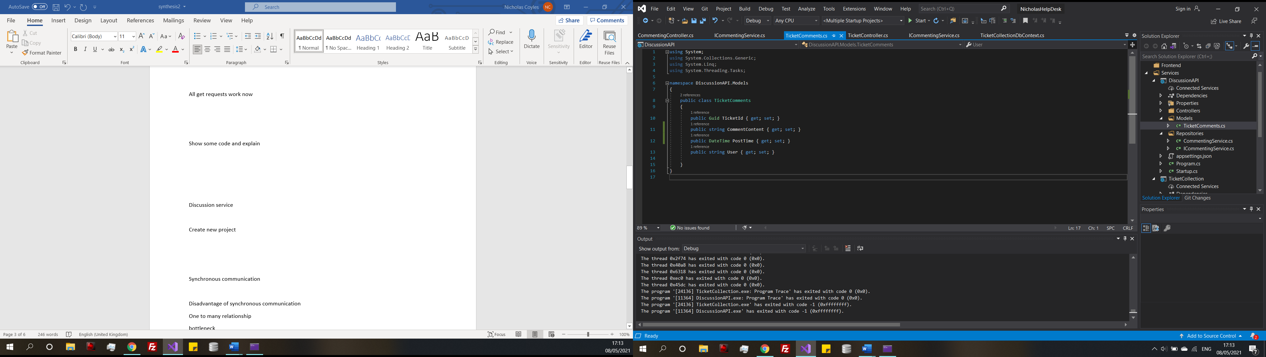

Figure 29

The same initial steps have been followed to create the project in the solution and set up the initial classes and repository for the ticket comment class (Figure 29)

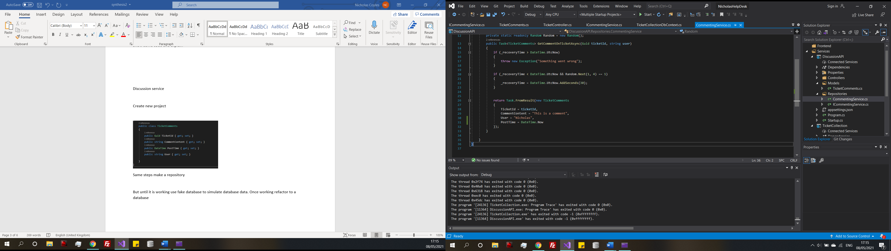

Figure 30

Firstly, before the database is added, some fake sample data has been hard coded (Figure 30) while the functionality is figured out. Once it functions correctly the database will be added in and this code will be removed.

**Controller**

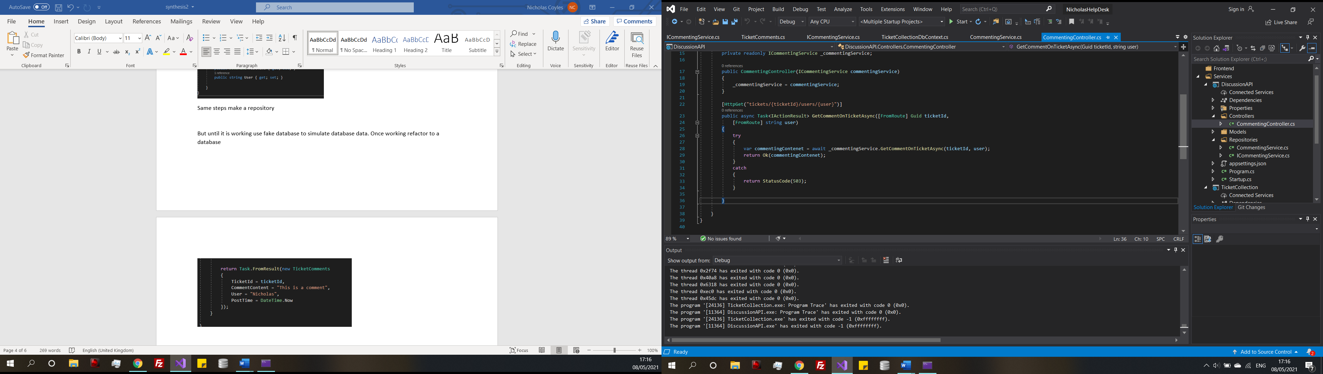

Figure 31

(Figure 31) shows get request function in the controller to get a comment on a ticket based off a ticket Id and a username. The whole API controller can be seen in (Appendix J) which also included a post comment function.

Back to the tickets collection service

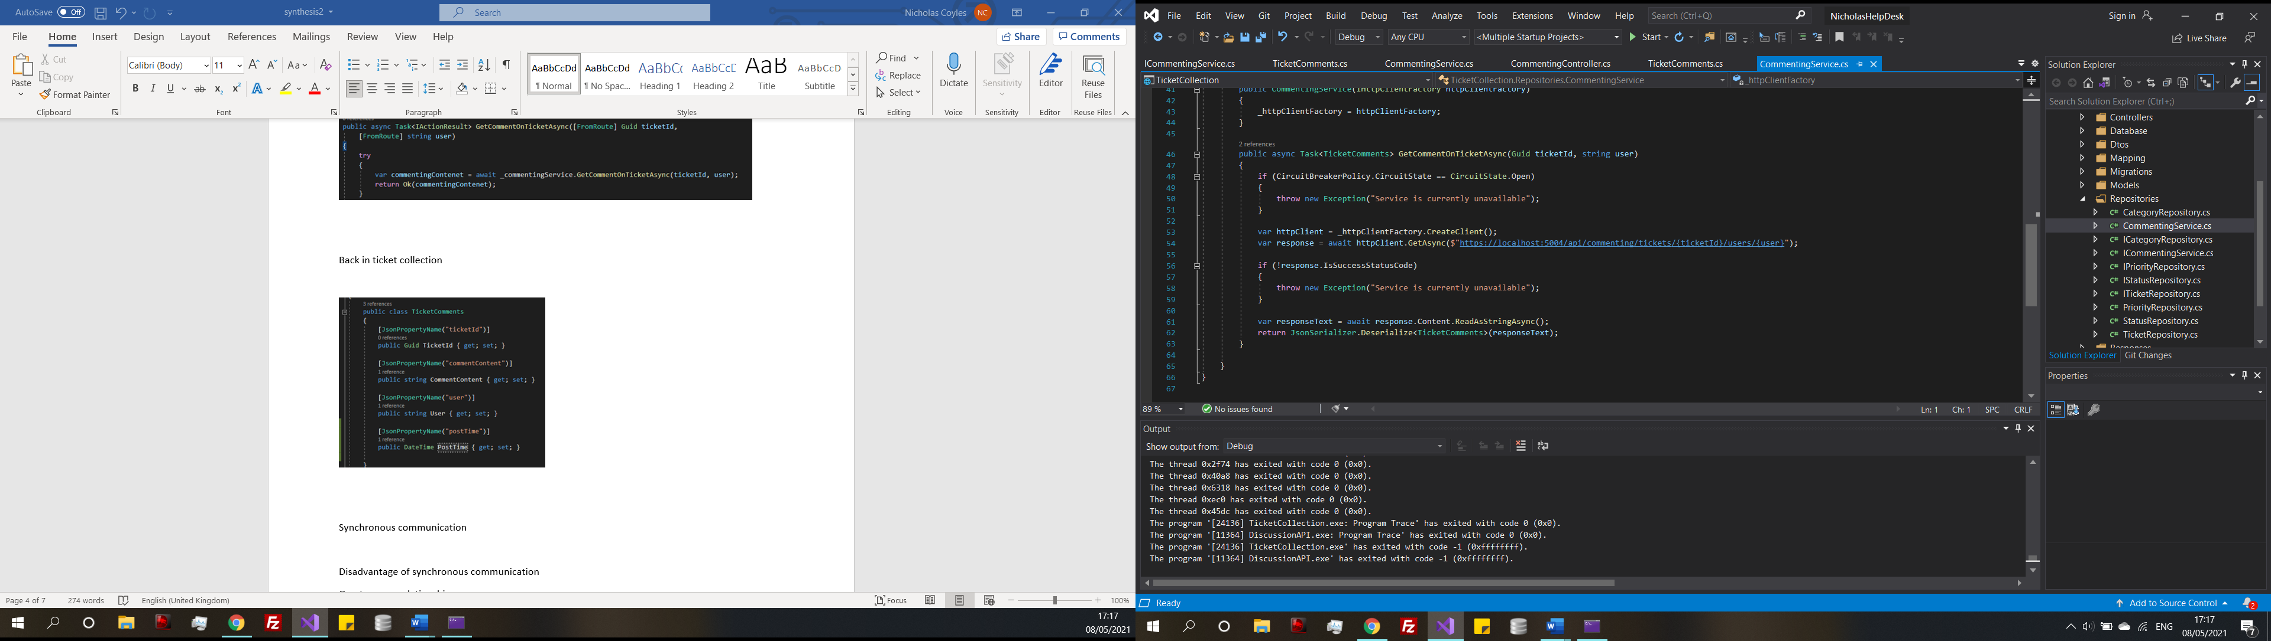

Figure 32

(Figure 32) shows a new class that has been created in the tickets service. Essentially when the tickets controller wants to request the comments associated with that ticket, this code will send a request to the discussion service and save the contents of the response. To do this the response needs to be serialized because it is currently in a JSON format but to be used by the program in needs to be a string object.

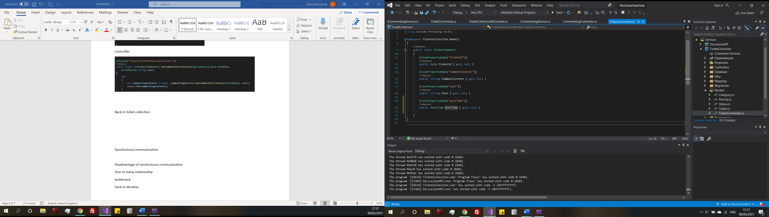

Figure 33

On the final line of (Figure 33) the response is in the format of Ticket Comments, tickets comments are a model class that will format the result and store the response into the relevant variable. Now the code knows how to structure the received data it can be used in the controller.

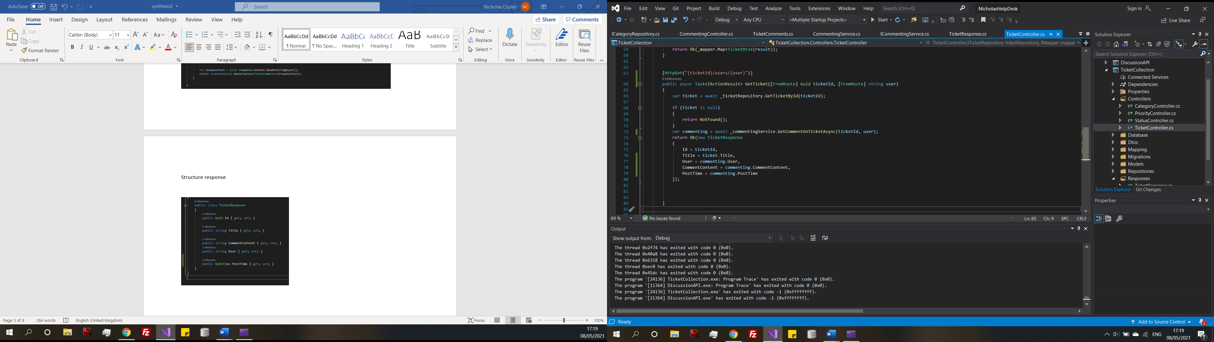

Figure 34

(Figure 34) shows the addition to the ticket controller, when this GET endpoint is requested with the ticket and user Id, the ticket will be selected and the comments related to that user will be returned and using the response class, format the result and return. Also is (Appendix J)

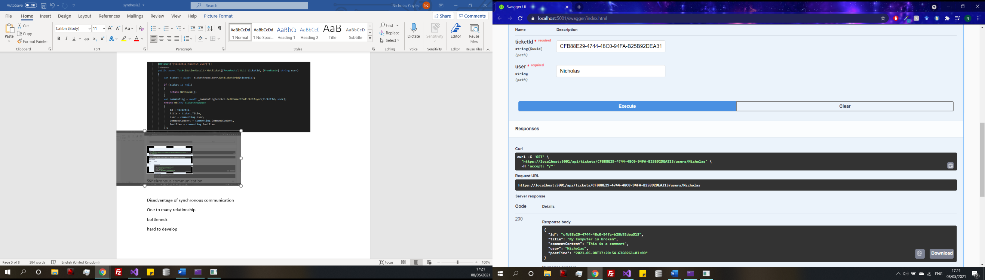

(Figure 35) demonstrated this where a ticket Id and user, the mock data stored in the discussion service has successful be received and manipulated to form the new response.

Figure 35

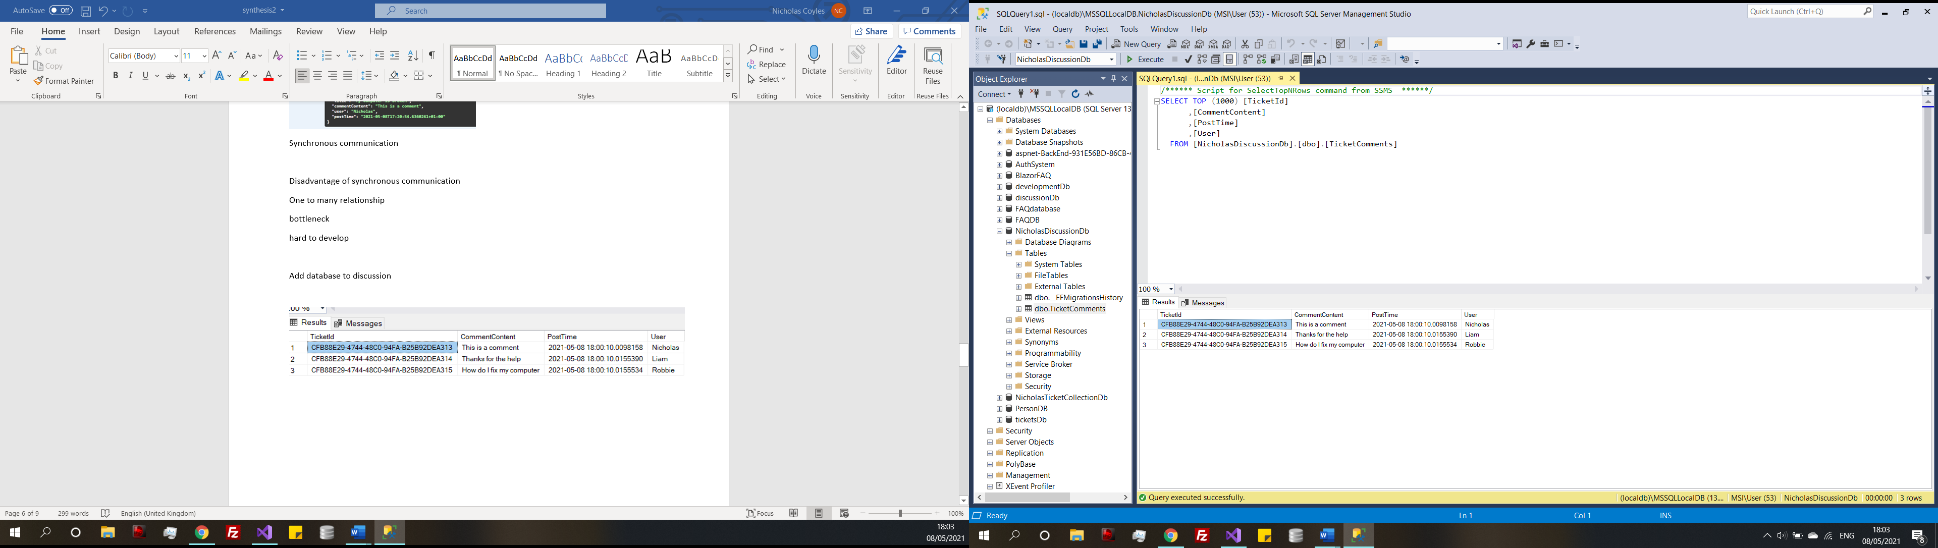

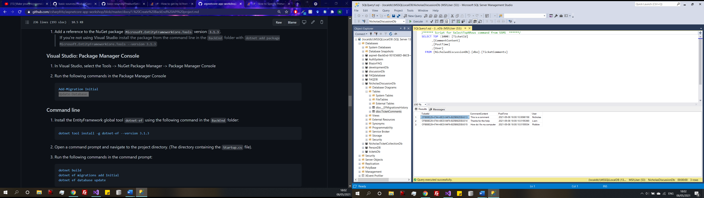

The same methods of creating the database and seeding data has been used here.

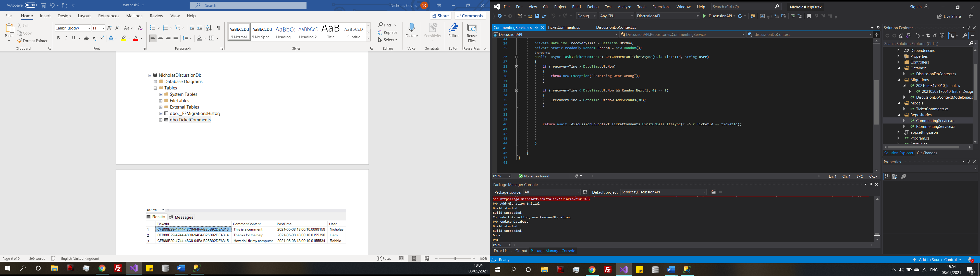

Figure 36

(Figure 36) is the added line of code in the discussion controller to return the contents of a ticket with the selected ticket Id.

Changes

After some consideration, some changes need to be changed with the discussions. Rather than having the ticket as the primary key, this would not allow for multiple comments because the ticket is a unique identifier. Instead of having ticket id giving, the comments their own id and having ticket id as another member of the database. As well as this just requesting the tickets by id because if the request also requires the username, then comments by multiple users cannot be requested.



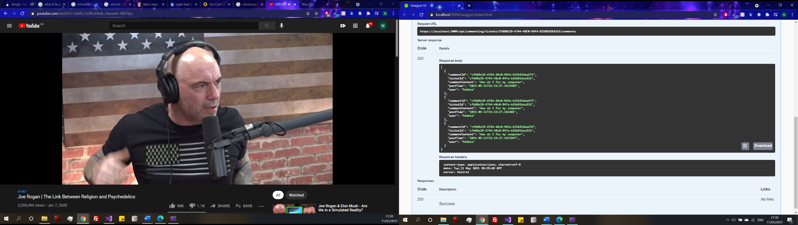

Figure 37

Now with the updated controller multiple comments on the same ticket can be returned. Rather than comments exclusive to one sure. The new response (Figure 37).

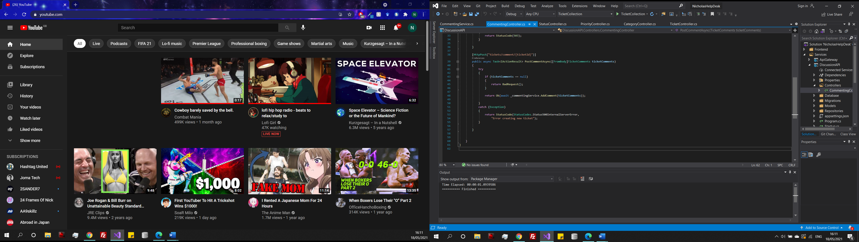

Figure 38

Tickets are returned but there is currently no functionality to add a new comment to ticket, (Figure 38) is the new addition to the discussions controller where a ticket is received by it is Id and a comment can be posted which is then associated with the ticket Id.

**7.1.3) FAQ Service (Iteration three)**

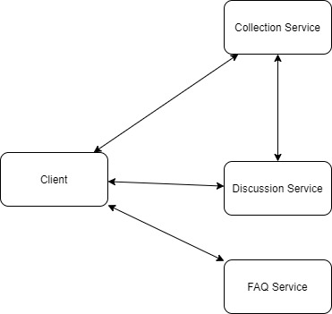

Figure 39

There is not much to discuss with the FAQ service, it is very simple and all the steps that have been used to create this service have already been commented on in the development section. A model has been created, database created and a controller with the default entity framework operations. A visual representation of the current system can be seen in Figure 39

**7.1.4) API Gateway (Iteration four)**

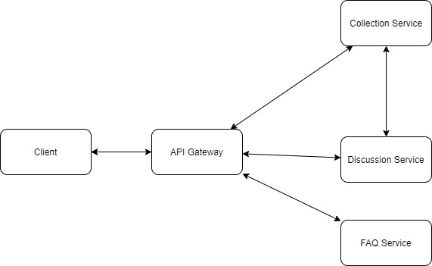

Figure 40

Figure 10 shows an API Gateway connecting the front end of the application to the back end microservices. The API gateway provides a bridge between the services taking requests from the client and forwarding them to the relevant service. Provide roughly the same functionalities in their implementation (e.g., security, authentication, monitoring, and load balancing) (Montesi, 2016). The gateway acts as the middleman in the application and can manage authentication, when the authentication service is created it will communicate with the gateway.

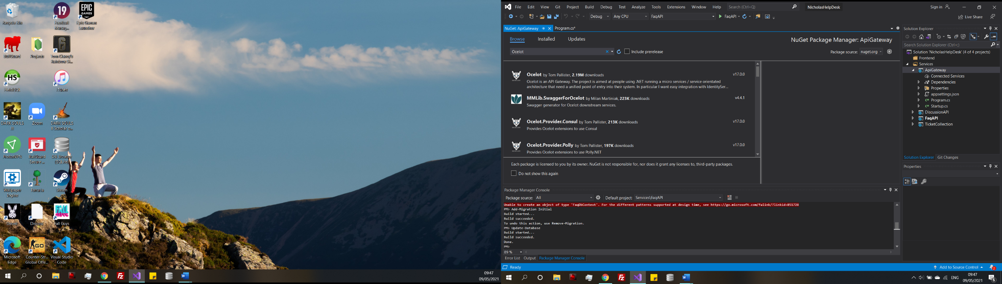

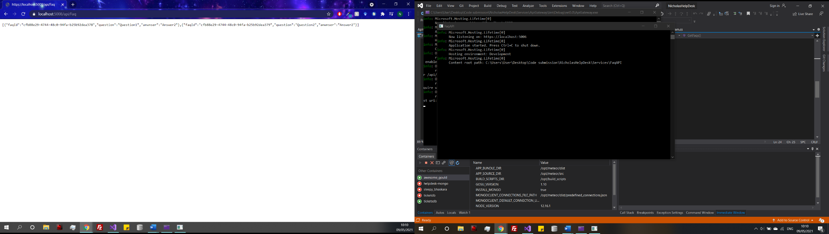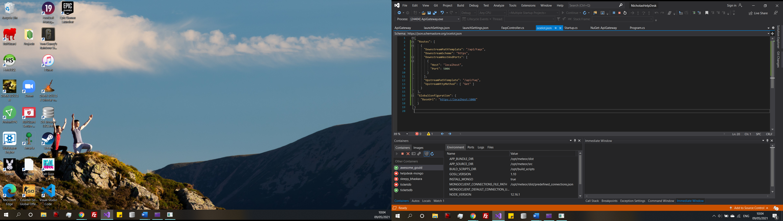

Figure 41

(Figure 41) shows the configuration for the API gateway. It collects the data from the endpoint in the downstream path from the referenced port and path. Which must be running at the same time. This is then re-routed from the base URL that the gateway is running on, plus the on the upstream path. In regular circumstances the gateway would not be running in the browser, but it helps with to demonstrate what is taking place. Navigating to the base URL with the /api/Faq bath, you can see in (Figure) the data is returned in the same json format as before but now it is coming from the api gateway. If there were more time for development this api gateway could be authorised using a jwt token which would then make the system secure because data being passed from the gateway would not be accessible with being authorised.

This method is the same for all the other endpoints as well, they just need to be configured within the Routes and then they are free to use via the endpoint. The full configuration can be seen in (Appendix k)

Disadvantages of implementing an API gateway should also be considered because it can cause performance degradation due to lots of happenings on the API Gateway as well it can become a single point of failure as it is the only point of entry for the requests, so it can potential be harmful and complex (Sharma, 2017).

**Circuit breakers**

Now there is a connection between the services some resilience needs to be added to meet the resilience non function requirement (Appendix). A circuit breaker checks the service status and considers low performance or unsuccessful requests to set the status as health or broken (Bigheti, 2019). Circuit breakers add stability and resilience to services they work by wrapping calls towards a service and monitoring their failure rates. If the service becomes slow or replies become slow or faults the circuit breaker will try and re initiate a connection if a fault is detected (Montesi, 2016).

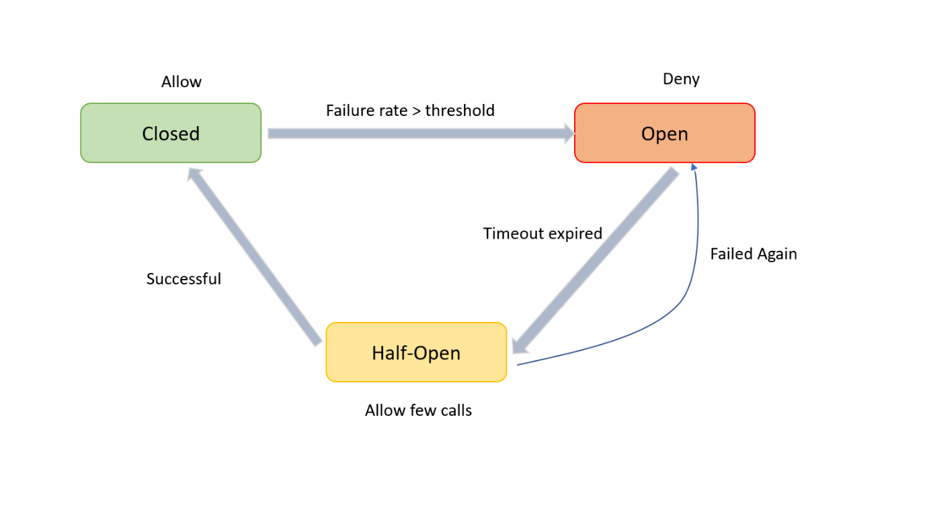

Figure 41: Importance of circuit breaker in microservices (Importance of Circuit Breaker in Microservices, 2020)

(Figure 41) demonstrates circuit breakers in action if the circuit breaker is triggered it will return an error instead of sending the call to the service. Then after a certain amount of time the circuit breaker tries to the connect to the service again. The circuit breaker pattern also works perfectly works together with the Load Balancer (Butzin, 2016) But as mentioned in (Chapter) load balancing is out of scope but are important for real world microservices. Fallback services could also be introduced at this point if there is a broken connection.

To then add circuit breakers to the project using a well testes third party library like Polly, which would be easier to implement than creating a circuit breaker from the ground up (da Costa Pinto, 2019).

**Polly**

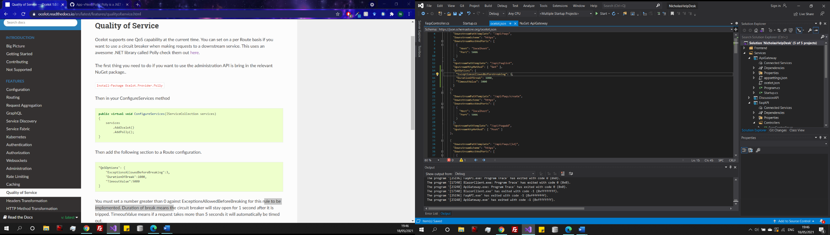

Figure 42

(Figure 42) is a very basic example of a circuit break that is being applied to all the API Gateway routes. Through ocelots Quality of service feature. If there is an exception, the circuit break will wait 1 second then time before timing out. An example of a time out policy. Other policies could be included such as a retry, cache or a bulkhead policy. But for purpose of example only a timeout, circuit breaker will be used.

**7.1.5) Blazor Front-end (Iteration five)**



Figure 43

**Micro Front end**

The theory of the micro front end is that you have the backend microservice connect to the micro front end web app, interacting with API calls rather than directly connected like a monolith which is what is trying to be avoided throughout the process. The major benefit of the structure is if a backend service is down, it should not affect the front end. Bring back the idea of loose coupling by Newman and Fowler where the dependencies between services are removed.

Blazor pages:

Blazor is based on HTML and C# and is currently used for both client-side and server-side implementation. It lets the programmer use a mix C# into HTML to provide logic and data manipulation (Sandberg, 2021). What makes it unique from these other languages it is based on the use of components rather than views and pages. The entire application is made up of a series Razor Components. For example, a component could be the nav bar, body or football which all join to make the application complete (Sandberg, 2021).

Blazor is a new technology that can be used to front a microservice and gather user inputs. Having it is benefits over traditional methods of web page creation, being that loading is all done on the client side leading to faster loads times from less interaction directly with the server and is quite similar Angular. As well as being able to make a web page full of multiple components means that data can be pulled and displayed from multiple microservices and displayed together on a web page (Sandberg, 2021). However, if the connection drops between the browser and the server some functionality will be lost (Himschoot, 2019). Displaying the necessary error message to the screen may be the appropriate thing to do in this case, but another idea is to have back up services to take the place of a service if there is a system failure.

Blazor is appropriate to be used in this project because it to is an emerging technology at is offers a

Benefits over traditional methods of front-end development as its main draw is the ability of displaying multiple microservices within a single project, which would be useful. It also provides a chance to evaluate another emerging technology.

**Authentication**

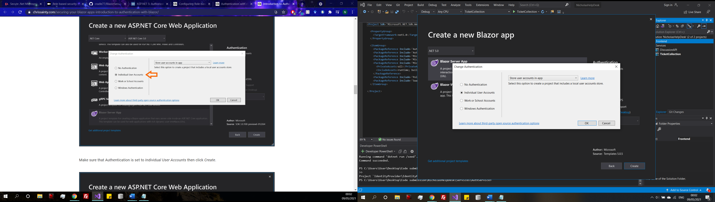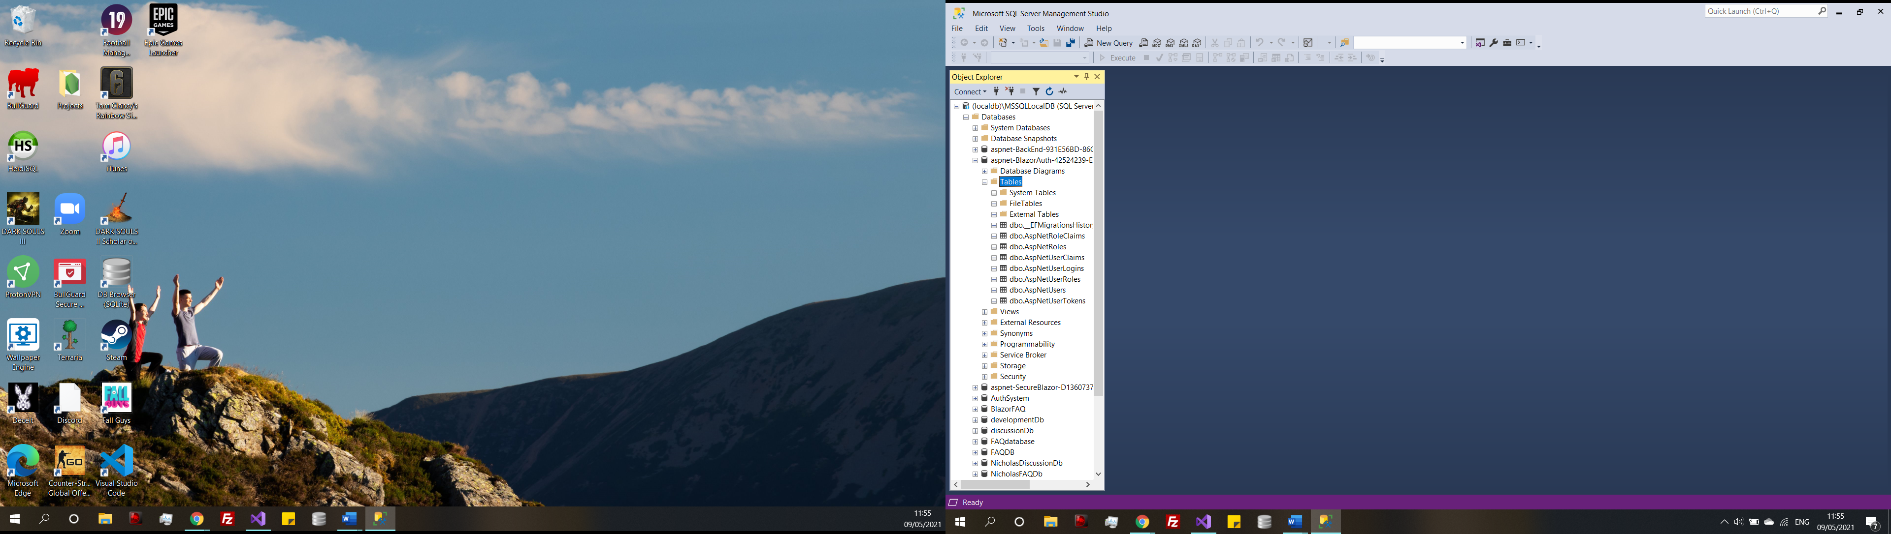

Figure 44

Rather than creating an authentication service from the ground up, .NET provides a Blazor server-side feature that can create user accounts automatically and generates a database with tables. Using this method will save time at this late stage of development (Figure 44) displays the Blazor options and the database tables that were created. This handles other features as well password reset, two face authentication and email change if necessary.

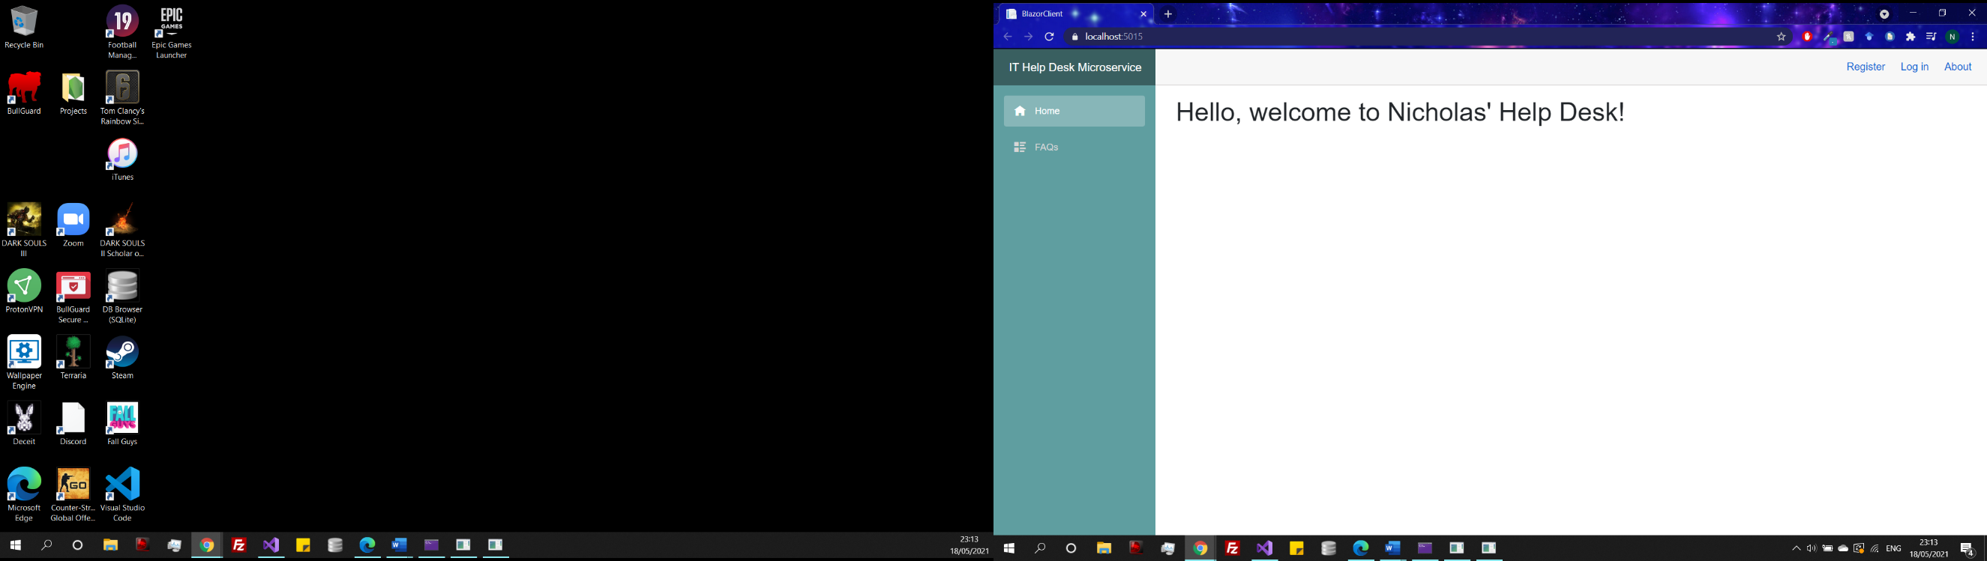Authentication has been used to restrict access to certain pages. If a user is not logged in, they will only be able to access the FAQ page. A logged in user will be able to create a ticket, and an admin will have access to all pages including management pages which. This was accomplished through a blazor feature called authorized user and checking if the users name was equal to the admins.

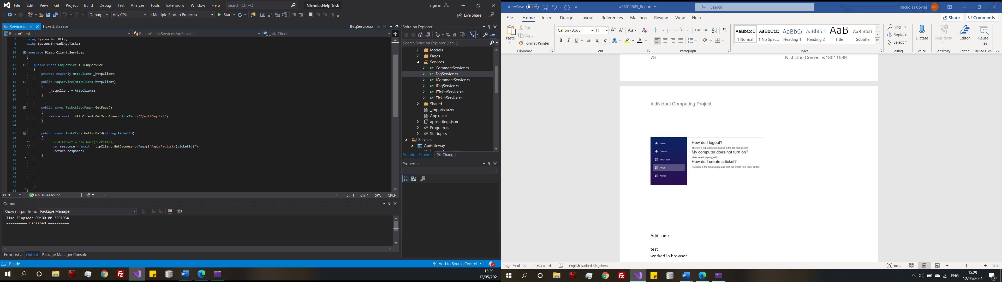

Figure 45

To display the request data onto the screen in (Figure 45) the method is practically the same as what was being used to access the database in the previous service iterations. However, this case in the request is over HTTP, requesting data through the API gateway configuration that was set up in (Chapter 7.1.4) and the response is sent back to the blazor page where it can be manipulated using HTML and CSS.

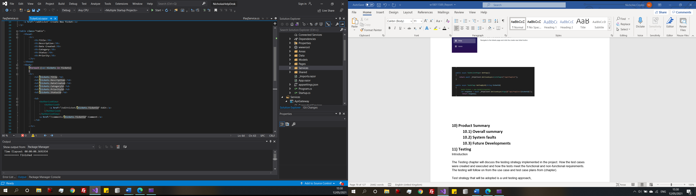

Figure 46

(Figure 46) displays a for loop fetching the data from tickets and displaying in a HTML format and functions very similarly to PHP.

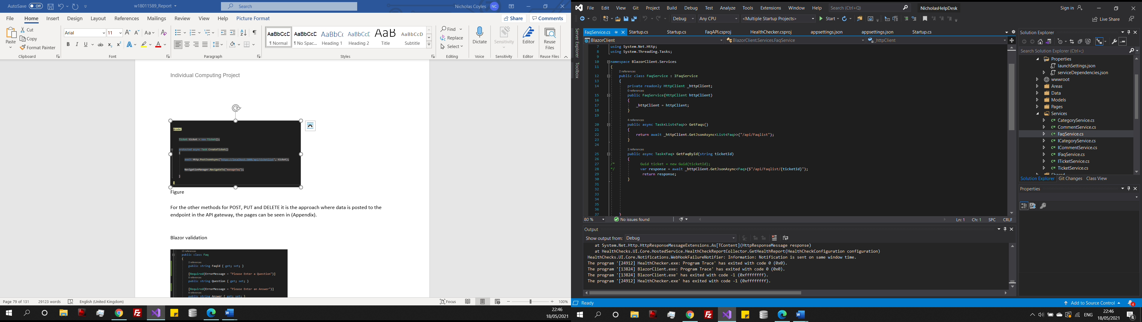

Figure 47

Figure 47 is an extract from the FAQ repository using the domain driven design, but the response is fetching the JSON from the API Gateway.

**Blazor validation**

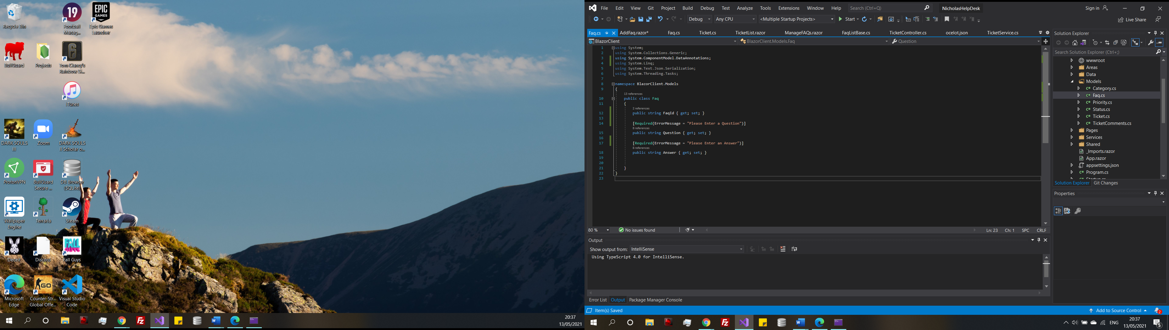

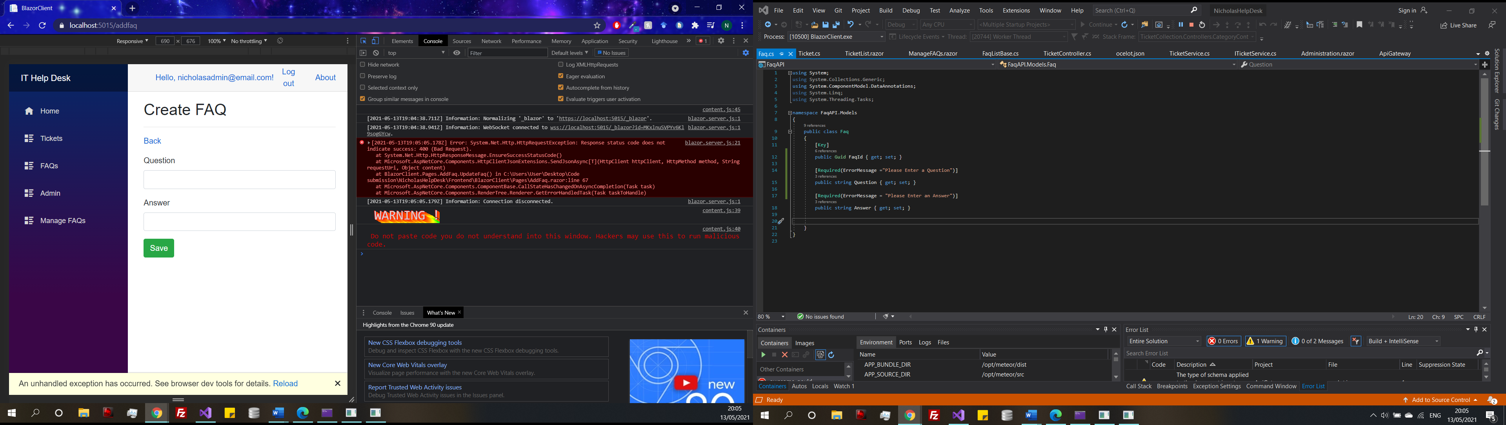

Figure 48

As the system is now dealing with user inputs directly through the user interface, it is important to add some validation to the data, so potential harmful data cannot be inputted into the database. (Figure 48) shows a required statement added to the fields in the FAQ class model within the Blazor solution. The resulting output if the field is left empty on the create FAQ form is a bad. It would be useful to add a visible error to the screen, so the user is notified that there is an error.

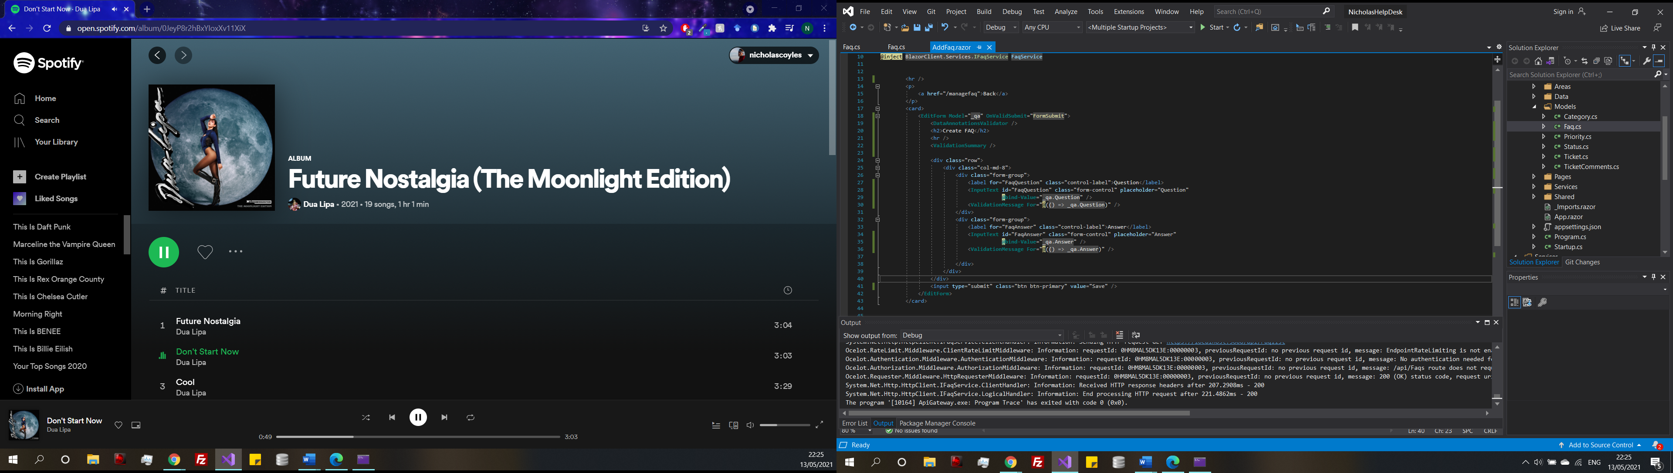

Figure 49

(Figure 49) Shows the form for creating a FAQ, Data annotation validator allows the form to make use of the and validation summary allows the display of the error messages on the screen. Making sure to link the message to the correct component. Finally, the form will only call the function to add the FAQ to the database when the form is valid. The reason that the data it being validated by here in the Blazor file because when the form submit it is known that the inputs are valid so there is no need for further validation on the API end.

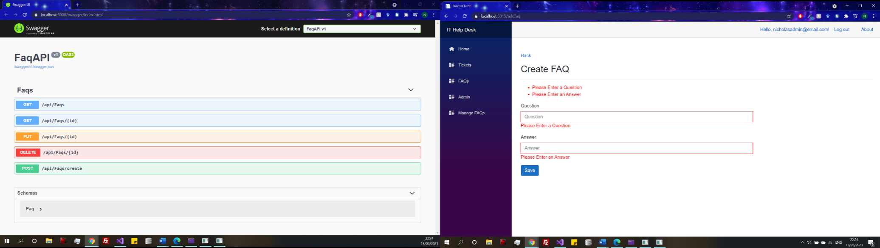 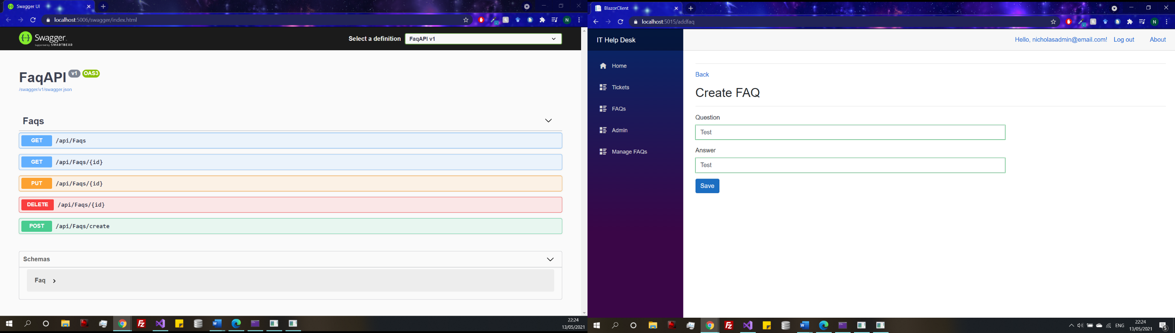

Figure 50

(Figure 50) shows the form in practice the first image is if there is an error, the messages are displayed on screen and the second image shows a valid input with a green success border around the input fields. This type of validation will be added to all the other remaining forms.

**Individual tickets**

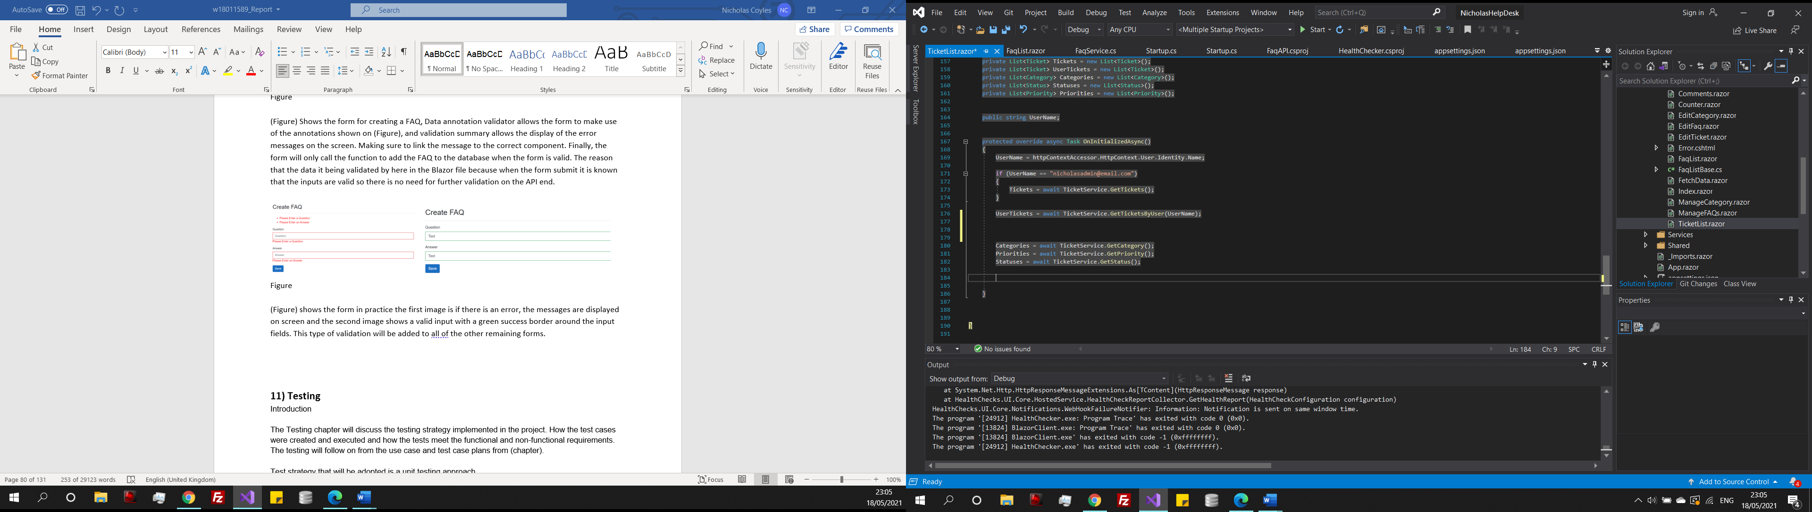

Figure 50

When a user navigated to the tickets page all the tickets that they have previously created if any need to be displayed. However, this needs to be specific to the user so other users do not have access. To achieve this, the accounts username has been retrieved and passed into the get ticket by username and then displayed on the screen. When a user created a ticket, their Id will also be attached. There is only one account with admin privileges where all the open tickets will be displayed if the admins username is present. Once a tickets status has been changed to closed it will now appear on the admin page in a closed ticket archive. If this system were developed further this would need to be updated as there would be more than one admin on the system so it would have to be checked by the role Id associated with the account rather than username.

**Ticket Discussions**

Fetching and posting data to the ticket discussions endpoints does not need to be discussed at length again, but with the ticket discussions page it was an idea to make it look like a chat forum. When comment is clicked all the comments with that that ticket Id are fetched and ordered by time posted.

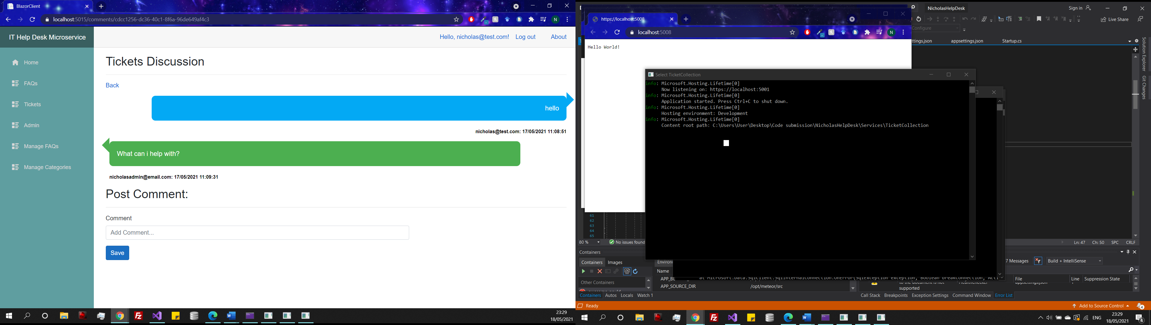

Figure 51

(Figure 51) demonstrates the discussion service. There has been styling applied to the comments, the user has posted a comment it is displayed in a blue box and admin in green. The username of the account that posted the comment can be seen underneath the post along with the date and specific time. A way that would make this better if it were updated in real time.

1. **Testing**

**Introduction**

The purpose of the testing plan is to test the product against the functional requirements developed in (Chapter 5.1) as well as the robustness of the system. Testing strategy technique that will be adopted is a unit testing approach, to be used in conjunction with the agile framework the is used during development (chapter 5.4). Where at the end of each agile iteration cycle, after a section of functionality has been added tests will be written and then conducted. These unit tests will be tests to test the behaviour of the system in reaction to inputs. All these tests are written by the author rather than using automated unit testing, which is an unfamiliar technique, so it was decided to not be used. However, in a real world microservice automated tests are more commonly used due to the complex that testing can become (Chapter 3.6).

When tests are conducted the next iteration will only begin when all the written tests are a success to minimise any potential errors. It is important to note that unit testing is not the optimal solution for testing, because tests are written by the developer it could be possible that test cases are missed so it is important that testing is given enough thought so that the result are a valuable contribution the two development. (Figure 52) shows an example of the test plan that is going to be used. The full test plan can be seen in (Appendix L).

|  |  |  |  |  |  |  |
| --- | --- | --- | --- | --- | --- | --- |
| Test reference | Function | Description | Expected Outcome | Actual Outcome | Success/Fail | Solution |
|  |  |  |  |  |  |  |

Figure 52

**8.1) Testing Results**

The testing was completed by trying each combination out outcomes, testing the functionality of each service at the end of the iterations. Most of the failed tests came from the first iteration as this was the first phase there was still some understanding to be gained with the technology, so it was understandable that there were failed tests here. The error were mainly logic errors I the code that were relatively straight corrections. Before the testing was continued on the first iteration the error was phased out during the development. Once corrected the tests were completed and the second iteration began, less error was encountered as most of the logic for the system was in the ticket collection service it allowed to gain some familiarity with the techniques which are now avoidable in the following iterations, so the same mistakes were not made.

With the API gateway testing there were limited errors, as the functionality of the endpoints had already been completed in the previous iterations all that was required was to configure the endpoints. The only error being a duplicate endpoint. Although already tested in their own iterations it was necessary to test each of the API endpoints again through the API gateway to ensure that there was no error created while configuring.

However, there was one change that was need in the API Gateway the addition of the timeout pattern was causing services to immediately timeout. After consulting Ocelot documentation, it was discovered that the ocelot has a timeout pattern by default which may have been affected by trying to manually implement an addition timeout. Therefore, it was decided to remove this feature.

With the Blazor page there was an element of trial and error as the functionality was already tests and validated the only real challenge was making sure that the correct data in the required formats were being passed into the endpoints. For example, there were error with the current time not being passed into a ticket on creation and using the incorrect type on an FAQ which had to be changed.

Another improvement that was discovered, was user access to admin pages. Restricted access had been applied to the main admin pages but not to the subpages such as edit FAQ and create Category. Which required an immediate update as it would be a major security flaw If users could access admin pages.

Once the final iteration was completed the systems main functionalities were then retested ensuring that everything functioned correctly and that there were no outstanding faults with the system.

**Evaluation Chapter:**

**9) Evaluation of the Product**

**Introduction**

The goal of the project was to design and develop an IT Help Desk system using the microservice architecture as discussed in the TOR Appendix A. The following evaluation will evaluate the product against the initial objectives from the TOP as well as referring to the requirements that were outlined in the requirements specification (Appendix B) determining whether the product that was created meets the functional and non-functional requirements as well as the robustness and fitness of purpose of the system.

**9.1) Strengths and weaknesses**

|  |  |  |  |
| --- | --- | --- | --- |
| Requirement number | Requirement | Description | Priority |
| 1 | Categorizing and Tagging tickets | Tickets should be assigned to a category, related to the task. Tickets should also have information such as creation time | High |
| 6 | Dashboard | Visual UI that users can interact with | HIGH |
| 11 | Ticket Status | The active status of a ticket needs to be tracked and updated once completed (Closed, open or on going) | HIGH |
| 13 | Ticket escalation | If the task for a certain ticket is too difficult for the assigned agent, the ticket can be escalated to a higher leveled agent | HGIH |
| 15 | Audit logs | The ability to track what ticket a specific agent was assigned to | HIGH |
| 16 | Use of REST API | The use of an API for web communication | HIGH |
| 17 | FAQ page | A visual FAQ page, with common questions and the answers. | HIGH |
| 18 | Login page | A Page where users can log in to an account | HIGH |
| 19 | Register Page | A page where a new user can register an account | HIGH |
| 20 | Ability to store data in a database | General database connection | HIGH |
| 21 | Log out of account | Users can log out of their account and return to the login page | HIGH |
| 22 | Create a ticket | A user can create a new ticket with the ability to select a category, priority as well as giving the ticket a title and adding a description | HIGH |
| 23 | Categories tickets | Tickets can be sorted by category | HIGH |
| 24 | Discussion on ticket | Comments can be left on a ticket by an agent where users can respond, like a chat log | HIGH |

Non-Functional requirements

|  |  |  |  |
| --- | --- | --- | --- |
| Requirement number | Requirement | Description | Priority |
| 25 | Scalable | Code must have the ability to be scalable without becoming a monolith | HIGH |
| 27 | Available | Services are loosely coupled. If one service goes down it does not directly affect the other services. | HIGH |

Figure 54

The strengths and weaknesses of the product will be assessed by completion or incompletion of the HIGH priority requirements from the requirements specification (Appendix B), Figure 54 displays both the functional and non-functional requirements.

**Strengths**

The functional requirements were partially focused on across the hold development (Figure 54) where the key functions were documented. After each iteration of a service testing took place (Chapter 8), where the error was filtered out and corrected leading to the issues with the functional requirements being removed. Most of the requirements were achieved through this process and is documented through the synthesis chapter and the relevant code in the appendices.

Even though HCI aspects were not listed as a High priority, they were considered in development do this is a success, the colour scheme from the Wireframes (Appendix D) and there were appropriate error messages returned to the front end in (Figure 50) as well as HTTP errors from API requests which can be seen across the test plans (Appendix L). Which is also an aspect of error handling. Error handling was a strength, all the endpoints have some form of error handling and validation to ensure only the correct valid data can be inserted into the database. Ensuring data integrity within the database.

Other non-function was addressed also, the code is scalable as it was developed using the Domain Driven approach (Chapter 3.8.2). The code was not built in a monolith fashion and functionality was moved from the controllers to repositories. Although slightly anaemic it is scalable using this method of development. However, the product is also not scalable with current methods that will be discussed in the weaknesses.

**Weaknesses**

Ticket escalation was not implemented, there was only one admin account created to have access to the tickets in this project. Therefore, it was not possible to include ticket escalation. However, if were to be implement it would have to be via roles assigned to accounts. Admin accounts would have a number assigned to their role to show their level. By default, a ticket with a low priority would be assigned to a lower levelled admin. If that cannot successful complete the ticket, they could escalate the ticket where the priority would increase and would now be assigned to a higher levelled admin. An outstanding error is that when a new category is created, and a ticket is created with that category it will not submit and the solution for this could not be found so it unfortunately remains.

Although not directly measured the speed of the application when it was running was noticeably slow when all the services were running at the same time. Which would not be acceptable in the real world as users should not have to experience a slow system. This could potentially be an issue with the computer used to run the project. However, it is most likely the issue with synchronous communication first discussed in Chapter 7.1.2, where the problems were presented. One of them being a bottleneck of the system for a chain of requests, which was visible even in system on a small scale and this type of communication would not be scalable, so it is important that it is refactored in the future. To correct this problem the system would need to be refactored to use asynchronous communication through available message brokers like Rabbit MQ and the system would then present closer to the systems diagram Figure 9. Another way that slow speeds could be reduced would be the implementation of Docker containers an example of containerization a method analysed in the literature review 3.9. A lightweight method to manage a collection of services. There was an attempt to implement Docker containers in Appendix M, which was unsuccessful. In the docker discussion using containers can increase the speed and experience while the application is running, therefore a successful implementation of Docker containers would fix this issue and improve user experience.

It was briefly mentioned in (Chapter 7.1.5) that the ticket discussion on tickets could have been improved if it updated in real time rather than needing the page to be refreshed. It is possible to make the service update in real time by adding Signal R to the application provides the ability to have server-side code pushed to the connected client and happens in real time. Signal R is one of the fastest real time frameworks around (Real-time ASP.NET with Signal | .NET, 2021). If Signal R were to be implemented the tickets discussion would be able to function in real time which would be more appropriate for a chat log.

Also, if this prototype were to be taken into development some of the current implementations would not be appropriate that environment and would need updating. For example, the Circuit breaker pattern would have to be improved as the one currently on the project is just a simple demonstration of a pattern (Figure 41), more resilience patterns would need to add to ensure resilience and to make the product even more high levelled the idea of back up services and versioning could be introduced. Where if a service cannot be reached a backup of that service will be used its place in the meantime to complete the task.

**9.2) Project Objectives**

3. Create an overall design of the system establishing what microservices are needed and how they will integrate.

The designs of the system received more focus that originally planned. This was because of the vagueness of the literature surrounding system design models. (Figure 8) shows the initial system design it was then updated after some time was spent doing further research and once again the system changed to accommodate the short time frame that remained (Figure 10) Other design documentation was created Use case diagrams (Appendix C), wireframes (Appendix D) and a ERD (Appendix E). The designed started of a weakness of the project because they required extra attention to make the design implementable. However, with this extra care spent focusing on the diagrams they were able to evolve over the duration of the project to contain more detail and are much more appropriate.

4. Create suitable design documentation for each individual element in the system.

Already covered in the objective 3.

1. Develop and implement the IT Help Service System with some full functioning applications.

The second section of the synthesis chapter demonstrated the process of the development and implementation of the system. (Chapter 7.1 and Appendix M/N). There were many difficulties encountered thorough the development process create three development cycle, the finial one being the full iterations and testing of all services.

6. Create system documentation including relevant test plans and cases.

A test plan was created in (Chapter 8) testing took place at the end of the implementation of each service. All the test cases can be seen in (Appendix L) all the test cases were written by the author and were used to test the functionality of each service and as an overall system once each service was implemented.

7. Test the system using the documentation as a reference.

This objective was carried out slightly different to what was planned. Rather than using the documentation as a reference, each services test plans were created based of their functionality. This allowed for more depth in the testing because the system documentation does not take validation into account it was more focused on the core capabilities of each service.

**9.3) Evaluation of Tools Used**

To project was developed using .NET Core. Technologies used were C# for the back-end development and a mix of HTML, CSS and JSON with C# for the front-end development. Several NuGet packages were taken advantage of, such as Entity Framework, Swagger, Ocelot, Polly, Http and SQL server. Swagger and entity framework were the most useful packages that aided the development of the product. It was discovered that Entity Framework was a very powerful tool that allowed for automated development of databases, which was extremely beneficial as there was no prior knowledge in setting up databases in .NET. Swagger was also helpful throughout, swagger allowed for REST APIs to be documented and tested through a user interface which made error correcting and testing a manageable process as each of the available endpoints for all the controllers were simply presented and data could be easily inputted, and the output would follow when executed.

There was the potential to use more packages within the product depending on the approach taken. For example, in the first attempted build (Chapter Appendix M) rather than using SQL server, an SQLite package was originally used to export the database to an external file which was then viewable in SQLite. It was discussed at the time in development, but this was the incorrect tool to use for accessing the database, leading to the change to SQL server which was a much more efficient way to connect to a database.

Another tool that was originally used and later removed was identity server in (Appendix M) there was a lengthy discussion of the methods for securing a microservice. However, after an attempt at implementing identity server there was a realization of the project scope and identity server although an industry standard method of securing a microservice it was out of scope and therefore was not taken into the final build cycle.

Other tools were used in other sections of the project also. Adobe XD was utilised to make wireframes (Appendix D). Draw.io to create all the systems diagrams (Chapter 6), use case diagrams (Appendix C) and ERD diagrams (Appendix E). Finally google chrome was used to test the application.

1. **Evaluation of the project process**

**Introduction**

The follow chapter is a critical evaluation of the process used to complete this project. Analysing the original project plan created in the Terms of Reference (Appendix B), comparing the plan, and comparing it to how the project progressed. With mention to the personal project management aspects, time management, workload management and learning curve. As well evaluating the objectives that were created at the start of the project and what lessons have been learnt throughout the project.

**10.1) The Plan**

To begin with the project was accomplished with a great deal of hardship and struggles. The project idea and task at hand were considerably more challenging than first thought, when then the idea was first presented.

The original plan that was created for the Terms of Reference in Appendix A and a breakdown of the hours assigned per task can be seen in (Figure 55) there are a few fundamental issues with the project plan. Firstly, it is very naive, the plan was created during the TOR and there was still a very limited knowledge of the topic, not enough depth to accurately plan out the tasks necessary in the project at that stage. Therefore, the chapter titles in the report have changed from what was initial planned.

The other fundamental issue was the development methodology which is discussed in detail in (Chapter 5.4), ties in with the project the plan. The project plan is linear in nature meaning that tasks are completed one after another not allowing for time to go back and make corrections if need be or if there are unforeseen challenges that occur that force a particular section to overrun. This is most evident after the analysis section was complete, the analysis chapter was the most well managed section as it is divided into chapters it allowed to follow and complete it in a linear fashion, which it resulted in the meeting the planned completion date.

The problems started to occur during the design and development phases of the project. A knock-on effect from the lack of concrete methods for designing microservices, lead to a very poor diagram which then caused problems coming into the development as there was little to no understanding at the begging of the chapter of how the product was going to complete.

Additionally, there was an extremely steep learning curve when it came to the complexity of implementing a microservice accompanied with zero prior knowledge in the programming language being used was a recipe for disaster and started the major fault of the project.

In the plan 30 hours were assigned to learn C#, nowhere near enough time to learn the fundamentals let alone, learn how to build a complex system. Hence the knowledge in C# had to be acquired at the same time as implementation which led to more time being expended getting accustom with the language. Likewise, when an error occurred it would take an overly long time to solve because these errors are new and it was difficult to know what to look for, wasting time that could have been applied in better places to make the project progress. With the struggles in competing a coherent design for the system re-evaluation were necessary. Which lead to the re start of development, this is an area where the management of the project could have been improved. At this point where the system was re-evaluated (Chapter 6.3.4 6.3.5) methods of implementation that were taken were too complex to create for what the goal of the project was. Leading to tunnel vision where more time was used creating something that was not used for the final product.

Even by the point of the final development attempt (Chapter 7.1) the knowledge of how to implement the system were still at a low level due to the current circumstances, learning environment and the complexity of the expected out was a daunting task. The time original planned for the whole synthesis chapter was close to an end. Ultimately, lots of additional time and effort was expended in creating the product which is not perfect. The final build cycle was complete in a very narrow time window. The final build was vastly superior to the other attempted builds, and the knowledge in microservices had improved to a level where implementation of a functioning system was possible. But was still a tedious process because at every step extra time need to be exerted to find methods of implementation that were achievable under the extremely limited time constrains. As well as how to implement them into the project. While at the same time making sure the report was completed. There was a two-week gap left for corrections at the end of the plan and most of this time was used finishing the build along with the report which proved to be a helpful addition to the project.

Overall, the consensus is that the project was managed effectively to a degree. The fault of this outcome could be pinned on the learning curve and complexity of what was trying to be achieve and it was not helped by the literature which was mostly theoretical and very with little literature in a practical environment. The loss of focus in the second development cycle can be criticised for a non-effective use of time but was the result of the learning curve. However, it could be said that this was a necessary step in gaining extra knowledge to complete the project and reset the scope of the development back onto the goals.

|  |  |
| --- | --- |
| Tasks | Duration (Hours) |
| PID form | 2 Hours |
| Terms of reference | 20 Hours |
| Ethics form and risk assessment | 5 Hours |
|  |  |
| **Report** |  |
| Abstract | 10 Hours |
| Introduction | 10 Hours |
| Literature Review |  |
| Discuss system architectures, coving existing architectures | 7.5 Hours |
| Discuss microservices | 7.5 Hours |
| Cover some real-world examples of microservice based systems | 7.5 Hours |
| Investigate how to design a microservice system | 7.5 Hours |
| Establish requirements | 4 Hours |
| Submit Analysis draft (4th December) |  |
| **Learn new skills** |  |
| Learn Microsoft Azure and C# | 30 Hours |
|  |  |
| **Synthesis** |  |
|  |  |
| Use Case Diagram | 8 Hours |
| Wireframes | 8 Hours |
| Entity relationship diagrams | 8 Hours |
|  |  |
| Design the systems structure |  |
| Develop the front-end service pages | 50 Hours |
| Develop the database | 25 Hours |
| Develop the back end | 80 Hours |
|  |  |
| Test Product | 30 Hours |
|  |  |
| **Evaluation and conclusion** |  |
| System evaluation | 10 Hours |
| Project process evaluation | 10 Hours |
| Conclusion and recommendation | 5 Hours |
|  | 0 |
| Work on Report | 55 Hours |
| Submission | Total 400 Hours |
| Figure 55 |  |

**Development methodology**

One of the biggest weaknesses of the project was the development and implementation methodology. Originally discussed in chapter (5.4). Although agile is a suitable method of rapid development in a majority or circumstances. A realisation from developing the product has shown that agile does not suit the development of a microservice architecture. This is because agile does not take the baseline architecture into account, meaning that aspect of the architecture is basically side-lined or forgotten about to accommodate the coding process as agile is a lightweight methodology. Creating a microservice requires a solid architectural understanding before developing which the process does not effectively allow.

Which in the case of the project turned out to a massive hinderance. As discovered the success of a microservice is dependent on the quality of the design documentation. Which is already hard to define due to the vagueness of the literature. This is evident with the numerous changes to the overall systems design in Figures (8 9 10). The design section should be a stand-alone section completed before the even starting the development because that would allow the time to create a suitable systems design. Also agile was not effective for testing, the test plan (Appendix L) was unit testing. Testing was done manually; tests may have been missed because the development does not focus on the changes needing in the code to refactor the make changes which is what was need on serval occasions. Instead, a better approach would to be use some form of continuous integration testing or automated unit testing. Automated unit testing was considered however due to the unfamiliarity with the technique it was decided not to take this approach, but this method would have been more successful if used.

However, agile would be using when refactoring toward a microservice from a monolith, in a monolith first type development (Chapter 3.3) because in this situation the systems design has already been created and the functionality only needs to move into services, so agile would be a good fit from this perspective.

Alternate development cycles are available. However current no methods exist despite SDLC, assist the need for creating base architecture before the requirements. The SDLC framework is arguably the most widely accepted method for describing the complex processes and issues involved in systems development, with a focus on design because system failures can regularly be attributed to faulty design choices (Zhang, 2004) (Valacich, 2004). The main steps are planning, analysis, design, and implementation.

The design phase is given lots of attention. Using the information, the analysis section is evaluated to create high level designs. It deals, with choosing the appropriate technologies and creating architecture and database designs (Alshamrani, 2015). Combined with the other phases of development SDLC would be the method of choice for future microservices. As the system will be more defined, and the implementation would easier thanks to the high-quality designs. Overall a complex problem can be better managed and produce a superior product.

Other more heavyweight frameworks could also be appropriate for microservice development. For example, UML based models like Unified Software Development Process (USDP) and Rational Unified Process (RUP). USDP is a modern object-oriented process for software development considered as a follow up of the UML. It is an iterative process for creating design and text documentation (Hnatkowska, 2002). Rup’s might have been a good approach as it is used to develop a high-quality robust product on a budget and a short time frame with consideration of development components such as documents and diagrams which would be beneficial for the microservice architecture (Anwar, 2014).

**10.2) Project Objectives**

1. Review the literature surrounding microservices, comparing to other architectures and include some real-world examples of microservice systems. As well as common patterns used in their development.

The analysis and literature review (Chapter 3) conducted a critical evaluation of the existing literature including current trends and design patterns. This chapter was a major benefit on setting the scene of what was to follow for the rest of the project. As the literature was very vague and sparce in certain areas lots of reading and research was conducted, to gain a broad range and alternate viewpoints. Also, as the topic of microservices is still emerging and only several years old it was important to look for the findings of the key players in the field like Newman and then look for literature in the recent times to verity their beliefs from the when the technology first emerged compared to current day to discover if there has been any alteration to techniques. This also allowed to find very new theoretical ideas which in turn resulting in broader frame of mind because the range of the available approaches. However, a downside was that there was not much research into existing microservice systems as the was limited resources available and the major business that currently adopt these systems are yet to officially release any academic papers, but any example of microservice in a practical setting would have prepared for the synthesis chapter so this could have been improved.

3. Establish requirements to address the points of focus during each stage of the project.

Requirements were addressed by the form of a survey of existing IT Help Desk systems (Chapter 4.2), and the findings from the literature were also used when it came to deciding on the relevant areas pf focus throughout the project.

8. Analysis the result of the tests/evaluation.

After the tests were complete, they were evaluated, and based on the results potential changes were discussed and applied to the product.

**10.3) Skills gained and lessons learnt**

Throughout, the projected a plethora of skills have been gained and developed. The project is split up into chapters containing analysis, design, and implementation all chapters providing a possibility to develop skills. The analysis needed a critical review of the existing material, which is a skill that has not been used before. Throughout analysing the literature provided useful experience in a previously undeveloped skill. The design chapter provided the time to re-introduce some skills and add further experiences. Through the creation and recreation of design documentation and requirements capture. The biggest area of knowledge improvement would be during the development of the application itself as it required the use of new technologies and complex ideas. Technical abilities gained from using C# .net in visual studio and a code first approach with entity framework. There was no prior knowledge in either of these attributes, meaning there was some way to go, from the start to creating a functioning application utilizing them. Even though lots of time was spent trying to understand the functionalities of both C# and entity framework functions the time was not a waste and strong base of knowledge has been formed from overcoming issues in development, broadening the authors coding capabilities with an understanding of how to create a microservice with several services with both inter communication and stand-alone capabilities each connected to a database. As well developing a further understanding of API communication and emerging web applications like Blazor. Also boarding knowledge in the topic of microservices, with respect to the variety of techniques available there are a multitude of different approaches to completing the same goal. For example, consuming API request, API gateways and authentication.

In summary, the skills and knowledge gained from completing this project are very valuable for the future because microservices are becoming widely used in industry and this project has allowed an exposure to the topic becoming familiar with concepts and ideas that would be unknown if the project were not undertaken.

**Summary**

The summary of the project process is that the experience was both an interesting from the viewpoint of the theory and researching the literature but very challenging and frustrating through the design and development stages. The complexity and the learning curve were difficult to manage, and it shows there would be a need for a change of plan if the project were to be completed again. In this situation there would be a need for another development methodology as already discussed in this chapter that would allow for suitable design documentation to be created. Resulting in a positive impact and make the development process easier and less time consuming. The skills needed to approach a complex task like this would need be to become familiar before implementation as learning and developing at same time leads to an inefficient build cycle. In the future the plan would need to be more fluid and allow time for changes and be less linearly structured, putting more focus on the technical side as having a prerequisite in the knowledge would allow for a better ability in determining what solutions to the problems at hand would be most effective.

**11) Conclusion and future recommendations**

In conclusion, the original aims of the project first disclosed in TOR (Appendix A). To investigate and analyse the use of different architectures, and the rise of microservices architecture and to design and develop an IT Help Desk System using microservice architecture. In terms of meeting these aims the project was a success and this is evident through all the chapters of the report.

The first conclusion came from the literature review. The review of the literature opened discussions into the rise of microservices and the current reasoning behind their use and some techniques and patterns used to model these systems. However, there is currently, a lack of available literature for design and the little literature that does exist is very vague, leaving most of the work up to interpretation. Although there are some emerging patterns coming through, they are immature and need time to develop to become certified design patterns. The only reason that this gap in knowledge existing is the limited time the microservices concept has been around. Only several years which in research terms is an extremely short amount of time, and it may be expected that the research is incomplete, and it will still take a number more years before existing methods develop. Leading on, from gathering techniques a survey was conducted on existing IT Help Desk application and a requirements specification was developed.

The next conclusion was the importance of a solid systems design, as development processed it became every more evident that it was necessary to have a high-level systems design to have a successful implementation, but due to lack of literature this was difficult time-consuming challenge. Tied together with the agile development framework was unsuccessful because the frameworks do not focus on the design documentation which it turned to be the most important part of the development. Therefore, a different development methodology would be needed to improve implementation.

Technically, the product was more complex than first perceived and the lack of prior knowledge really effect the beginning of development because the learning curve was very steep and required lots of time to improve the skills necessary to complete the product. Which lead to the final build being completed in a less than desirable timeframe. However, despite all the challenges face a product was completed that was successfully able to demonstrate the microservice architecture, including meeting the project objectives and implementing the majority of the HIGH priority requirements. The synthesis chapter allowed for an open discussion into the multiple ways that task could have been approached although some may not have been successful implemented, the discussion was beneficial as it mirrors the state of the literature in the ways that not one way has been defined as the best approach and it can be complex to implement thesis types of systems.

The overall conclusion is that development of a microservice is extremely complex and a difficult challenge for an individual with no prior knowledge in either the concept or language. This type of development would be more suitable for a development team with prior knowledge and overhead. However, despite the shortcomings of the project it opens the way for further discussion for designing and building microservices from the ground up. A main find from the literature would suggest that the current strategy for building a microservice is to first create a monolith and refactor to a microservice (chapter 3.3) as in this way the requirements for the baseline architecture can be defined than using a development methodology like agile. Unlike the struggles of this project where agile was used before the baseline requirements were defined, resulting in issues throughout development. For current development using microservice the best method may be a monolith first approach as this is what most of the current literature focuses on and the methods are more defined.

But there is still a long way to go before this complex task becomes more manageable and realistic. It would need principles to be validated so they are no longer vague leaving most up to interpretation and have a high level of skill in a particular coding language would remove the learning curve and make development a less challenging process.

For future recommendations of this work or any work focusing on microservices would be to first make sure that any design documentation is high level and fully denotes the whole system as the design is the foundation and very important. Technically there are lots of ways that the work could be improved but the first would to be to introduce asynchronous communication and docker containers to improve the overall performance and speed of the system. The next addition would be to incorporate load balancing and some sort of health checking service to ensure the health of the services and monitoring the interactions from behind the scenes, would be need if the application were moving towards a commercial project. Deployment of the system to cloud would need to be considered as there a multiple option to choose from, Microsoft Azure could potentially be a good option for a .NET microservice as it is developed by Microsoft the transition to the cloud may be easier than using another cloud service like AWS. Finally, if the system were deployed security would now become an issue and identity server or another form of security. Polly patterns could also be explained on to make the system fault tolerant and reliable.

**References**

Aas, J., Barnes, R., Case, B., Durumeric, Z., Eckersley, P., Flores-López, A., Halderman, J.A., Hoffman-Andrews, J., Kasten, J., Rescorla, E. and Schoen, S., 2019, November. Let's Encrypt: An automated certificate authority to encrypt the entire web. In *Proceedings of the 2019 ACM SIGSAC Conference on Computer and Communications Security* (pp. 2473-2487).

Abrahamsson, P., Salo, O., Ronkainen, J. and Warsta, J., 2017. Agile software development methods: Review and analysis. *arXiv preprint arXiv:1709.08439*.

Aderaldo, C.M., Mendonça, N.C., Pahl, C. and Jamshidi, P., 2017, May. Benchmark requirements for microservices architecture research. In *2017 IEEE/ACM 1st International Workshop on Establishing the Community-Wide Infrastructure for Architecture-Based Software Engineering (ECASE)* (pp. 8-13). IEEE.

Alshamrani, A. and Bahattab, A., 2015. A comparison between three SDLC models waterfall model, spiral model, and Incremental/Iterative model. *International Journal of Computer Science Issues (IJCSI)*, *12*(1), p.106.

Alshuqayran, N., Ali, N. and Evans, R., 2016, November. A systematic mapping study in microservice architecture. In *2016 IEEE 9th International Conference on Service-Oriented Computing and Applications (SOCA)* (pp. 44-51). IEEE.

Anwar, A., 2014. A review of rup (rational unified process). *International Journal of Software Engineering (IJSE)*, *5*(2), pp.12-19.

Baeldung. 2020. *How to Share DTO Across Microservices | Baeldung*. [online] Available at: <https://www.baeldung.com/java-microservices-share-dto>

Bánáti, A., Kail, E., Karóczkai, K. and Kozlovszky, M., 2018, May. Authentication and authorization orchestrator for microservice-based software architectures. In *2018 41st International Convention on Information and Communication Technology, Electronics and Microelectronics (MIPRO)* (pp. 1180-1184). IEEE.

Bao, L., Wu, C., Bu, X., Ren, N. and Shen, M., 2019. Performance modeling and workflow scheduling of microservice-based applications in clouds. *IEEE Transactions on Parallel and Distributed Systems*, *30*(9), pp.2114-2129.

Bigheti, J.A., Fernandes, M.M. and Godoy, E.P., 2019, June. Control as a Service: A Microservice Approach to Industry 4.0. In *2019 II Workshop on Metrology for Industry 4.0 and IoT (MetroInd4. 0&IoT)* (pp. 438-443). Ieee.

Bogner, J., Weller, A., Wagner, S. and Zimmermann, A., 2020. Exploring Maintainability Assurance Research for Service-and Microservice-Based Systems: Directions and Differences. In *Joint Post-proceedings of the First and Second International Conference on Microservices (Microservices 2017/2019)*. Schloss Dagstuhl-Leibniz-Zentrum für Informatik.

Bogner, J. and Zimmermann, A., 2016, September. Towards integrating microservices with adaptable enterprise architecture. In *2016 IEEE 20th International Enterprise Distributed Object Computing Workshop (EDOCW)* (pp. 1-6). IEEE.

Brooks Jr, F.P., 1995. *The mythical man-month: essays on software engineering*. Pearson Education.

Burch, C., 2010. Django, a web framework using python: Tutorial presentation. *Journal of Computing Sciences in Colleges*, *25*(5), pp.154-155.

Butzin, B., Golatowski, F. and Timmermann, D., 2016, September. Microservices approach for the internet of things. In *2016 IEEE 21st International Conference on Emerging Technologies and Factory Automation (ETFA)* (pp. 1-6). IEEE.

Cerrato, H., 2012. The meaning of colors. *The graphic designer*.

Chandramouli, R. and Butcher, Z., 2020. Building secure microservices-based applications using service-mesh architecture. *NIST Special Publication*, *800*, p.204A.

Chen, R., Li, S. and Li, Z., 2017, December. From monolith to microservices: a dataflow-driven approach. In *2017 24th Asia-Pacific Software Engineering Conference (APSEC)* (pp. 466-475). IEEE.

Chen, L., 2018, April. Microservices: architecting for continuous delivery and DevOps. In *2018 IEEE International conference on software architecture (ICSA)* (pp. 39-397). IEEE.

da Costa Pinto, J.P., 2019. Refactoring Monoliths to Microservices.

Data.gov.uk. 2021. *Requirements For Microsoft System Centre Service Manager Enhancement*. [online] Available at: <https://data.gov.uk/data/contracts-finder-archive/download/1579123/4fe03909-57da-47b8-bafd-ba9e52b7daf5>

Daya, S., Van Duy, N., Eati, K., Ferreira, C.M., Glozic, D., Gucer, V., Gupta, M., Joshi, S., Lampkin, V., Martins, M. and Narain, S., 2016. *Microservices from Theory to Practice: Creating Applications in IBM Bluemix Using the Microservices Approach*. IBM Redbooks.

de la Torre, C., Wagner, B. and Rousos, M., 2020. . NET Microservices: Architecture for Containerized. NET Applications.

Di Francesco, P., 2017, April. Architecting microservices. In *2017 IEEE International Conference on Software Architecture Workshops (ICSAW)* (pp. 224-229). IEEE.

Docs.microsoft.com. 2021. Migrations Overview - EF Core. [online] Available at: <https://docs.microsoft.com/en-us/ef/core/managing-schemas/migrations/?tabs=dotnet-core-cli>

Dragoni, N., Giallorenzo, S., Lafuente, A.L., Mazzara, M., Montesi, F., Mustafin, R. and Safina, L., 2017. Microservices: yesterday, today, and tomorrow. *Present and ulterior software engineering*, pp.195-216.

Esposito, C., Castiglione, A. and Choo, K.K.R., 2016. Challenges in delivering software in the cloud as microservices. *IEEE Cloud Computing*, *3*(5), pp.10-14.

Evans, E. and Evans, E.J., 2004. *Domain-driven design: tackling complexity in the heart of software*. Addison-Wesley Professional.

Freshservice.com. 2021. *Freshservice ITSM System | ITIL-aligned service desk software*. [online] Available at: <https://freshservice.com/features/it-service-desk-software>

Fritzsch, J., Bogner, J., Zimmermann, A. and Wagner, S., 2018, March. From monolith to microservices: a classification of refactoring approaches. In *International Workshop on Software Engineering Aspects of*

*Continuous Development and New Paradigms of Software Production and Deployment* (pp. 128-141). Springer, Cham.

Furda, A., Fidge, C., Zimmermann, O., Kelly, W. and Barros, A., 2017. Migrating enterprise legacy source code to microservices: on multitenancy, statefulness, and data consistency. *IEEE Software*, *35*(3), pp.63-72.

Gadge, S. and Kotwani, V., 2018. Microservice architecture: API gateway considerations. *GlobalLogic Organisations, Aug-2017*.

Garriga, M., 2017, September. Towards a taxonomy of microservices architectures. In *International Conference on Software Engineering and Formal Methods* (pp. 203-218). Springer, Cham.

Gouigoux, J.P. and Tamzalit, D., 2017, April. From monolith to microservices: Lessons learned on an industrial migration to a web oriented architecture. In *2017 IEEE International Conference on Software Architecture Workshops (ICSAW)* (pp. 62-65). IEEE.

Guntupally, K., Devarakonda, R. and Kehoe, K., 2018, December. Spring Boot based REST API to improve data quality report generation for big scientific data: ARM data center example. In *2018 IEEE International Conference on Big Data (Big Data)* (pp. 5328-5329). IEEE.

Harrison, W. and Ossher, H., 1993, October. Subject-oriented programming: a critique of pure objects. In *Proceedings of the eighth annual conference on Object-oriented programming systems, languages, and applications* (pp. 411-428).

Happyfox.com. 2021. *Simple Help Desk Features Makes HappyFox The Best Ticketing Software*. [online] Available at: <https://www.happyfox.com/help-desk-software-features-index/>

Haselböck, S., Weinreich, R., Buchgeher, G. and Kriechbaum, T., 2018, November. Microservice Design Space Analysis and Decision Documentation: A Case Study on API Management. In *2018 IEEE 11th Conference on Service-Oriented Computing and Applications (SOCA)* (pp. 1-8). IEEE.

Hassan, S., Ali, N. and Bahsoon, R., 2017, April. Microservice ambients: An architectural meta-modelling approach for microservice granularity. In *2017 IEEE International Conference on Software Architecture (ICSA)* (pp. 1-10). IEEE.

Hassan, S., Bahsoon, R. and Kazman, R., 2020. Microservice transition and its granularity problem: A systematic mapping study. *Software: Practice and Experience*, *50*(9), pp.1651-1681.

Himschoot, P., 2019. *Blazor Revealed*. Apress.

Hippchen, B., Schneider, M., Landerer, I., Giessler, P., Abeck, S. and Lavazza, L., 2019, March. Methodology for splitting business capabilities into a microservice architecture: Design and maintenance using a domain-driven approach. In *SOFTENG 2019* (pp. 53-61). Pearson Curran Associates, Inc.

Hnatkowska, B., Huzar, Z., Kuzniarz, L. and Tuzinkiewicz, L., 2002. A systematic approach to consistency within UML based software development process. *Blekinge Institute of Technology, Research Report*, *6*, pp.16-29.

Hoffman, K., 2017. *Building Microservices with ASP.NET Core*.

Hong, X.J., Yang, H.S. and Kim, Y.H., 2018, October. Performance analysis of RESTful API and RabbitMQ for microservice web application. In *2018 International Conference on Information and Communication Technology Convergence (ICTC)* (pp. 257-259). IEEE.

Jaramillo, D., Nguyen, D.V. and Smart, R., 2016, March. Leveraging microservices architecture by using Docker technology. In *SoutheastCon 2016* (pp. 1-5). IEEE.

Jin, W., Liu, T., Zheng, Q., Cui, D. and Cai, Y., 2018, July. Functionality-oriented microservice extraction based on execution trace clustering. In *2018 IEEE International Conference on Web Services (ICWS)* (pp. 211-218). IEEE.

Jitbit.com. 2021. *Helpdesk: Full List Of Features*. [online] Available at: <https://www.jitbit.com/helpdesk/helpdesk-features/>

Kalske, M., Mäkitalo, N. and Mikkonen, T., 2017, June. Challenges when moving from monolith to microservice architecture. In *International Conference on Web Engineering* (pp. 32-47). Springer, Cham.

Kostolny, J. and Bohacik, J., 2019, October. Development of an Education Information Portal with Microservices. In *2019 14th International Conference on Advanced Technologies, Systems and Services in Telecommunications (TELSIKS)* (pp. 368-371). IEEE.

Larrucea, X., Santamaria, I., Colomo-Palacios, R. and Ebert, C., 2018. Microservices. *IEEE Software*, *35*(3), pp.96-100.

Le, V.D., Neff, M.M., Stewart, R.V., Kelley, R., Fritzinger, E., Dascalu, S.M. and Harris, F.C., 2015, July. Microservice-based architecture for the NRDC. In *2015 IEEE 13th International Conference on Industrial Informatics (INDIN)* (pp. 1659-1664). IEEE.

Lerman, J. and Miller, R., 2011. *Programming Entity Framework: Code First: Creating and Configuring Data Models from Your Classes*. " O'Reilly Media, Inc.".

Lewis, J. and Fowler, M., 2014. Microservices. *MartinFowler. Com*.

LiveChat. 2021. *LiveChat Features | LiveChat*. [online] Available at: <https://www.livechat.com/features/>

Lu, D., Huang, D., Walenstein, A. and Medhi, D., 2017, April. A secure microservice framework for iot. In *2017 IEEE Symposium on Service-Oriented System Engineering (SOSE)* (pp. 9-18). IEEE.

Ma, S.P., Fan, C.Y., Chuang, Y., Lee, W.T., Lee, S.J. and Hsueh, N.L., 2018, July. Using service dependency graph to analyze and test microservices. In *2018 IEEE 42nd Annual Computer Software and Applications Conference (COMPSAC)* (Vol. 2, pp. 81-86). IEEE.

MacLean, A., Young, R.M., Bellotti, V.M. and Moran, T.P., 1991. Questions, options, and criteria: Elements of design space analysis. *Human–computer interaction*, *6*(3-4), pp.201-250.

Marinescu, F. and Avram, A., 2007. *Domain-driven design Quickly*. Lulu. com.

Martin, R.C., Martin, M. and Martin, M., 2007. *Agile principles, patterns, and practices in C#* (p. 768). Prentice Hall.

Medium. 2020. *Importance Of Circuit Breaker In Microservices*. [online] Available at: <https://medium.com/techno101/importance-of-circuit-breaker-in-microservices-742e0550804b>

Microsoft. 2021. *Real-time ASP.NET with SignalR | .NET*. [online] Available at: <https://dotnet.microsoft.com/apps/aspnet/signalr>

MongoDB. 2021. *When to Use NoSQL Databases*. [online] Available at: <https://www.mongodb.com/nosql-explained/when-to-use-nosql#:~:text=The%20structure%20of%20many%20different,unstructured%20data%20in%20one%20database.>

Montesi, F. and Weber, J., 2016. Circuit breakers, discovery, and API gateways in microservices. *arXiv preprint arXiv:1609.05830*.

Nadareishvili, I., Mitra, R., McLarty, M. and Amundsen, M., 2016. *Microservice architecture: aligning principles, practices, and culture*. " O'Reilly Media, Inc.".

Nayak, A., Poriya, A. and Poojary, D., 2013. Type of NOSQL databases and its comparison with relational databases. *International Journal of Applied Information Systems*, *5*(4), pp.16-19.

Neri, D., Soldani, J., Zimmermann, O. and Brogi, A., 2019. Design principles, architectural smells and refactorings for microservices: a multivocal review. *SICS Software-Intensive Cyber-Physical Systems*, pp.1-13.

Newman, S., 2015. *Building microservices: designing fine-grained systems*. " O'Reilly Media, Inc.".

Newman, S., 2019. *Monolith to microservices: evolutionary patterns to transform your monolith*. O'Reilly Media.

Nielsen, J., 1994, April. Enhancing the explanatory power of usability heuristics. In *Proceedings of the SIGCHI conference on Human Factors in Computing Systems* (pp. 152-158).

Niu, Y., Liu, F. and Li, Z., 2018, April. Load balancing across microservices. In *IEEE INFOCOM 2018-IEEE Conference on Computer Communications* (pp. 198-206). IEEE.

Oliveira, F.R. and del Val Cura, L., 2016, July. Performance evaluation of NoSQL multi-model data stores in polyglot persistence applications. In *Proceedings of the 20th International Database Engineering & Applications Symposium* (pp. 230-235).

Pahl, M.O. and Donini, L., 2018, April. Securing IoT microservices with certificates. In *NOMS 2018-2018 IEEE/IFIP Network Operations and Management Symposium* (pp. 1-5). IEEE.

Pancur, M., Ciglaric, M., Trampus, M. and Vidmar, T., 2003, September. Towards empirical evaluation of test-driven development in a university environment. In *The IEEE Region 8 EUROCON 2003. Computer as a Tool.* (Vol. 2, pp. 83-86). IEEE.

Pautasso, C., Zimmermann, O., Amundsen, M., Lewis, J. and Josuttis, N., 2017. Microservices in practice, part 1: Reality check and service design. *IEEE Software*, (1), pp.91-98.

Perry, D.E. and Wolf, A.L., 1992. Foundations for the study of software architecture. *ACM SIGSOFT Software engineering notes*, *17*(4), pp.40-52.

Preuveneers, D. and Joosen, W., 2019, June. Towards multi-party policy-based access control in federations of cloud and edge microservices. In *2019 IEEE European Symposium on Security and Privacy Workshops (EuroS&PW)* (pp. 29-38). IEEE.

Racheva, Z., Daneva, M. and Buglione, L., 2008, September. Supporting the dynamic reprioritization of requirements in agile development of software products. In *2008 Second International Workshop on Software Product Management* (pp. 49-58). IEEE.

Rademacher, F., Sachweh, S. and Zündorf, A., 2017, April. Differences between model-driven development of service-oriented and microservice architecture. In *2017 IEEE International Conference on Software Architecture Workshops (ICSAW)* (pp. 38-45). IEEE.

Richardson, C., 2018. *Microservices Pattern: Microservice Architecture Pattern*. [online] microservices.io. Available at: <https://microservices.io/patterns/microservices.html>

Richter, D., Konrad, M., Utecht, K. and Polze, A., 2017, July. Highly-available applications on unreliable infrastructure: Microservice architectures in practice. In *2017 IEEE International Conference on Software Quality, Reliability and Security Companion (QRS-C)* (pp. 130-137). IEEE.

Rello, L., Pielot, M. and Marcos, M.C., 2016, May. Make it big! The effect of font size and line spacing on online readability. In *Proceedings of the 2016 CHI conference on Human Factors in Computing Systems* (pp. 3637-3648).

Sanchez, C.P. and Vilariño, P.S., 2017. *PHP Microservices*. Packt Publishing Ltd.

Sandberg, E., 2021. Evaluating Blazor: A comparative examination of a web framework.

Shah, J. and Dubaria, D., 2019, January. Building modern clouds: using docker, kubernetes & Google cloud platform. In *2019 IEEE 9th Annual Computing and Communication Workshop and Conference (CCWC)* (pp. 0184-0189). IEEE.

Sharma, S., Singh, S. and Sharma, M., 2008. Performance analysis of load balancing algorithms. *World academy of science, engineering and technology*, *38*(3), pp.269-272.

Sharma, U.R., 2017. *Practical Microservices*. Packt Publishing Ltd.

Sill, A., 2016. The design and architecture of microservices. *IEEE Cloud Computing*, *3*(5), pp.76-80.

Singleton, A., 2016. The economics of microservices. *IEEE Cloud Computing*, *3*(5), pp.16-20.

Software Engineering Stack Exchange. 2019. *Application layer vs domain layer?*. [online] Available at: <https://softwareengineering.stackexchange.com/questions/140999/application-layer-vs-domain-layer>

Spoiala, C.C., Calinciuc, A., Turcu, C.O. and Filote, C., 2016, May. Performance comparison of a webrtc server on docker versus virtual machine. In *2016 International Conference on Development and Application Systems (DAS)* (pp. 295-298). IEEE.

Stefik, M. and Bobrow, D.G., 1985. Object-oriented programming: Themes and variations. *AI magazine*, *6*(4), pp.40-40.

Stubbs, J., Moreira, W. and Dooley, R., 2015, June. Distributed systems of microservices using docker and serfnode. In *2015 7th International Workshop on Science Gateways* (pp. 34-39). IEEE.

Suryotrisongko, H., Jayanto, D.P. and Tjahyanto, A., 2017. Design and development of backend application for public complaint systems using microservice spring boot. *Procedia Computer Science*, *124*, pp.736-743.

Sun, Y., Nanda, S. and Jaeger, T., 2015, November. Security-as-a-service for microservices-based cloud applications. In *2015 IEEE 7th International Conference on Cloud Computing Technology and Science (CloudCom)* (pp. 50-57). IEEE.

Taibi, D., Lenarduzzi, V. and Pahl, C., 2017. Processes, motivations, and issues for migrating to microservices architectures: An empirical investigation. *IEEE Cloud Computing*, *4*(5), pp.22-32.

Taibi, D., Lenarduzzi, V., Pahl, C. and Janes, A., 2017, May. Microservices in agile software development: a workshop-based study into issues, advantages, and disadvantages. In *Proceedings of the XP2017*

Taibi, D. and Lenarduzzi, V., 2018. On the definition of microservice bad smells. *IEEE software*, *35*(3), pp.56-62.

Taibi, D., Lenarduzzi, V. and Pahl, C., 2018, March. Architectural Patterns for Microservices: A Systematic Mapping Study. In *CLOSER* (pp. 221-232).

Terzić, B., Dimitrieski, V., Kordić, S., Milosavljević, G. and Luković, I., 2018. Development and evaluation of MicroBuilder: a Model-Driven tool for the specification of REST Microservice Software Architectures. *Enterprise Information Systems*, *12*(8-9), pp.1034-1057.

Torkura, K.A., Sukmana, M.I. and Meinel, C., 2017, December. Integrating continuous security assessments in microservices and cloud native applications. In Proceedings of the10th International Conference on Utility and Cloud Computing (pp. 171-180).

Thönes, J., 2015. Microservices. *IEEE software*, *32*(1), pp.116-116.

Villamizar, M., Garcés, O., Castro, H., Verano, M., Salamanca, L., Casallas, R. and Gil, S., 2015, September. Evaluating the monolithic and the microservice architecture pattern to deploy web applications in the cloud. In *2015 10th Computing Colombian Conference (10CCC)* (pp. 583-590). IEEE.

Valacich, J.S., George, J.F. and Hoffer, J.A., 2004. *Essentials of systems analysis and design*. Prentice Hall.

Vestola, M., 2010. A comparison of nine basic techniques for requirements prioritization. *Helsinki University of Technology*, pp.1-8.

Viggiato, M., Terra, R., Rocha, H., Valente, M.T. and Figueiredo, E., 2018. Microservices in practice: A survey study. *arXiv preprint arXiv:1808.04836*.

Villamizar, M., Garcés, O., Ochoa, L., Castro, H., Salamanca, L., Verano, M., Casallas, R., Gil, S., Valencia, C., Zambrano, A. and Lang, M., 2017. Cost comparison of running web applications in the cloud using monolithic, microservice, and AWS Lambda architectures. *Service Oriented Computing and Applications*, *11*(2), pp.233-247.

Vogel, P., Klooster, T., Andrikopoulos, V. and Lungu, M., 2017, September. A low-effort analytics platform for visualizing evolving Flask-based Python web services. In *2017 IEEE Working Conference on Software Visualization (VISSOFT)* (pp. 109-113). IEEE.

Vural, H., Koyuncu, M. and Guney, S., 2017, July. A systematic literature review on microservices. In *International Conference on Computational Science and Its Applications* (pp. 203-217). Springer, Cham.

Walsh, K. and Manferdelli, J., 2017, December. Mechanisms for mutual attested microservice communication. In *Companion Proceedings of the10th International Conference on Utility and Cloud Computing* (pp. 59-64).

Yarygina, T. and Bagge, A.H., 2018, March. Overcoming security challenges in microservice architectures. In *2018 IEEE Symposium on Service-Oriented System Engineering (SOSE)* (pp. 11-20). IEEE.

Zhang, P., Carey, J., Te'eni, D. and Tremaine, M., 2004. Integrating human-computer interaction development into SDLC: A methodology. *AMCIS 2004 Proceedings*, p.574.

Zoho. 2021. *Features | Zoho Desk*. [online] Available at: <https://www.zoho.com/desk/features.html> [Accessed 1 May 2021].

**Appendices**

Appendix A – Terms of Reference

KV6003: Individual Computing Project

Project Terms of Reference

Name: Nicholas Coyles

ID: 18011589

Supervisor: Mark Hurrell

Second Marker: Gary Elvin

Project Type: General Computing Project

Designing and developing a microservice architecture for an IT help desk system

1. Project Title

Designing and developing a microservice architecture for an IT help desk system.

1. Background to the Project

Every day we use applications on the internet, but rarely do we consider what has gone into the creation of the application or how it works. In fact, web applications can be more complex than meets the eye. Behind the application, developers have spent countless hours planning and designing the application before it’s physically created. This is where the idea of system architecture comes into play. Every system has been created around an architecture, which all have their own requirements and differ in the why a system is created. Aiming is to discuss these architectures, to hopefully find out why some are currently finding more uses than others within the world of computing.

Typically, a monolithic based architecture has been the architecture of choice when developing a system. They are comprised of 3 main parts: a client‐side user interface, a database, and a server‐side application (O'Connor, 2017). For example, you code your system in one specific software, that has a html interface with a SQL database attached to it. Once the system is created, all your logic for handling a request runs in a single process and you can horizontally scale the application (Lewis, J. and Fowler, M., 2014). Which means scaling is only possible by increasing the number of machines into the resource supply pool. Using a monolithic approach may be the desired approach if the application is only needed for one purpose and will never need to be expanded or changed in any way. However, it is very unlikely because in the modern world, technologies are constantly growing and expanding to suit for users’ needs and demands and if an application can’t keep up it will be left behind, and this is the cause of monolithic architectures major issues. As monolithic uses a single application if a change is made to any part of the application, it requires the entire monolith to be rebuilt and deployed (Lewis, J. and Fowler, M., 2014). Therefore, the development time directly increases when changes have to be made and if there is a need for quick development it may not be possible or efficient. Also, if an error occurs it affects the whole system as a whole and won’t work as intended until the error is found and fixed. Monolithic architecture isn’t a viable structure to a system, in a world where updated need to quick and systems will constantly need to grow and expand.

Which led to the microservice architectural style: building applications as suites of services (O'Connor, 2017) Unlike monolithic, microservice architecture has independent section. If there is a big system, it can be broken down into smaller parts that can run independently and have their own purpose within the overall system. The focus on being independent runs through all stages of development in a microservice application, parts are deployed independently, scaled independently, and tested independently (Thönes, J., 2015). Hence solving the issues with monolith, now the system that can be easier to maintain, deploy services rapidly to a production system and highly cohesive (O'Connor, 2017) all the advantages come from the fact that each section only depends on itself. Therefore, errors are self-contained and only affect the part that it’s in and won’t break the whole application. New parts can be added easily, reducing the time of the development cycle. “Over the last decade, leading software consultancy firms and product design companies have found the microservices approach to be an appealing architecture” (Alshuqayran, 2016). Companies like Amazon and Netflix have adopted this approach, suggesting that microservices is a viable architecture with some of the biggest applications in the world using them. Following on, another advantage is that microservices can take advantage of new technologies because an induvial section can be developed in a different technology to the rest of the system. Making it easier to refractor the system to modern technologies, which wouldn’t have been possible with monolithic system. Some traditional applications are moving to new and powerful frameworks for web development such as ASP.NET they help to assist the developers to build the front-end coding (Mao, X., 2018), whereas the back end is more conventional using technologies such as PHP and C# .

The first part of the project will be to research microservice in more detail during the literature review. Finding why microservices have become so popular and, beginning comparisons with other architectures. Also, an idea of how to design a successful microservice system should be found during this stage. Once completed the research, then the problem of the project can be addressed. This will be the development of an IT Help service desk system. Arguably the most important part of the project the design of the system, the design. The design is going to be the backbone for the rest of the project, meaning spending an adequate amount of time on this section is necessary for the project to manageable.

This project will give me the ability to delve further into the topic of systems architecture and allow me to create a solid design for a microservice architecture. Focusing this individual project around such a topic will not only be interesting and a challenge but also very beneficial for myself.

The idea for the project is interesting because it is not only relevant in the world of computing but also within, computer science with web development. The Idea came from Mark in our first meeting, he suggested the topic as he had done some reading around the topic and believed that it would be a good challenge and because there a wealth of literature to support the topic, and there would be enough information to support the ideas that are presented throughout the literature review and analysis.

There will be some new technologies introduced in the development of the system. For example, Microsoft asp.net will be used for the front end/active service pages, and C# for the back end. Microsoft asp.net and C# are completely new to me, so skills must be developed. For the database, an entity framework can be integrated with ASP which allows for data to be domain specific rather than dealing with the physical databases. (Entity Framework Overview - ADO.NET, 2020)

The challenge should remain constant across the whole project from designing a system, to translating the design into a web application. This project would be achievable over the course of the academic year and will provide an enough challenge.

1. Proposed Work

The project will begin with the introduction, briefing the reader about what is to come throughout the report and what to expect. This is then followed by the literature review where there is an investigation into several architectures, and analysis the benefits and disadvantages of them when they are used to make a system. Leading on to me introducing microservices with an explanation into how this newer architecture came to be and why it is become more widely used. The research will also look if the common patterns which can be applied in the development such as Restful states. Within the research it would be a good idea to gather information into the functionality of an IT help desk system, as IT help desks are a well-developed area the features that are required to create such as system will be obtainable through researching the relevant literatures.

Once completed the requirements specification needs to be addressed and an achievable list of reasonable lists of requirements need to be created.

Next suitable design documents are to be made, making sure the problem is well understood; this section of the project will be important for the overall success of the system as everything is going to be developed following these designs. Therefore, an adequate amount of time creating suitable design documents, identifying ways in which the system can be broken down into the microservice subsystems using findings from the literature review as a reference point for solid design of a microservice system. All the documents must also be fully notated.

The next section involves development of the system itself. As a microservice based system is to be created, each part is impendent from each other, which allows the unique ability to use a different technology for each sub system. At this point Microsoft Asp is the most appropriate why to create the service pages (front end). For the back-end C# will be used, rather than a more familiar technology like PHP because in this context PHP is outdated and using it to create a microservice system would not be practical. Entity framework is the best way to manage data as it can easily be used with ASP and will be easier than a SQL database to handle data in this context.

The system itself be created following the design documents. Some initial ideas for the functionality include users being able to submit a technical problem, they are assigned a help agent to them who can then assess the level of severity of the issue. If they believe the issue to be fairly easy they could then assign the issue to a lower agent, or if the problem is serious meaning it is affecting a number of people and needs to be addressed as soon as possible, it can be escalated to higher skilled agents. Once a problem has been solved the user will have the ability to rate the agent’s performance and each agent will have their own rating. Another feature will be a live chat where users can type messages to an agent in real time for answers to their technical questions.

After the system has been created, a test plan will be created. This plan will include several tests to see whether the system is functional and has appropriate usability. These tests could potentially be done by deploying the project onto Microsoft azure. Once the tests are complete, the results can be compared to the system requirements.

Finally, the evaluation and conclusion, in this last section of the project, the success of the systems development will be reviewed with an evaluation of the project overall. This includes a self-reflection suggesting areas where the project wasn’t successful and how it could have been improved. Lastly, there will be a conclusion with any relevant recommendations.

In conclusion, the project will result with the design and development of a microservice architecture. The challenge of the project is to research and explore the emerging and still relatively new area of developing a system with microservice architecture. With the goal of essentially evaluating the area and the problems encountered. Development of the system will be an important stage but so is the evaluation. During the evaluation it is necessary to critically evaluate the microservice architecture.

1. Aims of Project
2. “To investigate and analyse the use of different architectures, and the rise of microservices architecture.”
3. “To design and develop an IT Help Desk System using microservice architecture.”
4. Objectives
5. Review the literature surrounding microservices, comparing to other architectures and include some real-world examples of microservice systems. As well as common patterns used in their development.
6. Establish requirements to address the points of focus during each stage of the project.
7. Create an overall design of the system establishing what microservices are needed and how they will interrogate.
8. Create suitable design documentation for each individual element in the system.
9. Develop and implement the IT Help Service System with some full functioning applications
10. Create system documentation including relevant test plans and cases.
11. Test the system using the documentation as a reference.
12. Analysis the result of the tests/evaluation.
13. Evaluate the system.
14. Evaluate the project.
15. Evaluate the project process, including a self-reflection.
16. Conclude the project and give recommendations.
17. Skills

|  |  |  |
| --- | --- | --- |
| Skill | Current ability / Improvement needed? | Where the skill was learnt/ Where the skill will be developed |
| Software engineering | Good | KF5002 Web Programming  KF4009 Web Technologies  KF5012 Software Engineering  KF6012 Web Application Integration |
| SQL | Good | KC4000 Relational Databases  KF5012 Software Engineering |
| Microsoft ASP.NET | No Knowledge/Needs improvement | Learn from tutorials  https://docs.microsoft.com/en-us/aspnet/tutorials |
| C# | Limited/Needs improvement | Learn from tutorials as well as some Help from a module that Mark teaches. |

1. Sources of Information

O'Connor, R.V., Elger, P. and Clarke, P.M., 2017. Continuous software engineering—A microservices architecture perspective. *Journal of Software: Evolution and Process*, *29*(11), p.e1866.

Lewis, J. and Fowler, M., 2014. Microservices. *MartinFowler. com*.

Thönes, J., 2015. Microservices. *IEEE software*, *32*(1), pp.116-116.

Alshuqayran, N., Ali, N. and Evans, R., 2016, November. A systematic mapping study in microservice architecture. In *2016 IEEE 9th International Conference on Service-Oriented Computing and Applications (SOCA)* (pp. 44-51). IEEE.

Mao, X., 2018. Comparison between Symfony, ASP. NET MVC, And Node. js Express for Web Development.

Docs.microsoft.com. 2020. *Entity Framework Overview - ADO.NET*. [online] Available at: <https://docs.microsoft.com/en-us/dotnet/framework/data/adonet/ef/overview> [Accessed 17 November 2020].

1. Resources

* Fully functioning Computer
* Microsoft Asp
* Visual Studio Code
* Web browser such as google chrome
* Microsoft Office

1. Structure and contents of project report

* Report Structure

Abstract

Introduction

Analysis (Objectives 1 & 2)

Literature review (Objective 1)

* Discuss system architectures, coving existing architectures
* Discuss microservices and what makes them a better alternative to some other architectures
* Cover some real-world examples of microservice based systems
* Investigate how to create a suitable design for a microservice based system

Establish requirements specification (Objective 2)

Synthesis (Objectives 3,4, 5, 6 & 7)

Suitable Design Documentation (Objective 4)

Development and implementation of microservice system (Objective 5)

Testing (Objective 6, 7 & 8)

* Functionality and usability testing (Objective 7)
* Analysis test results (Objective 8)

Evaluation (Objective 9, 10 & 11)

* Evaluation of the IT Help Desk system (Objective 9)
* Evaluation the project (Objective 10)
* Self-reflection on the project (Objective 11)

Conclusion (Objective 12)

* Conclusion and Recommendations (Objective 12)

Bibliography

List of appendices

* Terms of reference
* Requirements specification
* Design documents
* Test plans
* Test results

1. Marking Scheme

|  |  |  |
| --- | --- | --- |
| General Computing Project | | |
|  | Report | 60% |
|  | Product | 30% |
|  | Viva | 10% |
|  | Total | 100% |
|  | | | |
| Report | |  |
|  | Abstract & Introduction | 5% |
|  | Analysis | 30% |
|  | Synthesis | 30% |
|  | Evaluation & Conclusions | 30% |
|  | Presentation | 5% |
|  | Total | 100% |
| Product | |  |
|  | Fitness for Purpose | 50% |
|  | Build Quality | 50% |
|  | Total | 100% |
| Viva | | |
|  | Presentation / Demonstration | 50% |
|  | Discussion | 50% |
|  | Total | 100 |

1. Project Plan

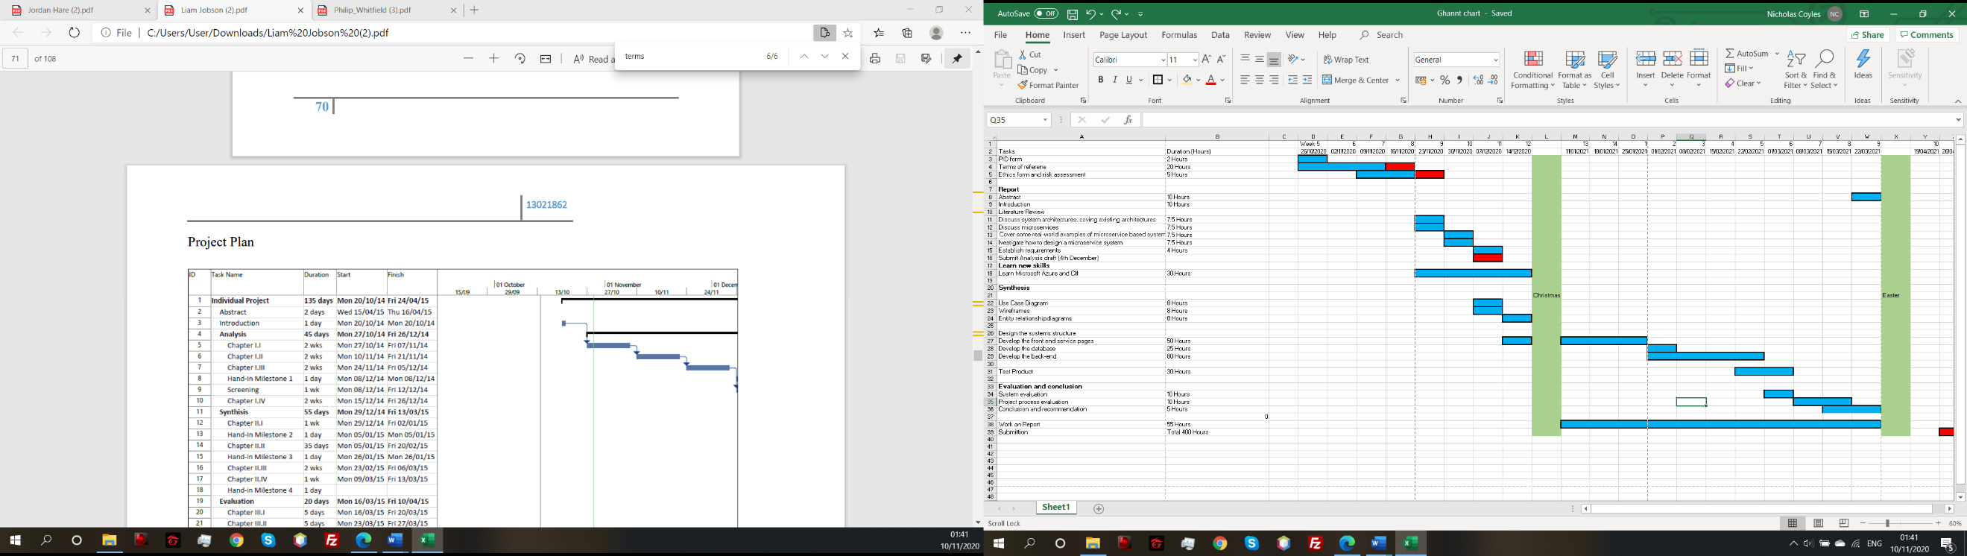



Appendix B – Requirements Specification

Functional requirements

|  |  |  |  |
| --- | --- | --- | --- |
| Requirement number | Requirement | Description | Priority |
| 1 | Categorizing and Tagging tickets | Tickets should be assigned to a category, related to the task. Tickets should also have information such as creation time | High |
| 2 | Live chat | A live chat where a user can chat to an agent | LOW |
| 3 | Asset management | Be able to track the history of a user and a ticket | MEDIUM |
| 4 | Email-integration | Monitors emails and converts emails into tickets | LOW |
| 6 | Dashboard | Visual UI that users can interact with | HIGH |
| 7 | Reports | A collection of analytics about tickets over a given time period | LOW |
| 8 | Sub tickets | Tickets can be separated into sub tickets and assigned to multiple agents | MEDIUM |
| 10 | User permissions | Different user has different levels of user privileges e.g. (basic user or a technician) | MEDIUM |
| 11 | Ticket Status | The active status of a ticket needs to be tracked and updated once completed (Closed, open or on going) | HIGH |
| 12 | Multi Assign | One ticket can be assigned to multiple agents | MEDIUM |
| 13 | Ticket escalation | If the task for a certain ticket is too difficult for the assigned agent, the ticket can be escalated to a higher leveled agent | HGIH |
| 14 | Multilingual | The help desk can support multiple languages | LOW |
| 15 | Audit logs | The ability to track what ticket a specific agent was assigned to | HIGH |
| 16 | Use of REST API | The use of an API for web communication | HIGH |
| 17 | FAQ page | A visual FAQ page, with common questions and the answers. | HIGH |
| 18 | Login page | A Page where users can log in to an account | HIGH |
| 19 | Register Page | A page where a new user can register an account | HIGH |
| 20 | Ability to store data in a database | General database connection | HIGH |
| 21 | Log out of account | Users can log out of their account and return to the login page | HIGH |
| 22 | Create a ticket | A user can create a new ticket with the ability to select a category, priority as well as giving the ticket a title and adding a description | HIGH |
| 23 | Categories tickets | Tickets can be sorted by category | HIGH |
| 24 | Discussion on ticket | Comments can be left on a ticket by an agent where users can respond, like a chat log | HIGH |

Non-Functional requirements

|  |  |  |  |
| --- | --- | --- | --- |
| Requirement number | Requirement | Description | Priority |
| 25 | Scalable | Code must have the ability to be scalable without becoming a monolith | HIGH |
| 26 | Maintainable | Services can be monitored using logs and health checks | MEDIUM |
| 27 | Available | Services are loosely coupled. If one service goes down it does not directly affect the other services. | HIGH |

(Bogner, 2020)

Appendix C – Use case diagrams

Requirements overview diagram

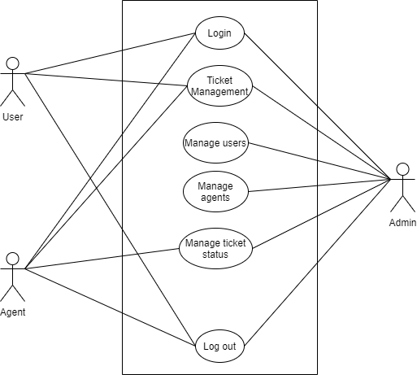

Login

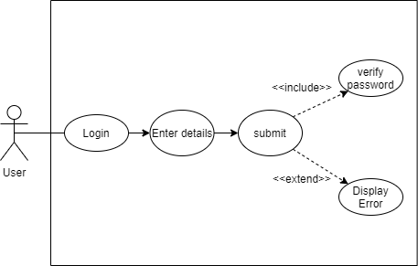

Register

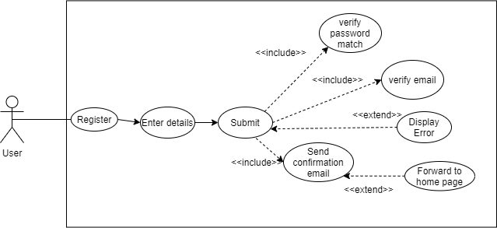

Update account

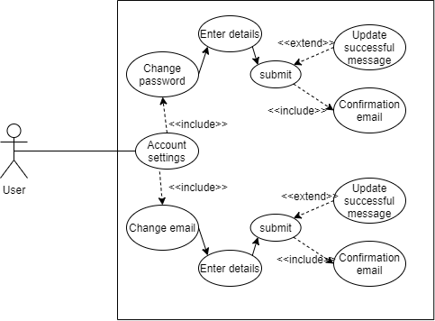

Ticket management

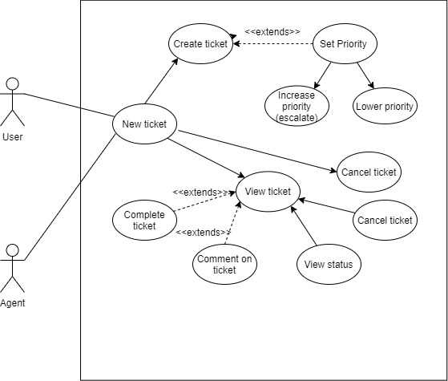

Update ticket status

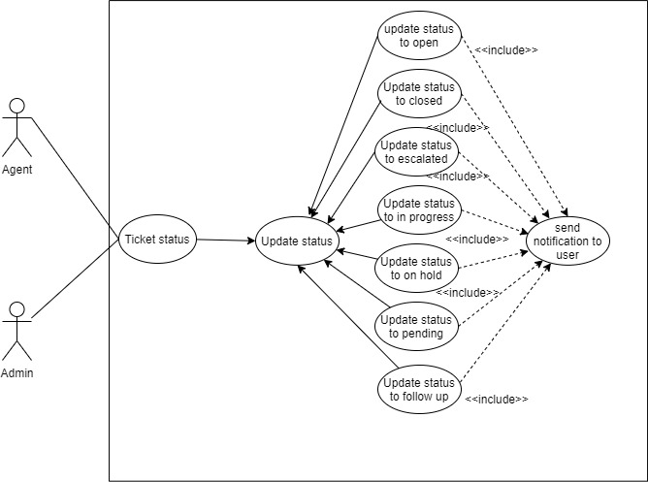

Manage users and agents

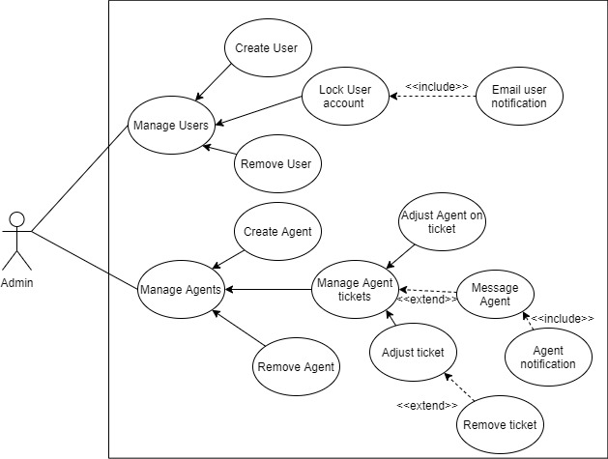

Logout

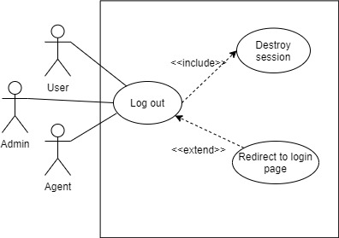

Appendix D – Wireframes

1. Login/Register

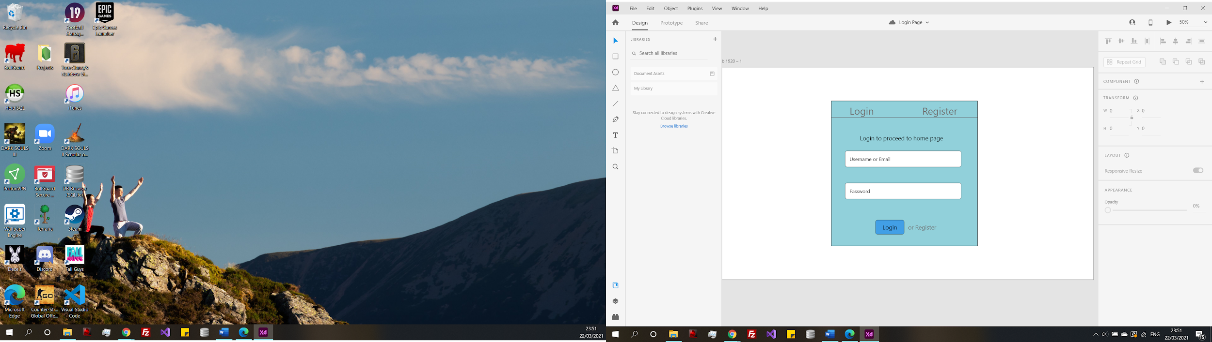

1. Create Ticket

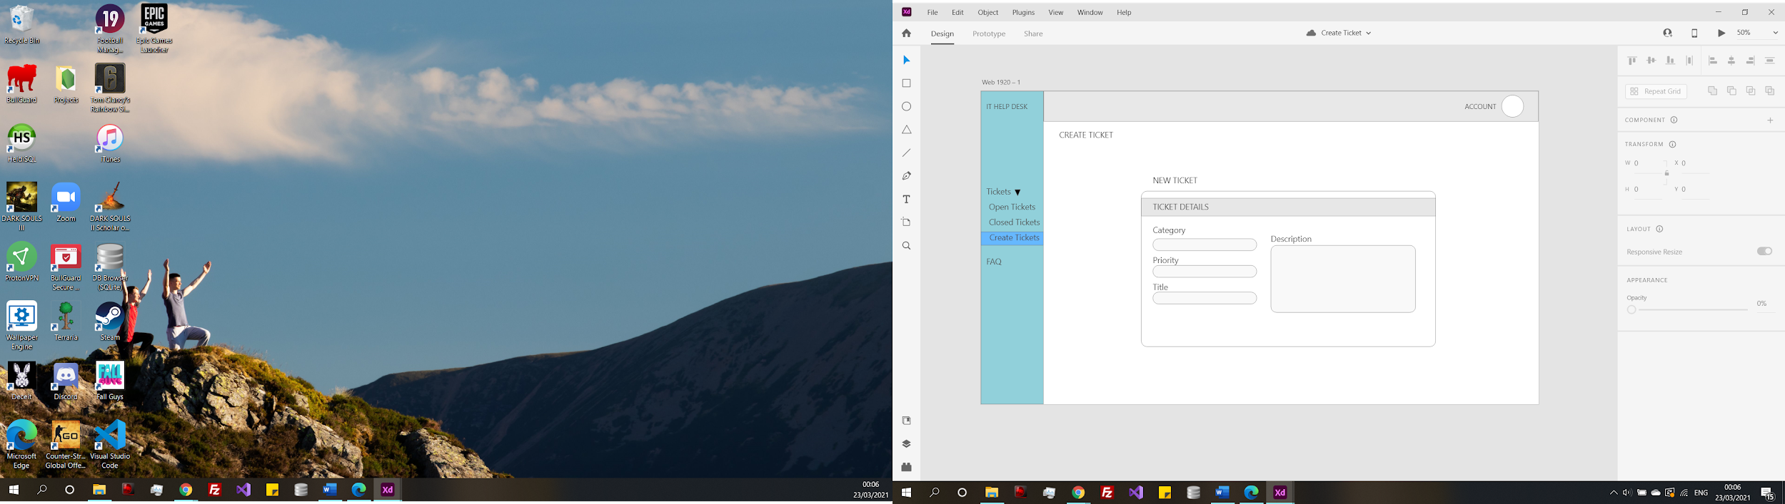

1. Ticket’s page

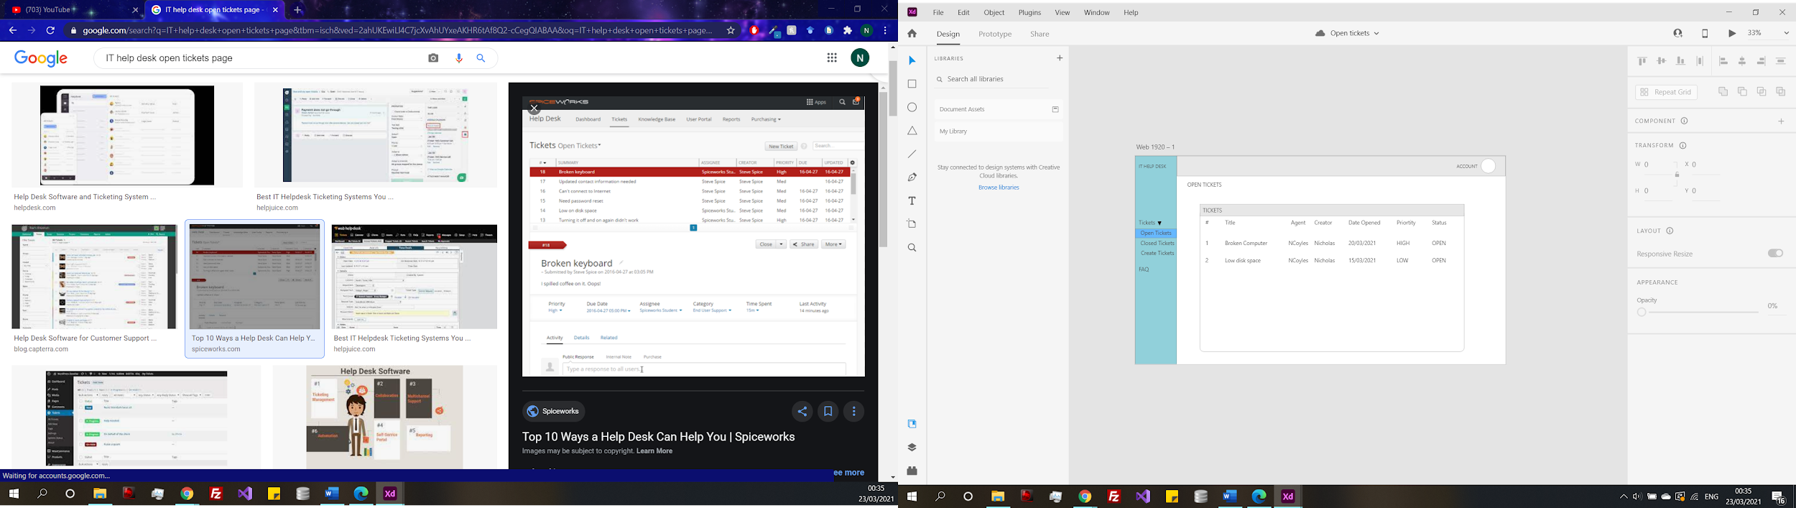

1. FAQ Page

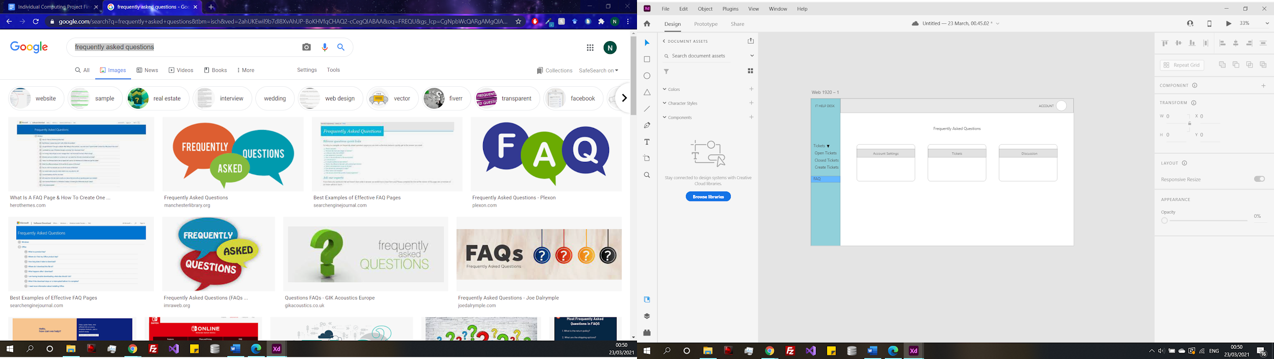

1. Discussions

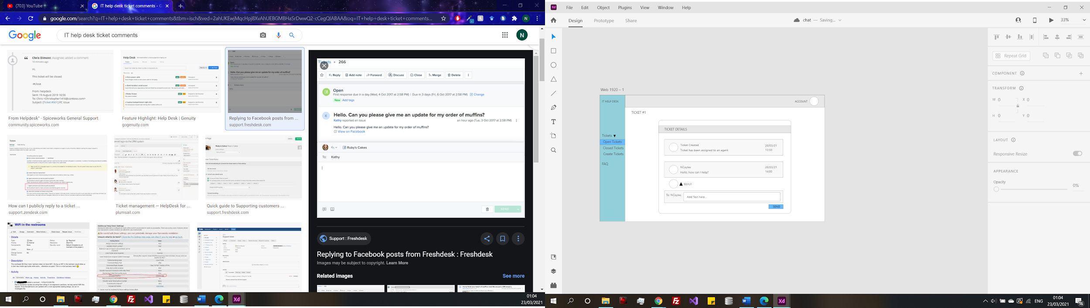

Appendix E – ERD diagrams

FAQ table

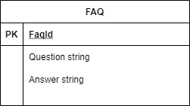

Tickets table

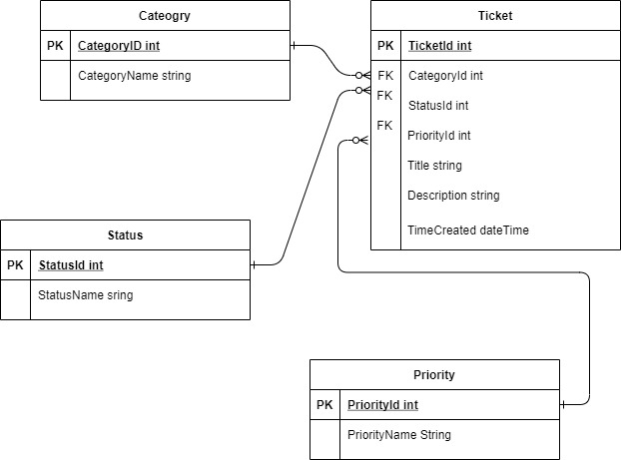

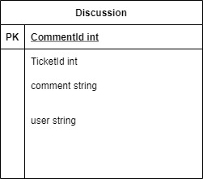Discussion table

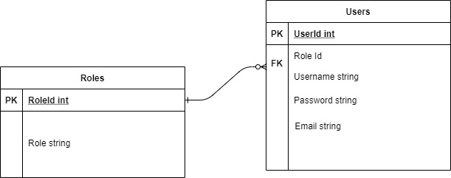users table

Appendix F – Ticket Collection Models

Ticket model



Status Model



Priority Model



Category Model



Appendix G – Ticket Database Context





Appendix H – Repository Interface classes

Ticket Interface



Status interface



Priority interface



Category interface



Appendix I – Repository classes

Ticket repository





Status Repository



Priorities repository



Category repository





Appendix J – Controller classes

Tickets Controller









Category Controller





Priority Controller



Status Controller



Ticket Comment



Appendix K – API Gateway Configuration



Appendix L – Test plan

Ticket Service testing

|  |  |  |  |  |  |  |
| --- | --- | --- | --- | --- | --- | --- |
| Test reference | Function | Description | Expected Outcome | Actual Outcome | Success/Fail | Solution |
| 1 | Add Migration | Add initial migration | New migration created | New migration created | Success |  |
| 2 | Update database | Adding update database using migration | Database creates | Fail error unique identifier not unique | Fail | Needed to add a primary key to the database |
| 3 | Update database | Adding update database using migration | Database creates | Database creates | Success |  |
| 4 | Data loaded into database | Seeded data added to database | Data loaded into database | Data loaded into database | Success |  |
| 5 | Get all categories | Return all existing categories | All categories returned | Returned empty | Fail | Needed to create the category repository |
| 6 | Get all Priorities | Return all existing priorities | All priorities returned | Returned empty | Fail | Needed to create the priority repository |
| 7 | Get all statuses | Return all existing statuses | All statuses returned | Returned empty | Fail | Needed to create the status repository |
| 8 | Get ticket by category | Return all tickets with that categories | All ticket tickets with inputted category returned | Null, no output | Fail | Needed to map the category id to the category name |
| 9 | Get ticket by status | Return all ticket with that status | All tickets with inputted category returned | Tickets returned but mapping was not correct | Success/Fail | Needed to map the status id to the category name |
| 10 | Get ticket by priority | Return all tickets with that priority | All tickets with inputted priority returned | Null, no output | Fail | Needed to add a where priority id equals ticket priority |
| 11 | Get ticket by Id | Return ticket with inputted Id | All ticket data returned for that Id | Ticket returned | Success |  |
| 12 | Exception message if data cannot be received from database | If there is an issue receiving data from the database an error is returned | Error retuned | Error returned | Success |  |
| 13 | Category id mapped with name | When ticket is returned the category, name is visible | Category name related to the id is displayed | Category name related to the id is displayed | Success |  |
| 14 | Status id mapped with name | When ticket is returned the status, name is visible | Status name related to the id is displayed | Status name related to the id is displayed | Success |  |
| 15 | Priority id mapped with name | When ticket is returned the priority, name is visible | Priority name related to the id is displayed | Priority name related to the id is displayed | Success |  |
| 16 | If no tickets with inputted status return empty | If there are no ticket under the status return empty result | Empty result | Empty result | Success |  |
| 17 | If no tickets with inputted category return empty | If there are no ticket under the category return empty result | Empty result | Empty result | Success |  |
| 18 | If no tickets with inputted priority return empty | If there are no ticket under the priority return empty result | Empty result | Empty result | Success |  |
| 19 | If no ticket with inputted id returns not found message | If the ticket with that id doesn’t’ exist return error message | Return error message | Error message returned | Success |  |
| 20 | If inputted create a ticket values are invalid return bad request | If the create a ticket values do not match the required input | Return bad request | Bad request returned | Success |  |
| 21 | Ticket created added to database | When a new ticket is created, it is added to the database | Ticket added to database | Ticket has been added to the database | Success |  |
| 22 | Updated ticket added to database | When a ticket is updated, the database is updated | Ticket in database updated | Database has not been updated | Fail | Original the request was a post request which was changed to a put request |
| 23 | If inputted ticket to update has incorrect id return error | If the ticket trying to be updated does not match a ticket id in the database return an error | Error returned | Error returned | Success |  |
| 24 | Ticket updated to database | If success the ticket in the database will update | Ticket updates | Ticket updates in database | Success |  |
| 25 | Ticket to delete does not exist throw error message | If the ticket does not exist a message will be returned | Error message returned | Error message returned | Success |  |
| 26 | Delete ticket from database | When ticket is deleted, it removed the record from the database | Ticket removed from database | Ticket removed | Success |  |
| 27 | Create new Category | New category can be crated | Category added to the database | Add to the database | Success |  |
| 28 | Create new category | create with no input data | Bad request returned | Bad request returned | Success |  |
| 29 | Error creating category | If there is an error while creating a category return error message | Return an error message | Error message returned | Success |  |
| 30 | Delete a category by Id | Input Id of category to be deleted | Category removed from database | Category removed from database | Success |  |
| 31 | Delete a category by Id | If category with inputted Id cannot be found returned error message | Return error message | Error message returned | Success |  |
| 32 | Error deleting category | If there is an error while deleting return error | Return internal server error | Internal server error returned | Success |  |
| 33 | Update Category | Update category on category Id | Category updated in database | Category updated | Success |  |
| 34 | Update Category | If category with inputted Id cannot be found returned error message | Return error message | Error message returned | Success |  |
| 35 | Update Category error | If there is an error while updating return error | Return internal server error | Internal server error returned | Success |  |
| 36 | Get ticket by user | Get all tickets with a username | All tickets returned | Tickets returned | Success |  |
| 37 | Get ticket by user | If tickets with inputted username cannot be found returned error message | Return error message | Error message returned | Success |  |
| 38 | Get comments on a ticket | Return all the comments under the ticket Id | All comments returned | All comments returned | Success |  |
| 39 | Get comments on a ticket | If ticket Id cannot be found return error | Bad request returned | Bad request returned | Success |  |

Discussion Service testing

|  |  |  |  |  |  |  |
| --- | --- | --- | --- | --- | --- | --- |
| Test reference | Function | Description | Expected Outcome | Actual Outcome | Success/Fail | Solution |
| 1 | Add Migration | Add initial migration | New migration created | New migration created | Success |  |
| 2 | Update Database |  |  |  | Success |  |
| 3 | Get comments on a ticket | Return all the comments under the ticket Id | All comments returned | All comments returned | Success |  |
| 4 | Get comments on a ticket | If ticket Id cannot be found return error | Bad request returned | Bad request returned | Success |  |
| 5 | Post Comment | Add a new comment to a ticket | Comment added to database | Comment added | Success |  |
| 6 | Post Comment | If ticket cannot be found return error message | Bad request returned | Bad request returned | Success |  |
| 7 | Error posting comment | If there is an error posting comment return error | Internal server error returned | Internal server error returned | Success |  |
| 8 | Error getting comments | If there is an error getting comment return error | Internal server error returned | Internal server error returned | Success |  |

FAQ service testing

|  |  |  |  |  |  |  |
| --- | --- | --- | --- | --- | --- | --- |
| Test reference | Function | Description | Expected Outcome | Actual Outcome | Success/Fail | Solution |
| 1 | Add migration | Add initial migration | New migration created | New migration created | Success |  |
| 2 | Update database |  |  |  | Success |  |
| 3 | Get all FAQs |  |  |  | Success |  |
| 4 | Create FAQ |  |  |  | Success |  |
| 5 | Get FAQ by id |  |  |  | Success |  |
| 6 | Update FAQ |  |  |  | Success |  |
| 7 | Delete FAQ |  |  |  | Success |  |
| 8 | Getting all FAQs | If there is an error getting all FAQs return error message | Internal server error returned | Internal server error returned | Success |  |
| 9 | Get FAQ by Id | If the Id cannot be found return error message | Not found error returned | Error returned | Success |  |
| 10 | Get FAQ by Id | If there is an error getting the FAQ return error | Internal server error returned | Internal server error returned | Success |  |
| 11 | Update FAQ | If the Id cannot be found return error message | Not found error returned | Error returned | Success |  |
| 12 | Update FAQ | If there is an error updating the FAQ return error | Internal server error returned | Internal server error returned | Success |  |
| 13 | Create FAQ | Once created FAQ returned | FAQ returned | FAQ returned | Success |  |
| 14 | Delete FAQ | If the Id cannot be found return error message | Return Not found error | Not Found | Success |  |

Gateway tests

|  |  |  |  |  |  |  |
| --- | --- | --- | --- | --- | --- | --- |
| Test reference | Function | Description | Expected Outcome | Actual Outcome | Success/Fail | Solution |
| 1 | Get all tickets | Get all tickets through gateway | All tickets returned | All tickets returned | Success |  |
| 2 | Get ticket by Id | Ger a ticket by id through gateway | Ticket with that id returned | Ticket returned | Success |  |
| 3 | Get comments by ticket id | Get comments on ticket through gateway | Comments on that Id returned | Comments returned | Success |  |
| 4 | Get all FAQs | Get all FAQs through gateway | All FAQs returned | All FAQs returned | Success |  |
| 5 | Get FAQ by id | Get FAQs by id through gateway | FAQ for that Id returned | Internal Server error | Fail | Duplicate gateway endpoint |
| 6 | Get FAQ by id | Get FAQs by id through gateway | FAQ for that Id returned | FAQ returned | Success | Duplicate gateway endpoint |
| 7 | Update FAQ by id | Update FAQ by id through the gateway | FAQ updated in database | FAQ updated | Success |  |
| 8 | Delete FAQ by Id | Delete FAQ by id through the gateway | FAQ removed from database | FAQ removed | Success |  |
| 9 | Create FAQ | Create FAQ through gateway | FAQ added to the database | FAQ added to the database | Success |  |
| 10 | Get all categories | Get all categories through gateway | All categories returned | All categories returned | Success |  |
| 11 | Create a category | Create category through gateway | Category created | Category created | Success |  |
| 12 | Get category by Id | Get category by Id through gateway | Category returned | Category returned | Success |  |
| 13 | Update Category by Id | Update category by Id through gateway | Category updated | Category updated | Success |  |
| 14 | Delete Category by Id | Delete category by Id through gateway | Category deleted | Category deleted | Success |  |
| 15 | Create ticket | Create ticket through gateway | Ticket created | Ticket created | Success |  |
| 16 | Update ticket by Id | Update ticket by Id through gateway | Ticket updated | Ticket updated | Success |  |
| 17 | Delete ticket by Id | Delete ticket by Id through gateway | Ticket deleted | Ticket deleted | Success |  |
| 18 | Get ticket by Username | Get ticket by username through gateway | Ticket created by that user returned | Ticket created by that user returned | Success |  |
| 19 | Get comments by ticket id | Get comments by ticket id through gateway | Comments returned | Comments returned | Success |  |
| 20 | Get all statuses | Get a list of all statuses through gateway | Statuses returned | Statuses returned | Success |  |
| 21 | Get all priorities | Get a list of all priorities through gateway | Priorities returned | Priorities returned | Success |  |
| 22 | Post a comment on a ticket | Post a comment to a ticket through gateway | Comment posted to ticket | Comment posted to ticket | Success |  |
| 23 | Quality of service | System timeout after an error | System times out and error can be seen on console | System timed out when there was no error | Fail | Exceptions before time has been changed from 1 to 3 to allow to some a preemptive timeout |
| 24 | Quality of service | Does circuit |  |  |  |  |

Blazor testing

|  |  |  |  |  |  |  |
| --- | --- | --- | --- | --- | --- | --- |
| Test reference | Function | Description | Expected Outcome | Actual Outcome | Success/Fail | Solution |
| 1 | Load | Blazor pages load | Blazor page loads when application is started | Page’s load | Success |  |
| 2 | Not logged in | Only the FAQ and home page can be access when not logged in | FAQ and home page are the only pages on nav bar | Only home and FAQ accessible by a user not logged in | Success |  |
| 3 | Not logged in | Try and access endpoint through URL while not logged in | Need to log in displayed on screen | Message displayed | Success |  |
| 4 | FAQ | FAQ page loads all the FAQs from the database | FAQs load and displayed on screen | FAQs displayed | Success |  |
| 5 | Log in | Log in displayed welcome message and username on screen | Name displayed on screen | Name displayed | Success |  |
| 6 | Ticket’s page | User has access to ticket page | Ticket page is now accessible | Ticket page loads | Success |  |
| 7 | Ticket’s page | Tickets created by that user displayed | Only the tickets created by this user are visible | Only relevant tickets load | Success |  |
| 8 | Create ticket | Blank ticket cannot be created | Error message displayed | Error messages displayed | Success |  |
| 9 | Create ticket | Only title filled in | Enter description error message | Error message displayed | Success |  |
| 10 | Create ticket | All categories in a drop down | Any category can be selected in a drop down | All categories in a drop down | Success |  |
| 11 | Create ticket | All priorities in a drop down | Any priority can be selected in a drop down | All priorities in a drop down | Success |  |
| 12 | Create ticket | Valid title and description | Green border around input fields | Input fields indicate success | Success |  |
| 13 | Create ticket | Redirected on submit | Redirected to ticket list after form submit | Redirected to ticket list | Success |  |
| 14 | Ticket page | New ticket visible | Ticket that was created is now on the list | Ticket visible | Success |  |
| 15 | Ticket page | Time created | Time created should be the current time | Time created is 00:00 | Fail | Time is not being set to current time |
| 16 | Ticket page | Time created | Time created should be the current time | Time created is now the current time | Success |  |
| 17 | Ticket page | Ticket details | All the ticket details are visible on the list including category, status, and priority | All details visible and the relevant name is linked to the category | Success |  |
| 18 | Ticket page | Edit ticket button | User should not be able to see edit ticket button | Edit button visible | Fail | Add check that only admin can see button |
| 19 | Ticket page | Edit ticket button | User should not be able to see edit ticket button | Edit button no longer visible | Success |  |
| 20 | Ticket discussion | Clicking ticket comments loads comments | All comments on that ticket are loaded | Comments are loaded | Success |  |
| 21 | Ticket discussion | Blank comment cannot be posted | Error message displayed | Error message displayed | Success |  |
| 22 | Ticket discussion | User comments are highlighted in blue | When a comment is posted by a user it is blue | Comment in blue | Success |  |
| 23 | Ticket discussion | Username, date and time are under the comment | Details about the comment are underneath the comment | Details relevant to comment are visible# | Success |  |
| 24 | Ticket discussion | Comments are ordered by time posted | Oldest comment at the top and new comments follows | Comments in time order | Success |  |
| 25 | Admin page | User cannot access admin pages | Error message displayed on screen | Error message displayed on screen | Success |  |
| 26 | Log out | User logs out | Redirect to home screen | Redirected successfully | Success |  |
| 27 | Register account | User can register new account | Once registered re directed to home screen | Redirected successfully | Success |  |
| 28 | Admin tickets page | Admin ticket page loads all tickets that are not closed | All tickets loaded | All tickets loaded | Success |  |
| 29 | Admin can edit a ticket | Ticket details are brought up | Details for that ticket are brought up when edit is clicked | Ticket details loaded | Success |  |
| 30 | Edit ticket | Admin can change the ticket | Admin can update the ticket | Admin can update the ticket | Success |  |
| 31 | Edit ticket | Ticket updates | Once submitted the ticket updates on the list | Ticket updates | Success |  |
| 32 | Edit ticket | Ticket closed | If admin changed status to closed ticket is removed from the list | Ticket removed | Success |  |
| 33 | Ticket discussion | Admin comment | If an admin comments on ticket the comment is highlighted in green | Comment is highlighted in green | Success |  |
| 34 | Admin page | Remove user | Admin can delete a user account | User account deleted | Success |  |
| 35 | Admin page | Closed tickets | All tickets with a closed status are visible | All closed tickets are visible | Success |  |
| 36 | Admin page | Closed tickets | If status is changed from closed ticket is sent back to the ticket list | Ticket is removed from the closed tickets | Success |  |
| 37 | Manage FAQs | FAQ list | All FAQs are displayed on screen | All FAQs are displayed on screen | Success |  |
| 38 | Manage Categories | Category list | All Categories are displayed on screen | All Categories are displayed on screen | Success |  |
| 39 | Create FAQ | Create new FAQ | New FAQ is added to the list of FAQs | Error, system guid cannot be converted to string | Fail | Changed guid type to string |
| 40 | Create FAQ | Create new FAQ | New FAQ is added to the list of FAQs | FAQ added to list | Success |  |
| 40 | FAQ page | New FAQ visible | New FAQ is also visible on the FAQ page | FAQ visible | Success |  |
| 41 | Create Category | Create new Category | New category added to the list | Category added | Success |  |
| 42 | Categories | New category in category drop\down | New category should be in the category drop down when creating a ticket | Category is displayed in drop down | Success |  |
| 43 | Create FAQ | Form validation | Blank form cannot be submitted | Error message displayed | Success |  |
| 44 | Create Category | Form validation | Blank form cannot be submitted | Error message displayed | Success |  |
| 45 | Create FAQ | Form validation | Only one field filled | Error message displayed for blank field | Success |  |
| 46 | Delete FAQ | Remove FAQ | FAQ removed from list | FAQ removed | Success |  |
| 47 | Delete Category | Remove Category | Category removed from list | Category removed | Success |  |

Integration functionality testing

|  |  |  |  |  |  |  |
| --- | --- | --- | --- | --- | --- | --- |
| Test reference | Function | Description | Expected Outcome | Actual Outcome | Success/Fail | Solution |
| 1 | Create ticket | A ticket can be created | Ticket added to ticket list | Ticket added to list | Success |  |
| 2 | Edit ticket | A ticket can be edited | Ticket updated on list | Ticket updated | Success |  |
| 3 | Delete ticket | Ticket removed from list | Comments on that Id returned | Comments returned | Success |  |
| 4 | Comment on ticket | posted on a ticket | Comment posted on ticket | Comment posted | Success |  |
| 5 | Create FAQ | A FAQ can be created | FAQ added to list of FAQs | FAQ added to list | Success |  |
| 6 | Create Category | A category can be created | Category added to list of categories | Category added | Success |  |
| 7 | Delete Category | A category can be deleted | Category can be deleted from list | Category removed | Success |  |
| 8 | Delete FAQ | A FAQ can be deleted | FAQ deleted from list | FAQ removed | Success |  |
| 9 | Log in as admin | Admin can log in | Admin user can log in | Admin logged in | Success |  |
| 10 | Log in as user | User can log out | User can log in | User logged in | Success |  |
| 11 | See user tickets | User can see all their tickets | User tickets displayed | All tickets created by that user displayed | Success |  |
| 12 | See all tickets as admin | Admin can see all tickets | All tickets displayed | All tickets displayed | Success |  |
| 13 | Closed tickets are moved from list | When admin closed ticket, it is removed from ticket list | Closed ticket removed | Ticket removed | Success |  |
| 14 | Closed tickets on admin page | Closed tickets can be seen on admin page | Closed tickets shown on admin page | Tickets can be seen on admin page | Success |  |
| 15 | Admin can update users | Admin can update user details | User details updated | Details updated | Success |  |
| 16 | Logout | Users can log out | Logged out of account | User logged out | Success |  |
| 17 | User can register | Users can register new account | Account should be registered | Account registered | Success |  |

Appendix M - Build cycle 1

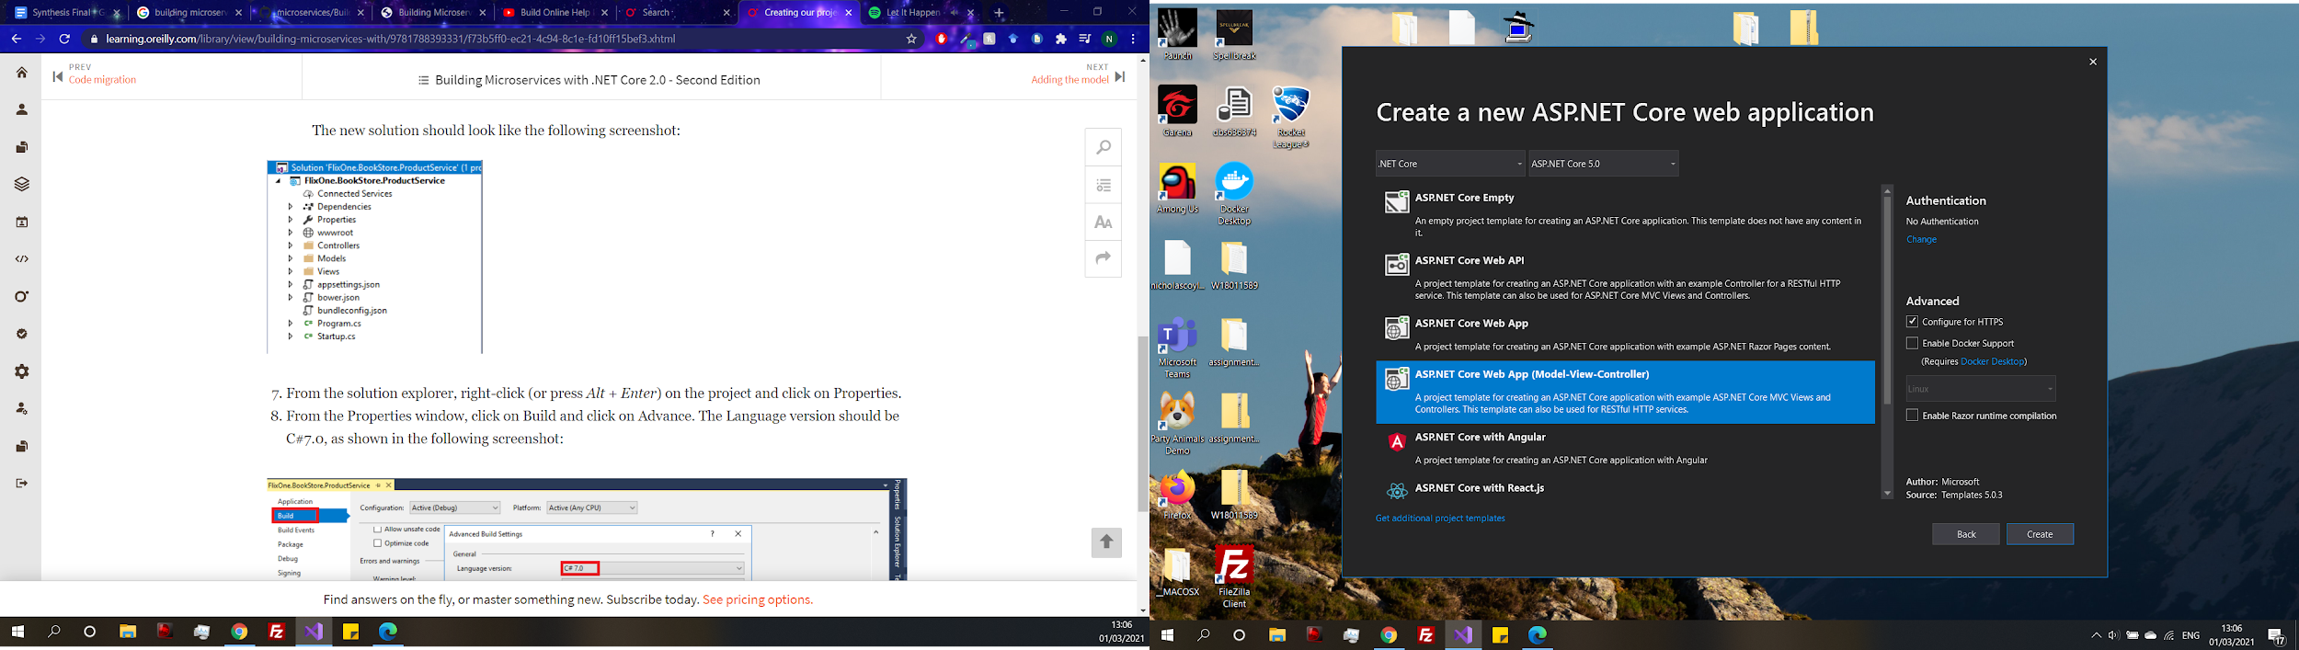

The first step is to create the application where the project will be built. Using ASP.NET Core Web App (Model-view-Controller). Allows for the use of RESTful HTTP services to create communication between services for the microservice but also lets an MVC approach to be used. Essentially, using an MVC application is a specialized form of microservice with HTML rendered onto endpoints, in addition to text and JSON endpoints (Hoffman, 2017).

The controller controls how the user interacts with the application, the models represent the data required by the controller and the views present the interaction between the user and the application (Hoffman, 2017). Adding models is the next step, a model in this context will represent the data used by the controller and the view and is not dependent on anything its only purpose is store data and represent the logic for a certain class which can then be used by the controllers and view.

**Entity Framework and Packages**

To manage any data entity framework packages, need to be added to the project. By managing NuGet packages, packages can be installed to the project. The reasoning for this is because entity framework allows for the connection to a database which can then be used within the project. Other packages besides entity framework will be used to handle other aspects of the project and will be added to the solution. For example, for user authentication.

Microsoft.EntityFrameworkCore - Enables entity framework support

Microsoft.EntityFrameworkCore. SqlServer - Allows for entity framework to be used with microsoft sql server

Microsoft.EntityFrameworkCore. Tools - Enables the use of common commands that can be used

A Models folder is added to the Backend solution, in the model’s folder is where data will be stored about the IT Helpdesk. Essentially, the same as other programming languages work by creating classes with properties to store data. Tickets will be the first model that is added to the project.

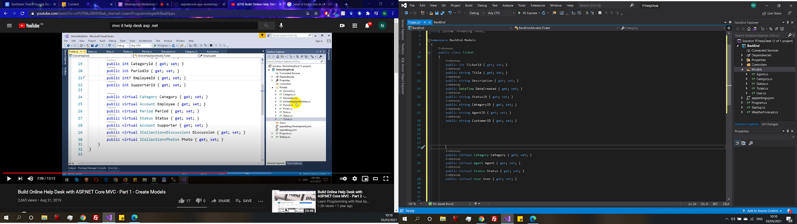

Each ticket will have a ticketID, a title, a description, the date/time it was created, its status, a category, the assigned agent, and the customers Id who created the ticket.

By just adding what data tickets should manage, you can see some other models that need to be added. For example, status would need its own model so that status can be set and have its own ID and relevant description. The same can be said about category, agent, and customer. Now models have been created for status, category, discussion, agent, and user within the model’s folder for each of these. Then cross reference them in the ticket so the data will be accessible.

ApplicationDbContext class added to the Models folder the purpose of adding db context to services is so the application can control up how the db will interact with entity framework in this case extending the default context provided by the entity framework.

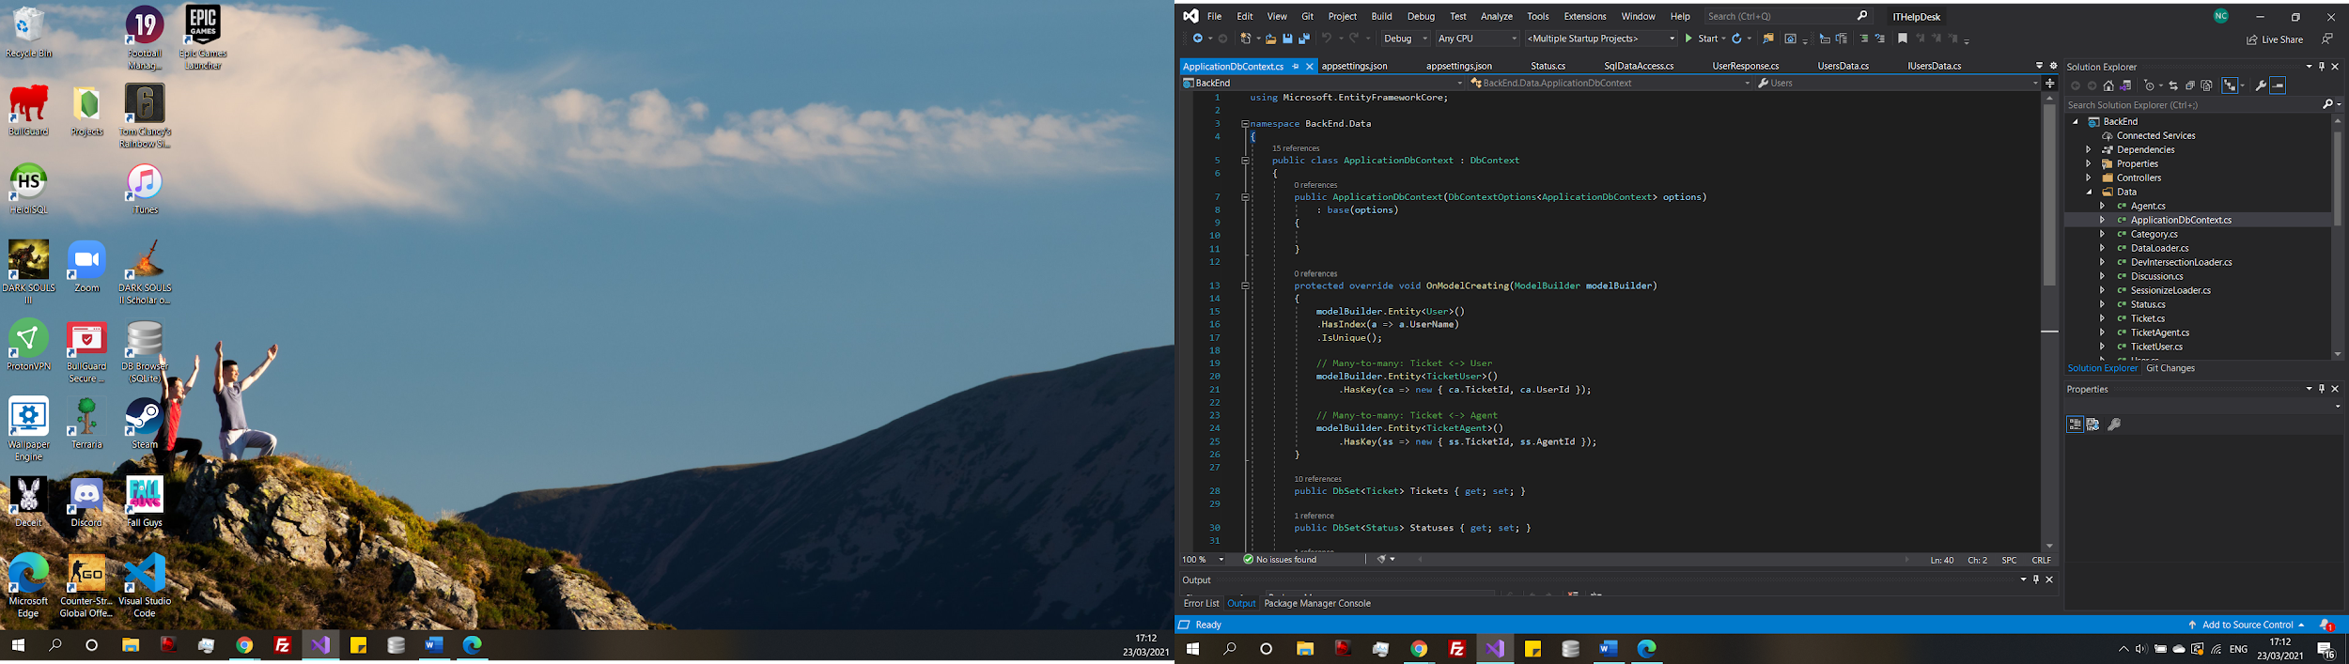

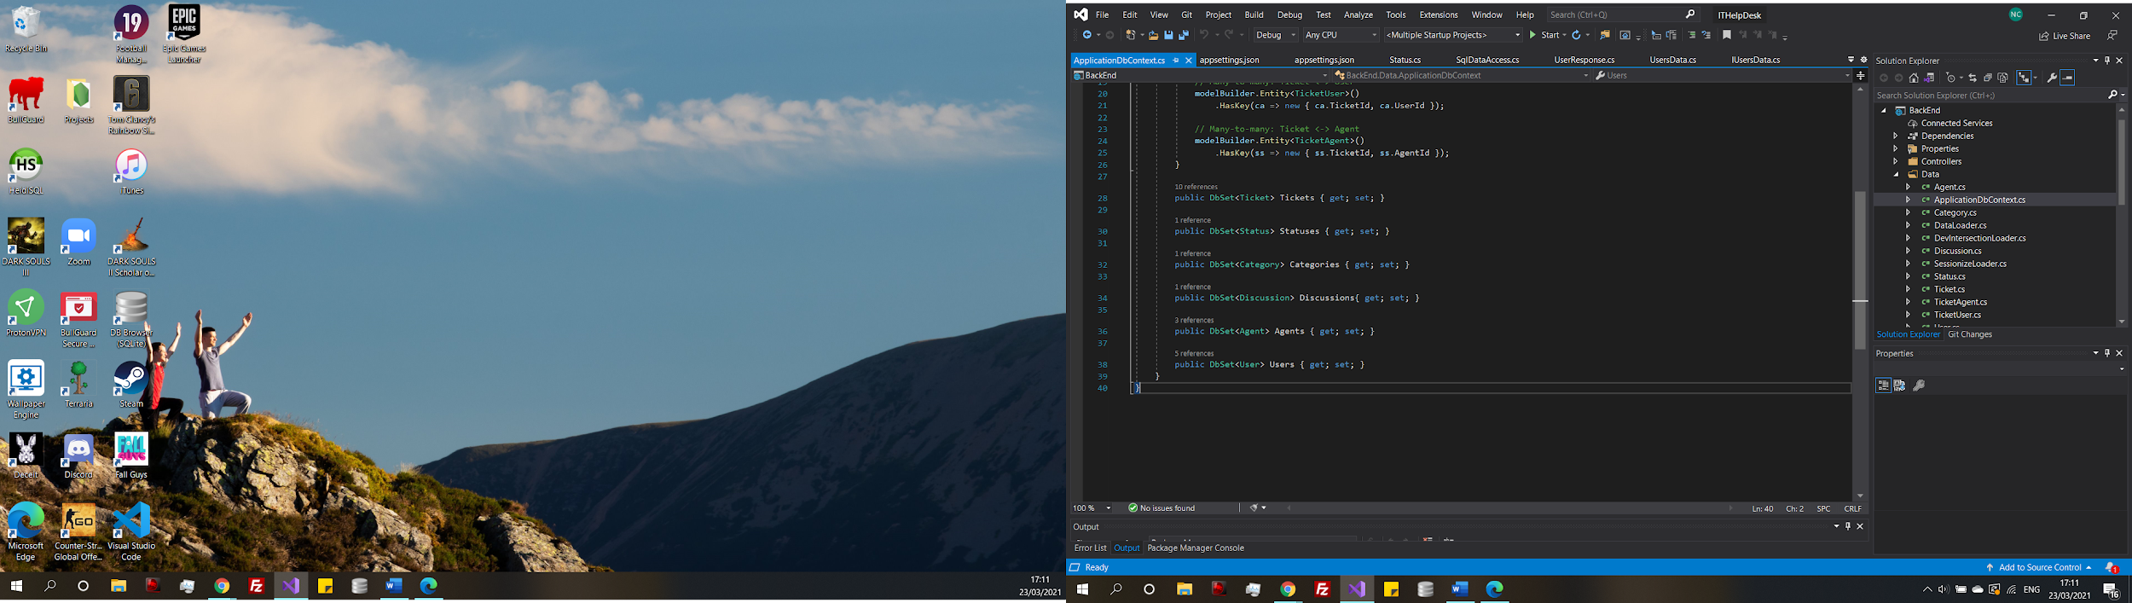

In DB context the database is defined to set up the database. The way this is working is creating tables of type Tickets, Statuses, Categories, Discussions, Agents and Users. Entity framework uses the corresponding classes to create the database entities and how the tables link together.

The first migration can be added, and database updated via the NuGet packet manager.

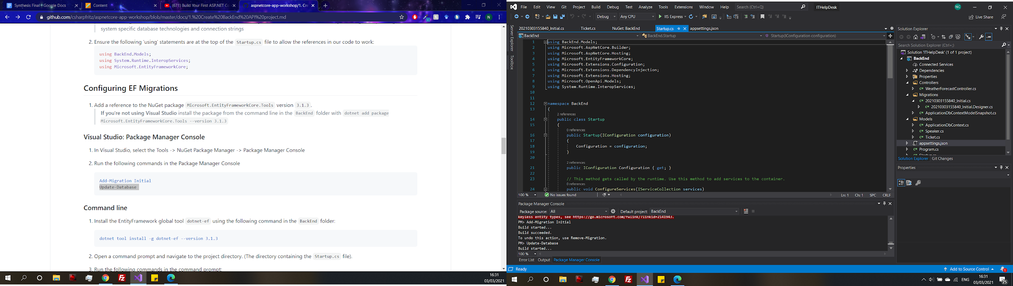

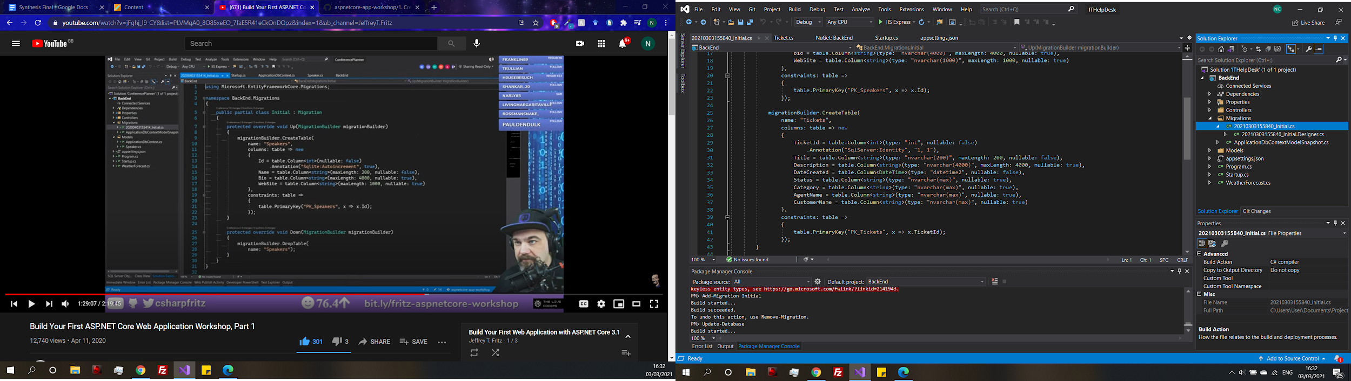

Code has been generated that defines the database. The initial migration creates a table with all the fields that were in the model class. As an example, TicketId has also been defined as a primary key automatically. Migrations can be reversed and if so, the table will be dropped.

**SQLITE**

To show this in practice the database has been exported to a database file, so it is possible to see what is going on after the migration. In the first screenshot the ticket table, which is empty because it has only been told to create the table and no data is to be imputed yet. In the second screenshot is an auto generated table that gets updated each time the project is migrated. It currently has data already inputted, the name of the migration and Product Version is the version of .NET that was used to apply the migration.

The decision to use SQLite came when looking for a way to view the database that entity framework creates. There is a .Net package available that allies for the database to be exported as an SQLite file when a migration accord. SQLite was chosen because of some familiarity with the software. However, after a discussion with the supervisor, SQLite is not necessary because there is an inbuilt database tool within Visual studio which does the same job as SQLite, but it can also generate a database diagram. In result of the discussion with Mark, exporting the database tables into an SQLite will no longer take place. The only reason why it was used was because of familiarity with the tool and it would not be suitable in a real development.

**Controllers**

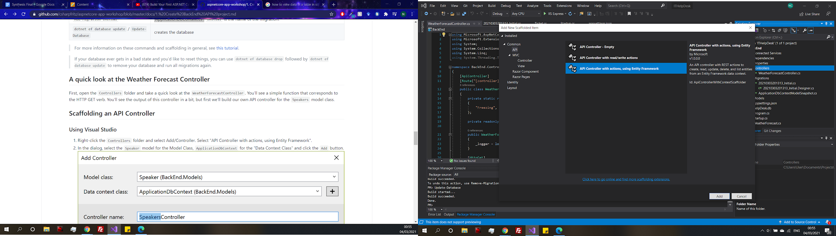

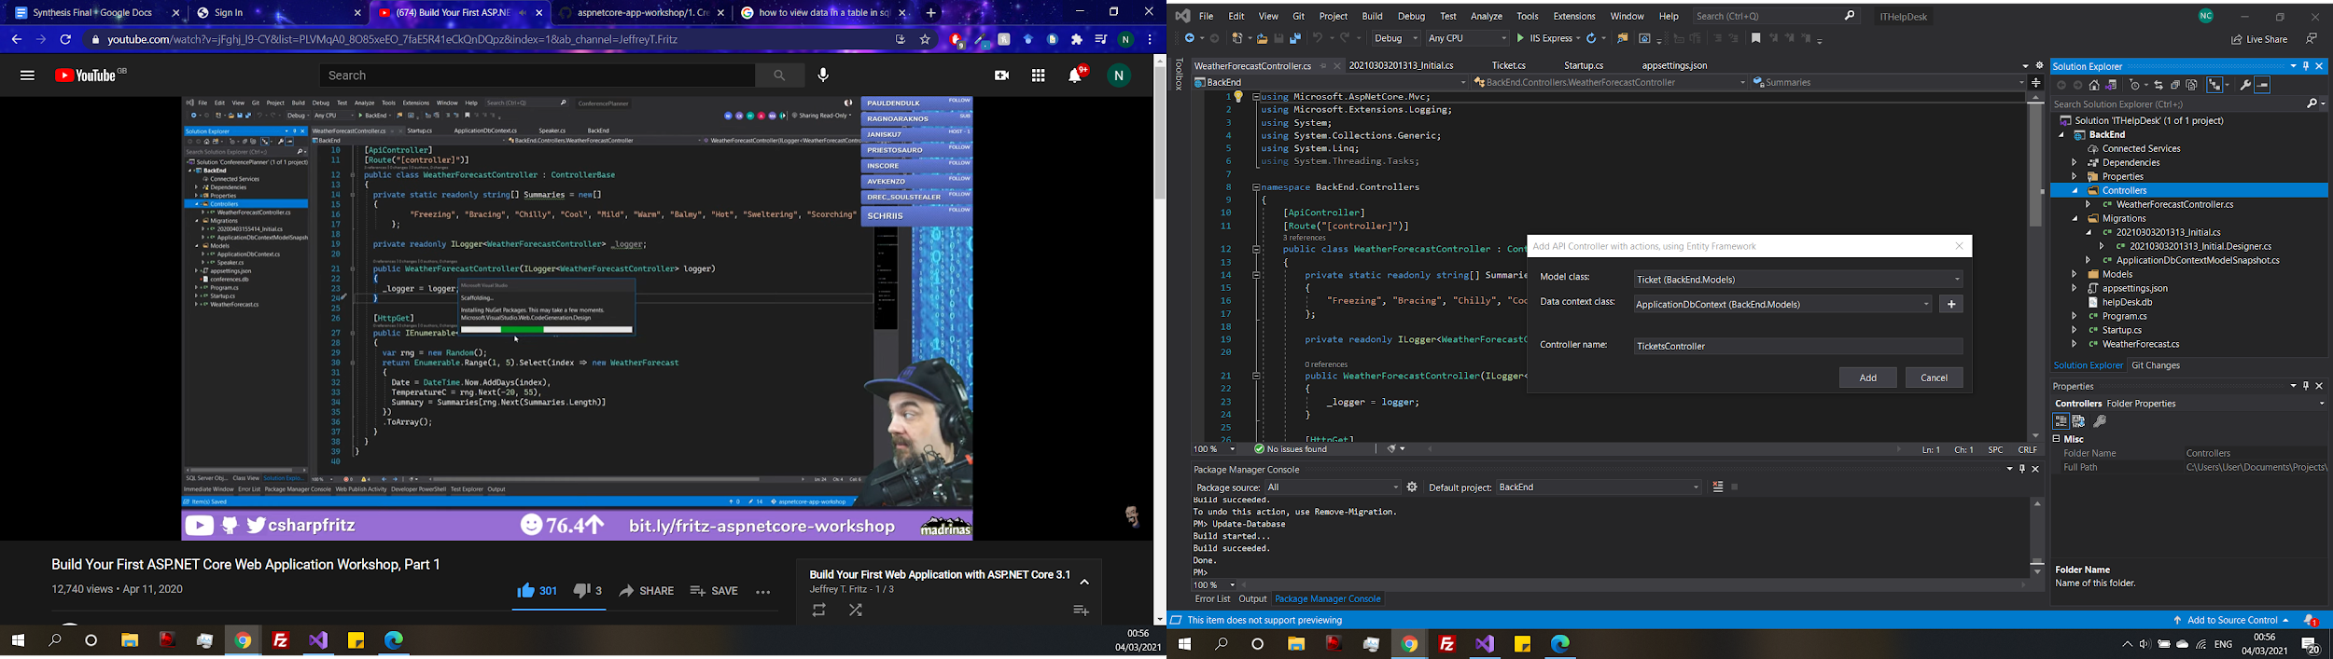

The controller references db context by default which lets the controller receive the applicationDbContext, which allows for the database connection to be used inside the controller.

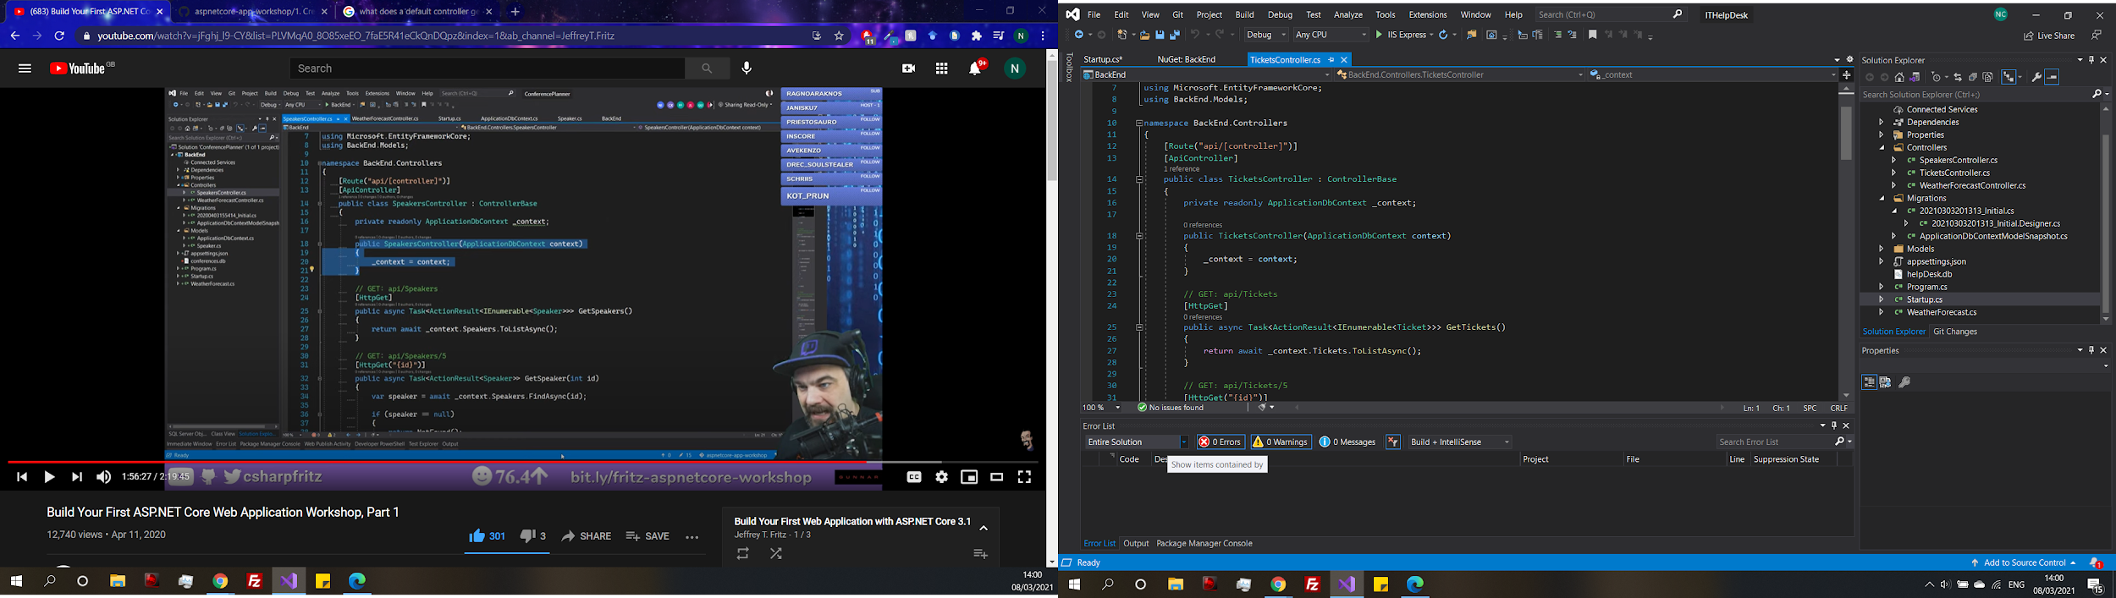

It also automatically generates some API statements using the db context. For example, getting all the tickets or just a specific ticket and even putting a new ticket in the database all generated using the controller scaffold.

Now to test the API to see how it functions adding a plugin will make it easier to see what is happening. Swash buckle is going to be added to the project, in the same way other plugins have previously been added. Swash buckle is an open-source project that generates documentation for Web APIs built with ASP.Net Core. Once Swash buckle has been added, it needs to be configured in the start-up file.

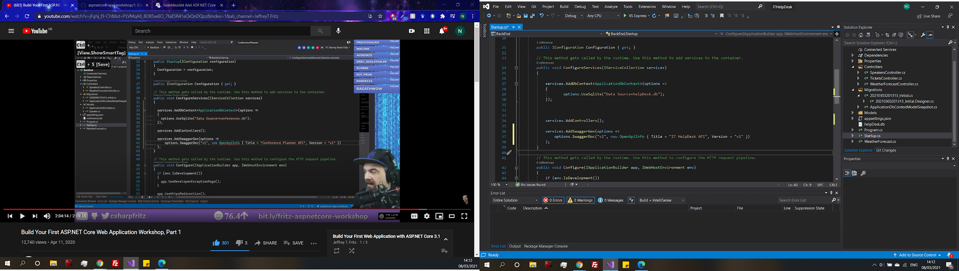

Add the Swagger generation, which will generate documentation with the title IT Help Desk and will note that it is version 1.

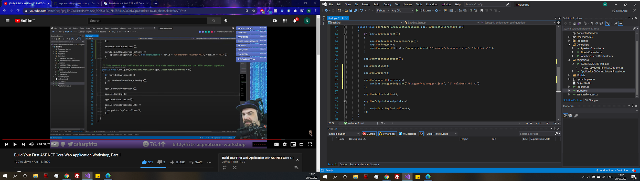

A reference is added into the Http pipeline part of the configuration. Essentially, when the application receives a request. When the application starts it goes step by step though these references in the config. Adding swagger into the references will generate the swagger user interface and route appropriately when it is requested.

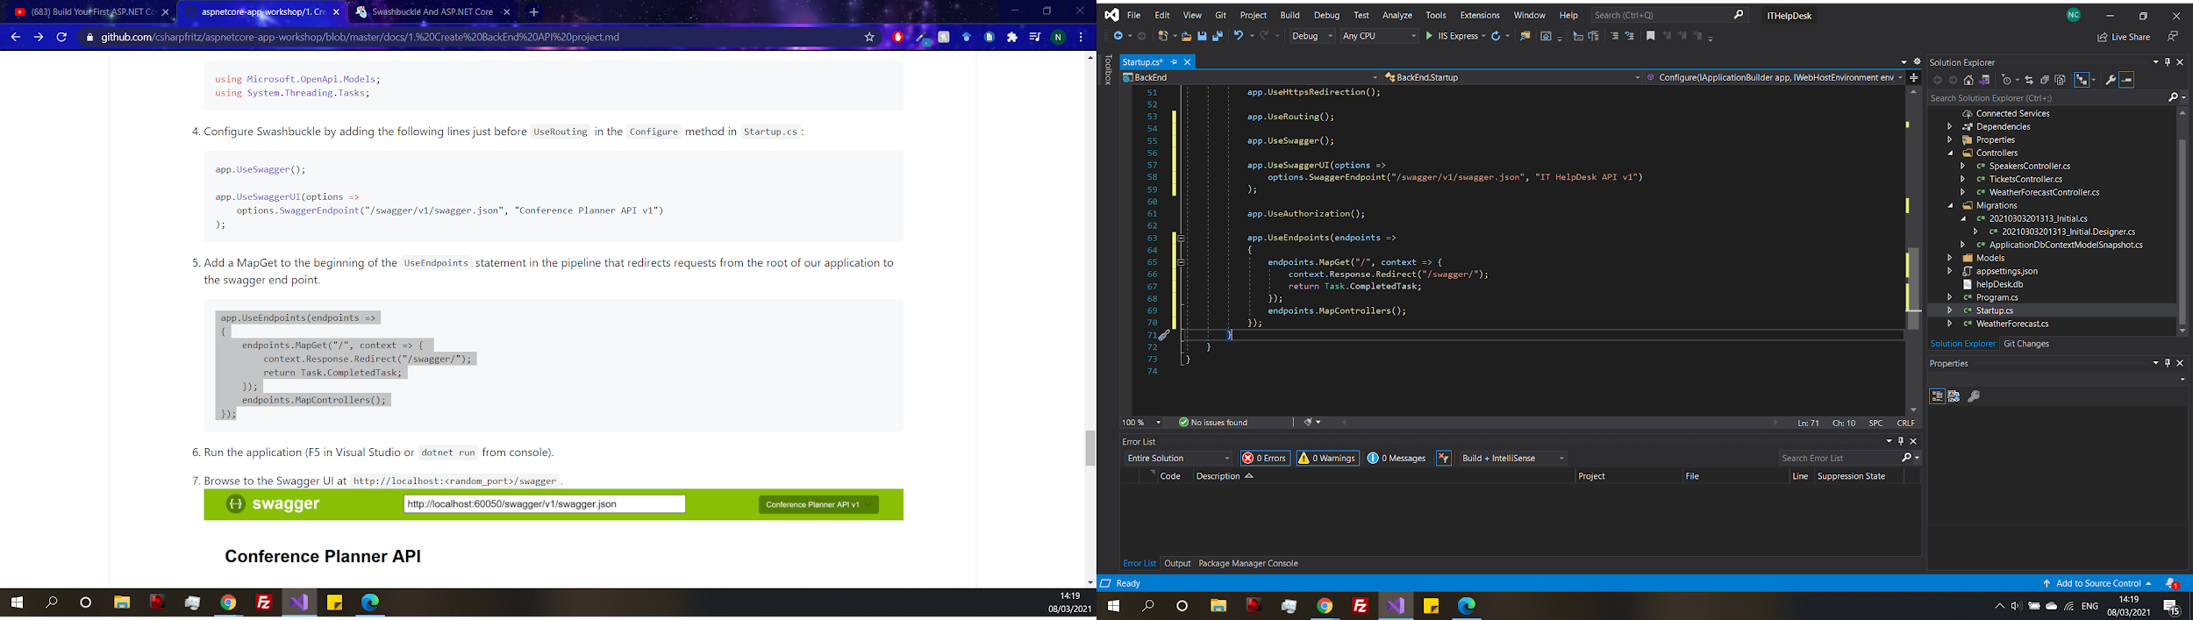

For now, a redirect to the swagger documentation has been added so that when the application runs it will automatically redirect to this page, just to save time while the back end is being worked on.

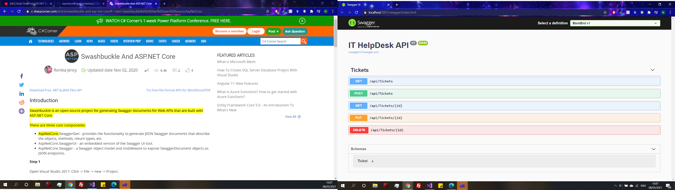

Now when the application is run it has a swagger UI where each of the API requests that were generated earlier can be seen. To test the API a post request can be submitted then a get request should be able to see the created ticket.

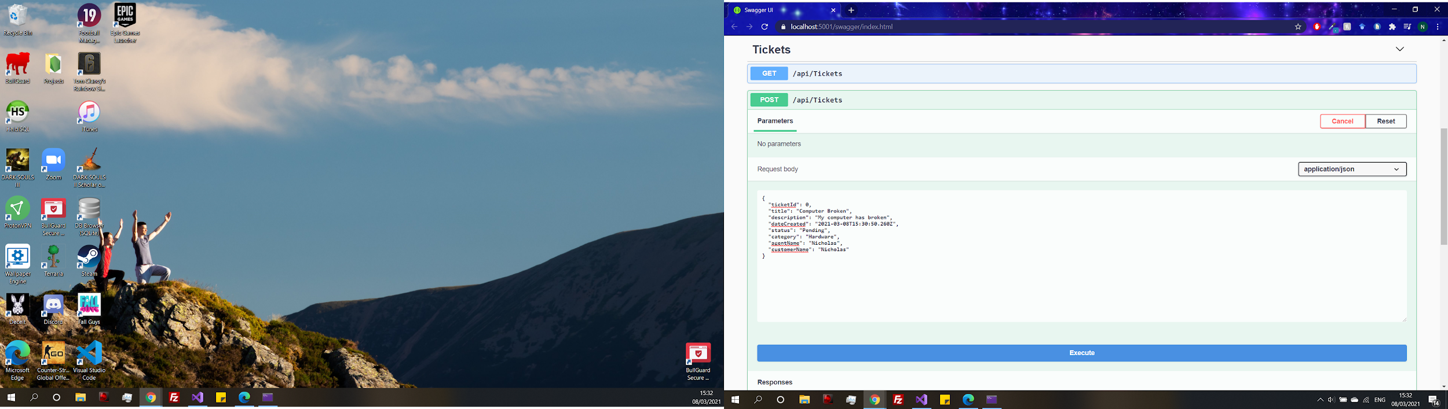

The user interface shows the format of the json data, the data can be changed and then posted. However, it should be noted that status, category, agent Name and customer Name are still stringing and will remain like this until the tests are complete. Once the application is functioning correctly, they will all receive their own models and controllers like tickets.

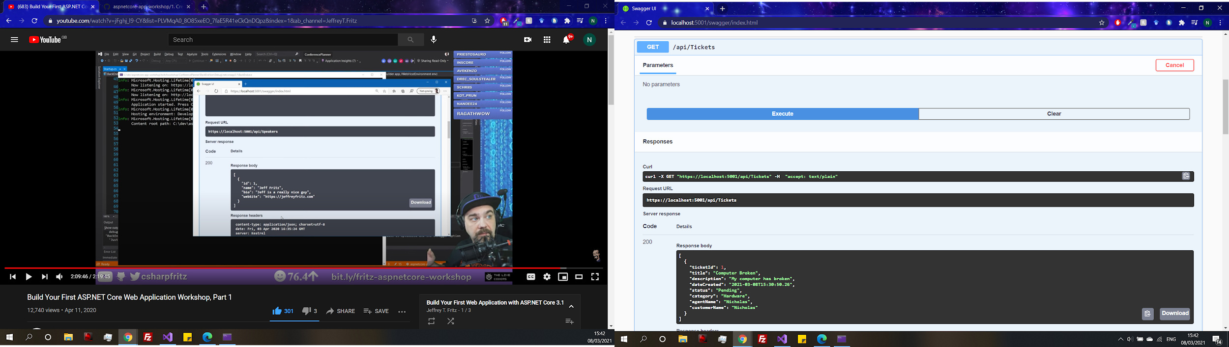

The response from the PUT request can be seen first was successful a new ticket was created with the ID 1, now if the GET tickets requests endpoint is executed it should show the new ticket. While it does the new ticket exists and has successfully been created and stored in the database. This simple test with the API shows that interacting with the API works and can now be built upon.

**Data transfer**

One consideration is to think about how the application is going to use data. There is the data being processed by the back end which has already been seen, but the data being used by the back end is mainly going to be coming from the front end that will be created later in development. There needs to be a way to pass data between them as in the microservice architecture they are separate and do not directly interact with each other. A way to do this is to create a data library

The main reason for this is that we do not want to expose the complexity of our domain through the services to the clients. Instead,we expose DTOs between our services that serve application clients through REST APIs (Baeldung. 2020).

First step of adding a DTL is to add a class library to the project called ITHelpDeskDTO. By default, it defined a .NET standard of 2.0 which has the highest level of compatibility between a wide range of technologies. This allows the project to be integrated with other .NET projects like what is being undertaken in this project. But also, in the future can be referenced in other applications of a different technology to then can process data between the microservice. Which brings in the idea of that major of a microservice being very scalable from the literature review.

Add a reference from the backend to the ITHelpDeskDTO

Now both parts are linked together the model that is created needs to be refactored into the DTL, so it is shared.

Added NuGet package - System.ComponentModel.Annotations

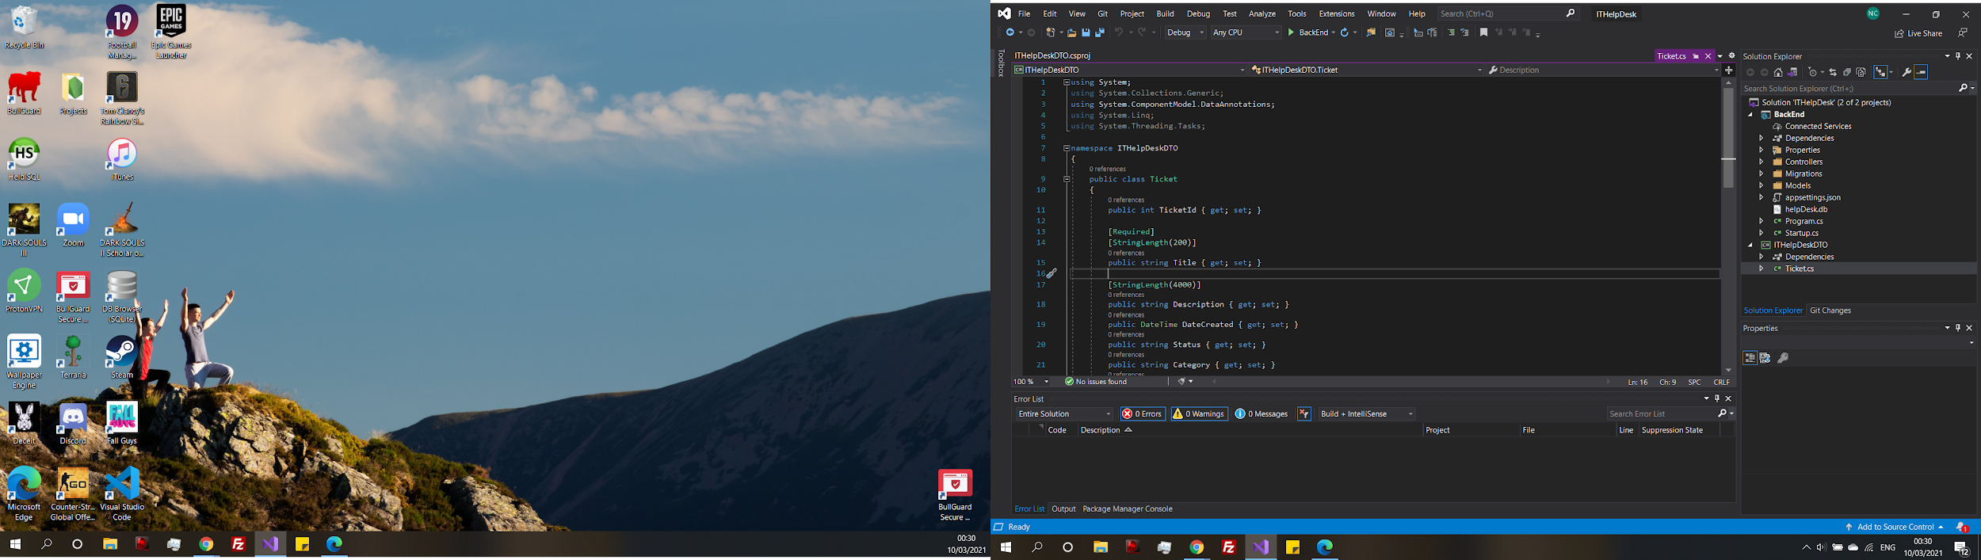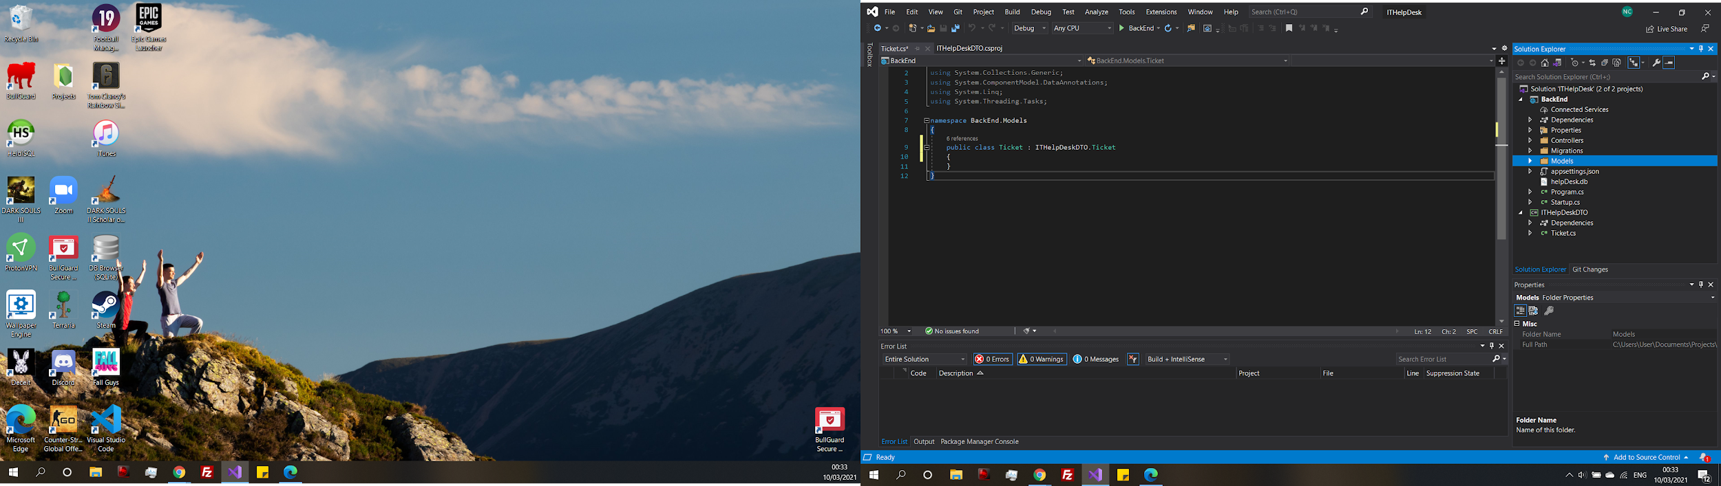

Now what can be done is the tickets model created in the Backend project can be moved into the DTL project and now with the that each project references each other, in the model’s ticket class it no longer needs to define each method instead the tickets class can inherit from the DTL tickets class and have access to all the functionality that it used to have through inheritance. It still works the same way that it did in the API tests. The same has also been done for the other models.

Once added the ApplicatioDbContext need to be updated

A new database migration needs to be added so the database knows how to update with the changes made.

Updates include all the new objects/methods

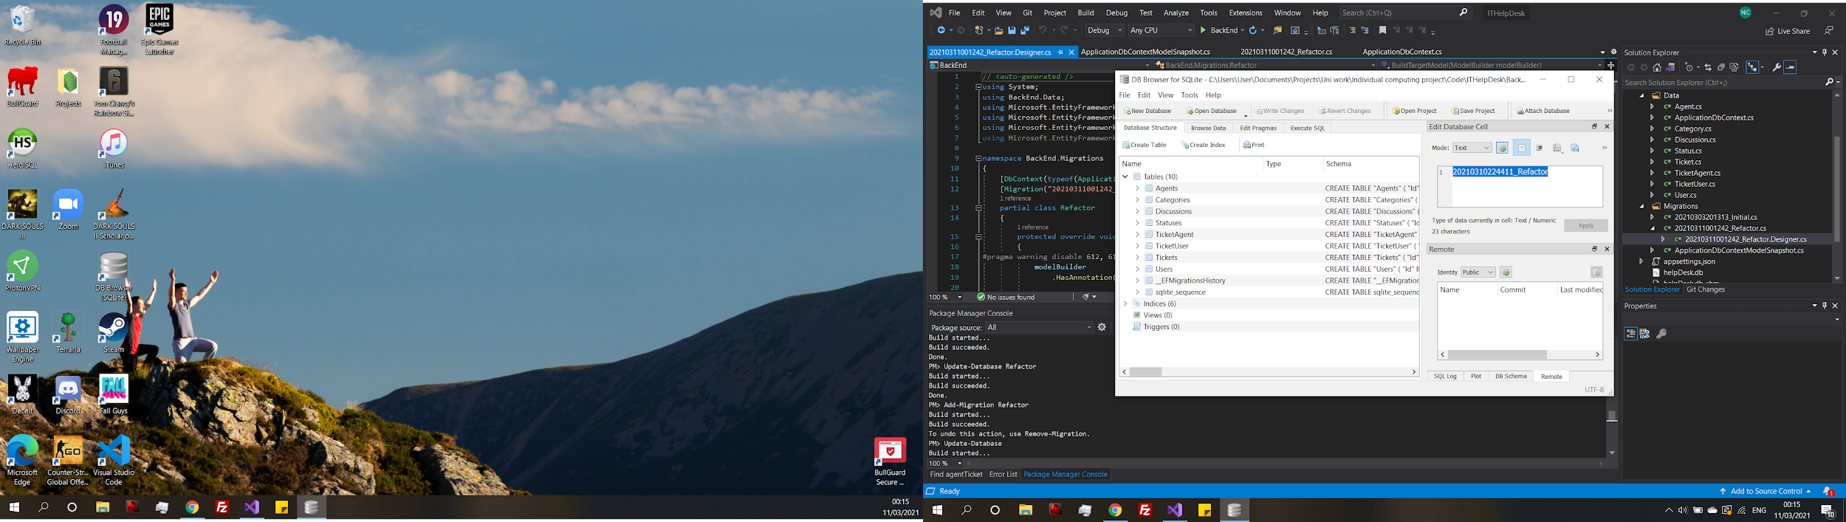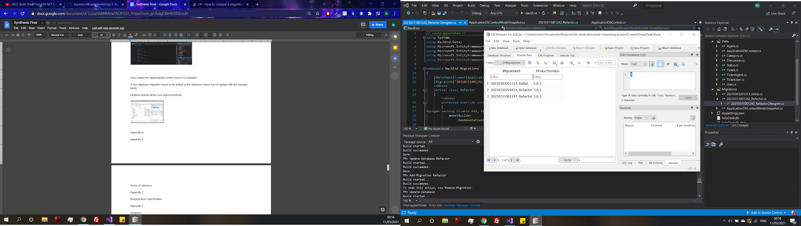

New tables have been added to the database

Migration history has been inserted, there are three migrations now because there was a naming error with a table in the second migration, so it had to be re-done.

**Are DTL the best way forward?**

Even though using a DTL is beneficial to pass data between microservices and allows for some form of flexibility in terms of technology hierarchy. It only works with Microsoft technologies which in fact counteracts the purpose of a microservice. This is something to consider because the reason for using a microservice is to allow for scalability and the allowing multiple languages to be used and using a DTO as part of the solution is in fact limited which is not ideal. Therefore, some research is to be done to look for another solution that allows for data transfer between services but is also scalable.

Also referencing directly between projects in this way adds an extra layer of dependency. Having a dependency between services would make the microservice un scalable because the services are no longer functioning individually, and it makes everything unnecessarily complex. There is a need to a have a look at the system from the begin to plan a more effective development approach.

Appendix N - Build cycle 2

At this point in the development process a re-evaluation of the system was need because there was confusion with how the .NET tools work and the lack of prior knowledge really took its toll here because the whole development essentially had to restart, and some time was needed to try and understand the technical complexity before jumping in and trying to code. Before starting to code again the systems diagram was re-created after studying more literature, because of the gap in knowledge referring to defining service boundaries it was clear more clarity was needed before any meaningful attempt at development could be made.

(Figure 9) shows the new systems diagram, it is considerably different from the first design (Figure 8). The first design more represented a database table, rather than the business capabilities. The book “Domain Driven Design” by Eric Evans (Evans, 2004), was used to help gain some basic knowledge on how to define a system. (Figure 9) was made along with ERD diagrams (Chapter 6.3.3) the new systems diagram had the individual services and how the ticket collection will communicate with the ticket service and then the ticket service will communicate with a message bus with the discussion service.

At the same time was spent learning more technical skills by studying Microsoft’s example microservice eShop along with the accompanying documentation. To then begin development again.

(de la Torre, 2020)



The new Ticket class has references to other models for category, priority and status linking the classes together.



The classes that ticket references can be seen here.

Before setting up entity framework the generic c# classes have been created, at this point they are not a microservice, it is easier to start with a monolith in this way for now when staring off. In the tickets class a couple of attributes have been defined and there is also Id to other classes such as status, category, and priority. Which have their own classes, where each Id is assigned to a name or status and so on, the tickets would like to access these details so there needs to be navigation references in the ticket class.

**Ticket discussions**

Tickets should have a discussion attached to them like a chat log. Where the user can leave a comment and so can an agent. The issue is whether the best approach is to create a model for ticket discussions and link it to the ticket like the status or if it would be better to split it into its own microservice. As it is technically its own business capability it is believed that discussion should be its own service and will communicate with the tickets service



Fluent API has been used here to configure the model classes

**Docker**

Docker is a form of containerisation discussed in chapter (3.9), docker is used to run multiple applications on the same machine. Which is exactly what will be needed as more service applications are added to the project. Each application is contained within an isolated environment known as the container (Shah, 2019). The benefits of using docker does not use as much memory as a virtual machine to run because the docker containers only exist while the service is running, and they process faster (Shah, 2019).

Docker does sound like using a virtual machine, even though they sound similar there some differences that make docker better than a virtual machine for microservice development. The isolated environments between services increase security, and are Linux based so docker can run on any Linux server so there is not as much cost as setting up a virtual machine. As they run as part of the operating system rather than setting up another operating system like a virtual machine there is a better experience running applications in docker (Spoiala, 2016).

**Creating Docker image**

Creating a docker image on a port can be used like a server with the intentions of connection to this image with the newly created entity framework code to automatically generate the tables used the constrains displayed in the fluent API



A connection string is added in the application file using the details for the docker contain to allow the project to connect to the container on the local port

The same as the previous build the initial migration need to be added along with updating the database in the NuGet pack manager.

The initial migration automatically created the SQL needed to generate the tables as well as defining the primary and foreign keys linking the tables together.

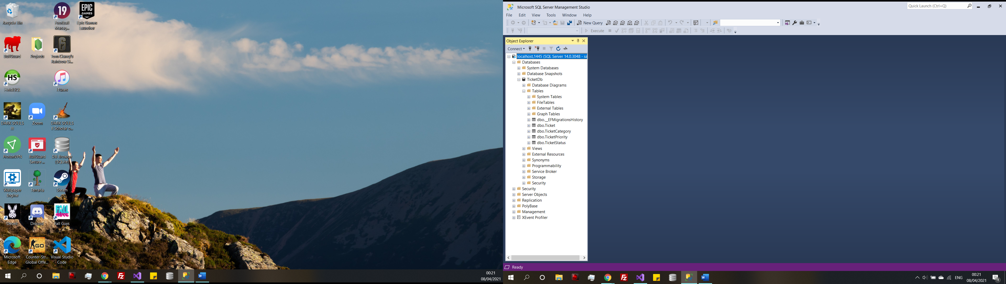

Tables have now been successfully created. However, there is currently, no data in the tables. One way to approach this in entity framework is to seed the initial data into the database, which is inserted into the database on application start up to create the initial set of data. There is a level of robustness added here. An error message will be displayed if there is a problem connecting the database.



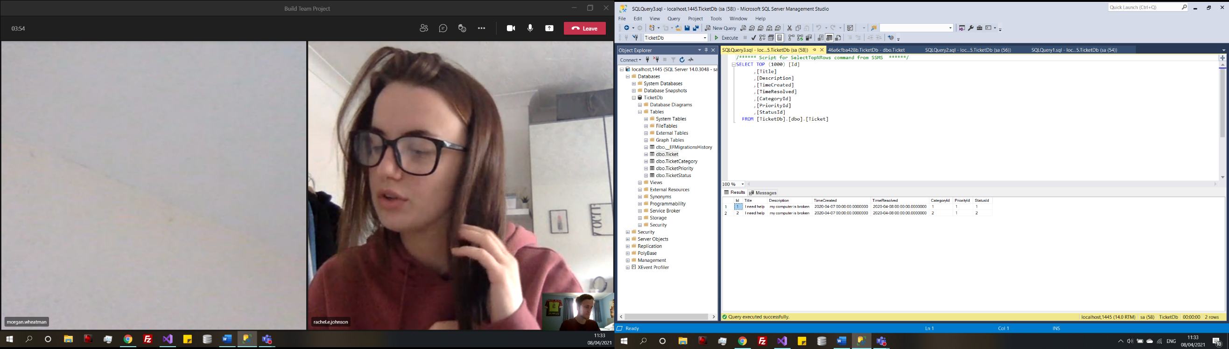

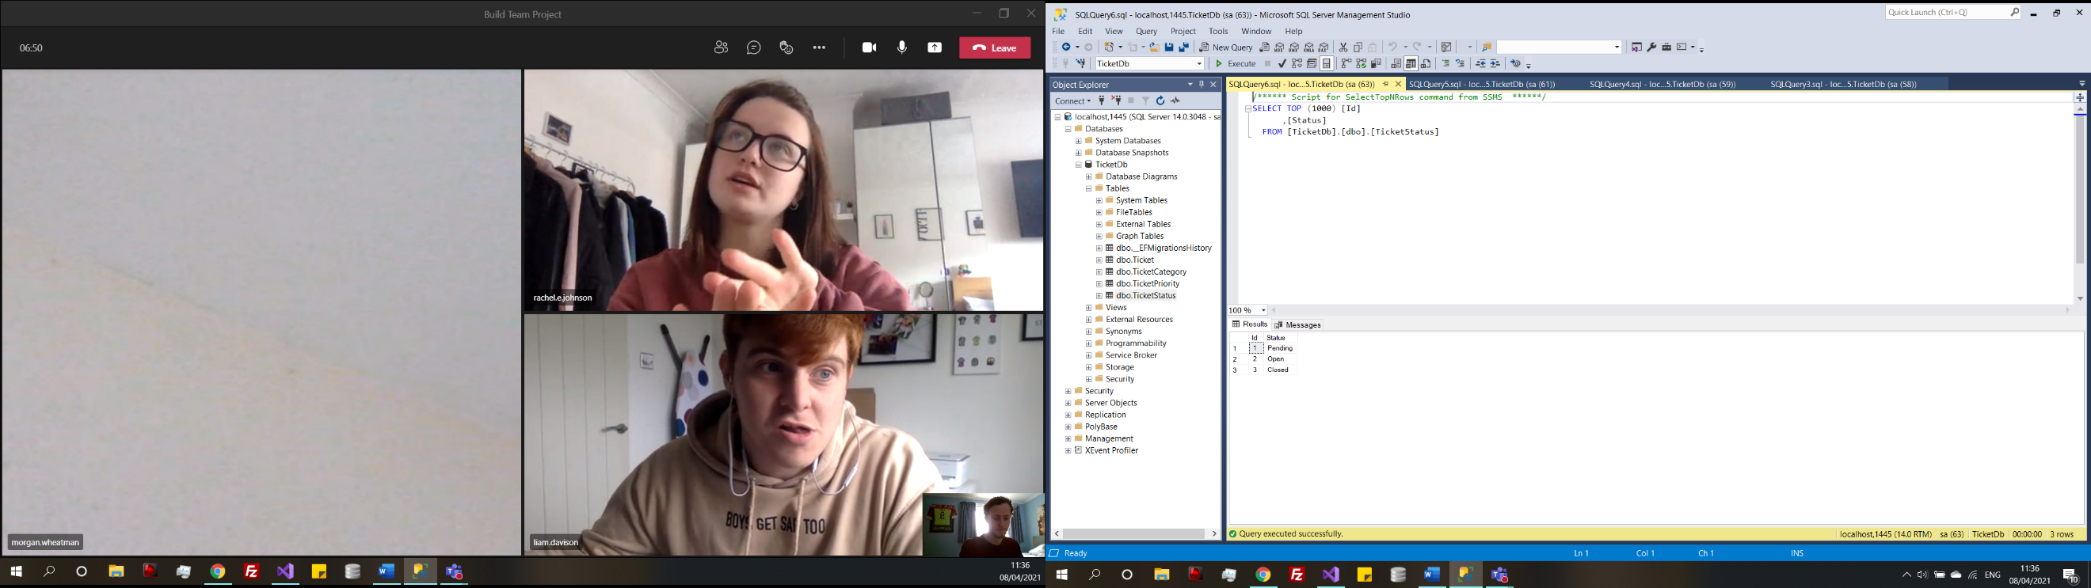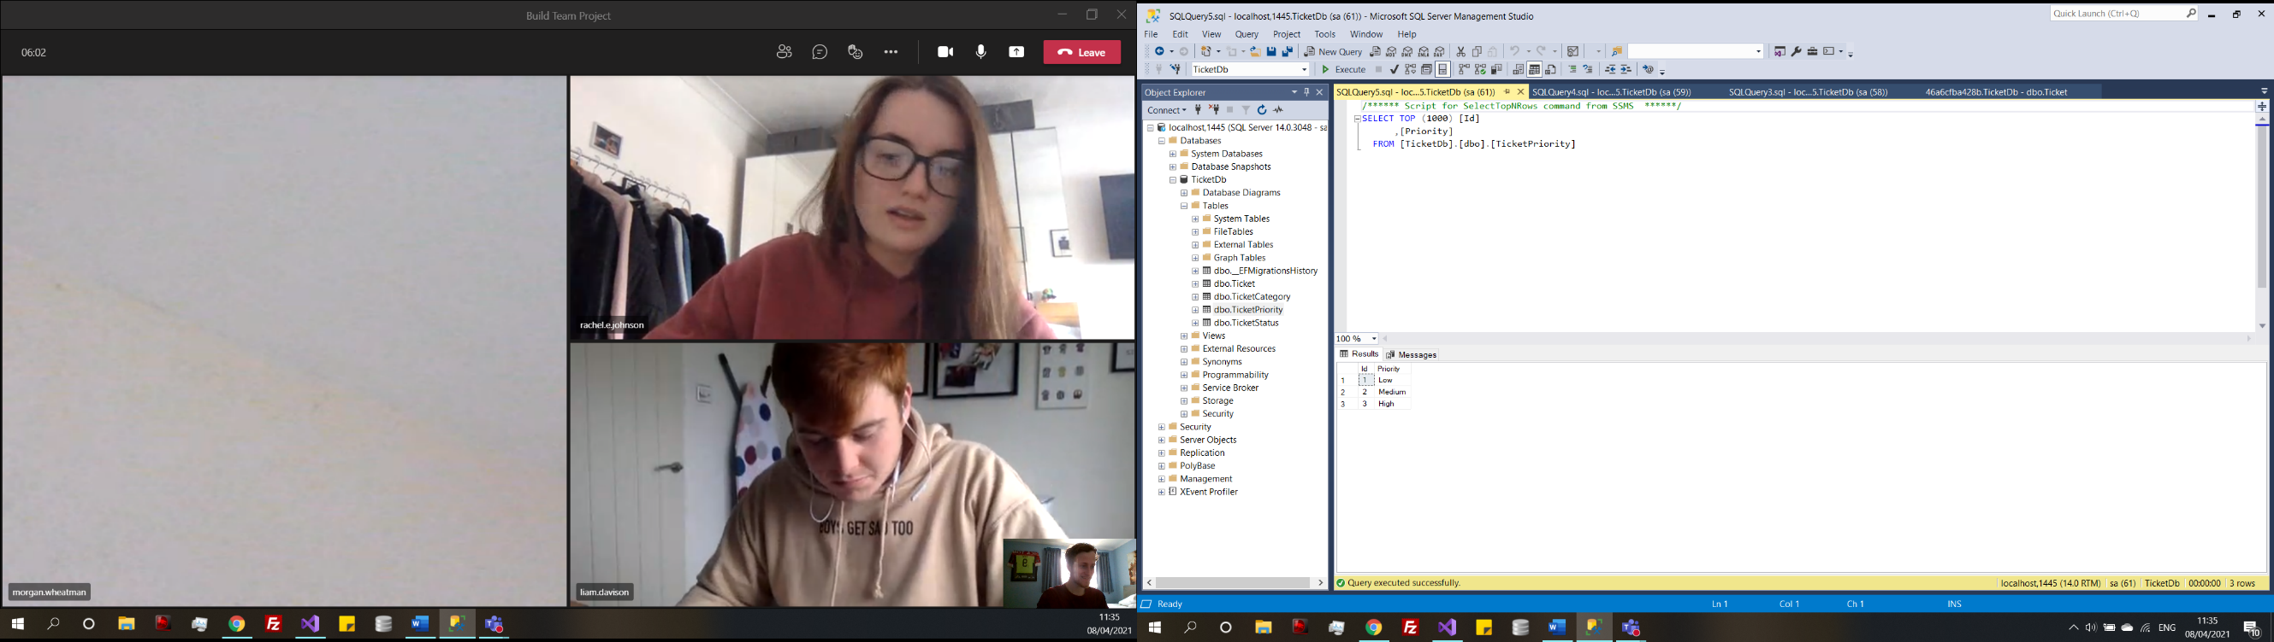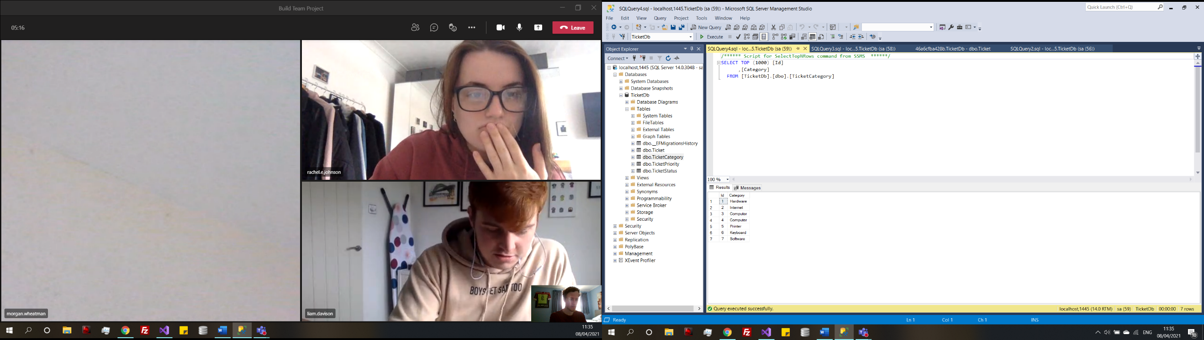

Now some test data can be added into the tables, which will be helpful for later when the API needs to be tested as there will be data to be returned. The four tables have been filled in with the data and in the ticket table the Id’s have been cross referenced.

Using an in-memory database which is supported by entity framework would be more appropriate to use during development because it removes the memory consumption of a real database minimizing the demand on the CPU.

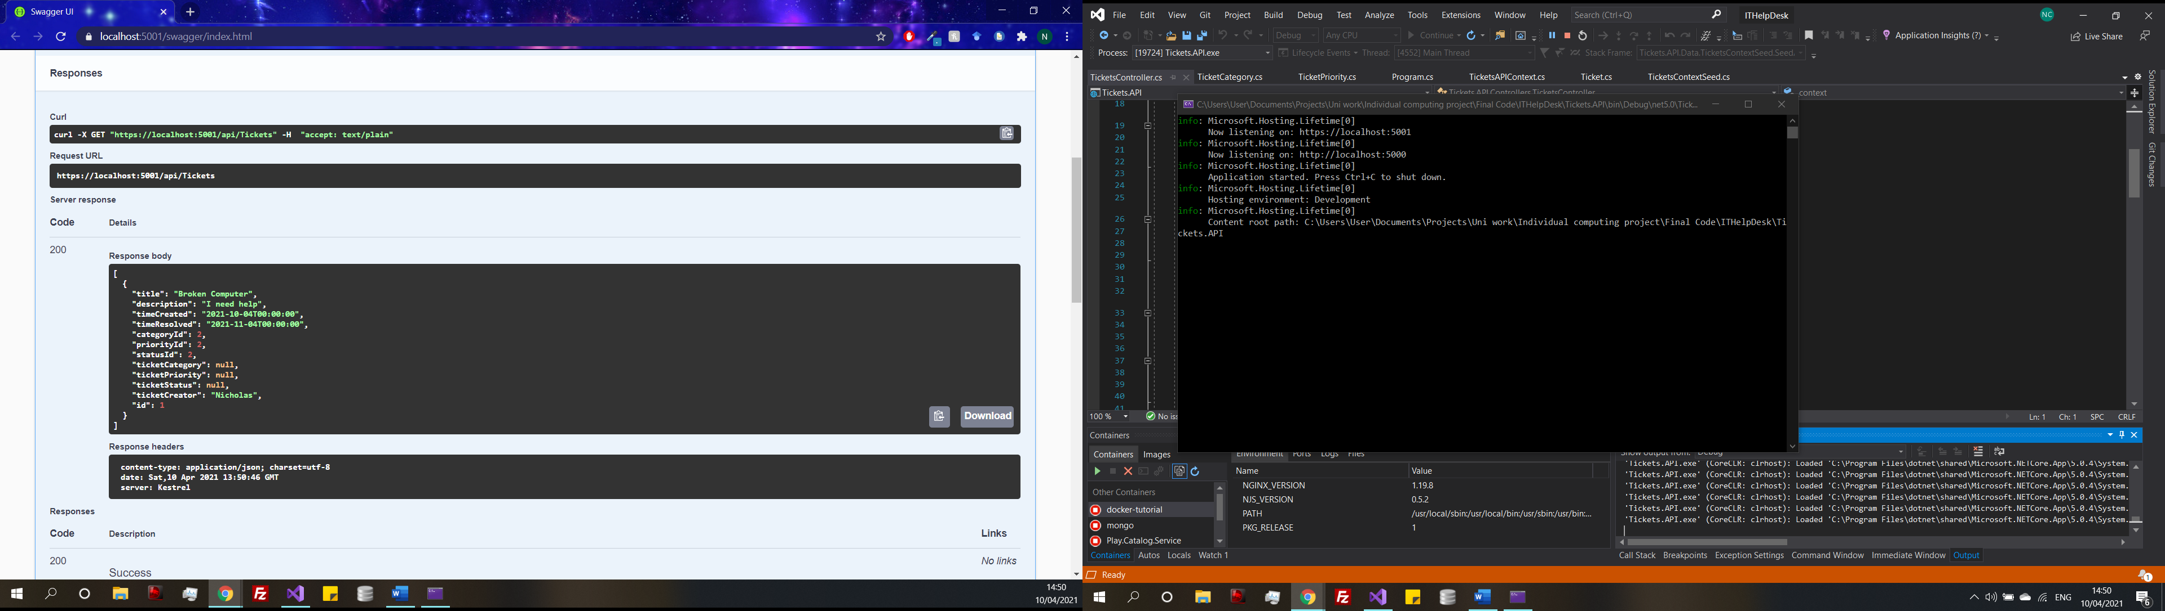

The functionality work but the controller will need to be updated so that it pulls back the category, priority and status associated with the Id, but it is pulling back the Id like it is supposed to.

Using an entity class for common attributes such as id



A class called Entity has been created and it will contain common properties that appear across multiple classes. For example, Id in each of the model classes an Id is defined so to make the code more efficient only defining the Id attribute once in the entity class then inheriting the entity in the ticket class, like shown above the class gets to use that attribute without having to create it multiple times.

**Microservice Authentication/Identity service**

As the system requires users to have individual accounts, where tickets their tickets and over services will be presented. To accomplish this there is going to be an authentication service that can authorize to the users’ details and then present them with the home page. Shown in the wireframes (Appendix D). However, here a choice needs to be made to decide the most appropriate method of authentication in microservices. One method involving tokens has already been discussed in (Chapter 3.7).

**Types of microservice authentication discussion?**

The topic was discussed by Yarygina and briefly mentioned in the literature review (Chapter 3.7). He states that currently there are a limited number of industry practices for securing microservices one being tokens the focus in the literature review and the other being Mutual Transport Layer Security (MTLS) (Yarygina, 2018) MTLS is more focused on network security for a microservice rather than authentication, so it is out of scope. Now it would be appropriate to revisit this topic looking into what methods of authentication have the potential to be implemented into the help desk, to create a secure application where users need to log in to view content. A recent study from Chandramouli lists authentication policies which can provide secure coverage over APIs.

* Certificate generation
* Single sign-on (SSO) tokens

(Chandramouli, 2020)

Certificate generation authentication is a well-known method of cryptology. Where entities trusted by Web browsers to validate a server’s identity and issue a digitally signed certificate binding the identity to the server’s public key (Aas, 2019). The key and certificate cain are authorised over a TCP channel. Completing a TLS handshake between both parties, being client browser and web server (Walsh, 2017). In a microservice context a single microservice will hold a key for the duration of a session. Meaning one authenticated a user is free to use the service until the instance is end and the user will need to be authenticated again. This is done to stop exploits between services (Walsh, 2017). Even though certificate authentication is well known area of cryptology Bánáti believes that it is not an efficient method of authentication with microservices because certificates require a centralised solution, which would mean that all services share one solution which is not scalable due to the nature of microservice and would start leaning into a monolithic design and it would also require complex implementation (Bánáti, 2018).

Now on the other side a JSON web is a safe means of representing claims to be transferred between two parties (Lu, 2017). The token itself contains information relating to claims like scope, actor, and expiry time all together in a single token and once the expiry time has passed on the token the user will need to log back into the system. There are in fact some pre-existing methods that are currently used in industry to use this exact method to secure microservices. Identity management and OAuth mange user accounts and single sign on (Lu, 2017). JSON web tokens and OAuth have become industry standard as of late because they can provide secure access to web APIs, the main form of communication for microservices. The major benefit they can be transmitted between parties, verified and trusted because they are digitally signed, containing what a user is authorised to do within the application (Preuveneers, 2019). An open-source server like IdentityServer4 makes it possible to implement your own authorization server and integrate with existing identity stores (Gadge, 2017).

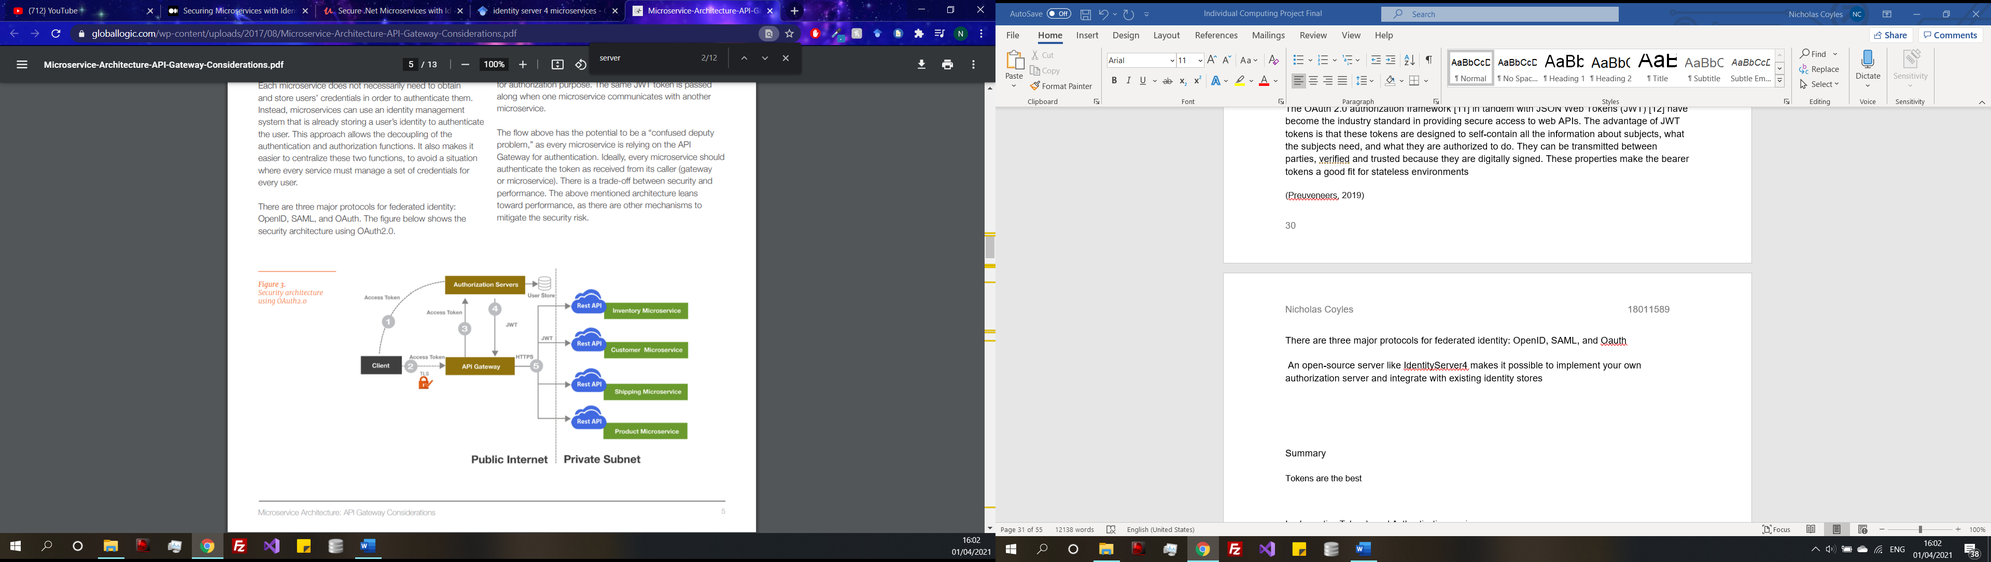

Security architecture using Oauth 2.0 (Gadge, 2017)

**Summary**

In summary token-based authentication has the edge over a certificate authentication, because of the pre-existing services such as Identity service and OAuth that allow for token authentication to be integrated into an application. Which makes development slightly easier, rather than having to build an authentication system from the ground up. The other advantage is that tokens can carry scope and policy information. Meaning that multiple scopes could potentially be created to provide security to multiple services, but a policy could be created for a user and an admin so specific access could be given to an admin after the login process. For example, an admin dashboard that a user will not be able to access. A visual representation of an authentication service using tokens can be seen in Figure 6, when the user logs in through the client an access token will be requested from the authentication service, the token will then be passed through the API gateway back to the authentication service where the user credentials are validated. If valid a JSON token is produced and now the services are now available.

**Implementing authentication service**

Identity server will be used to protect the data from the Tickets API service using tokens

Firstly, creating a new project to the solution which will be called Authentication Service. Making sure that this project is set up to run on a different port from the other because multiple solutions cannot run on the same port.

Add the identity server 4 NuGet package and configure in the start up



**Configuration**





One of the available endpoints with Identity Server 4 is the token endpoint. If that endpoint is requested using the grant type, scope, client id and secret a token should be returned if successful.

To test this a third part application called Postman is being used which allows get and post requests to be sent like swagger.

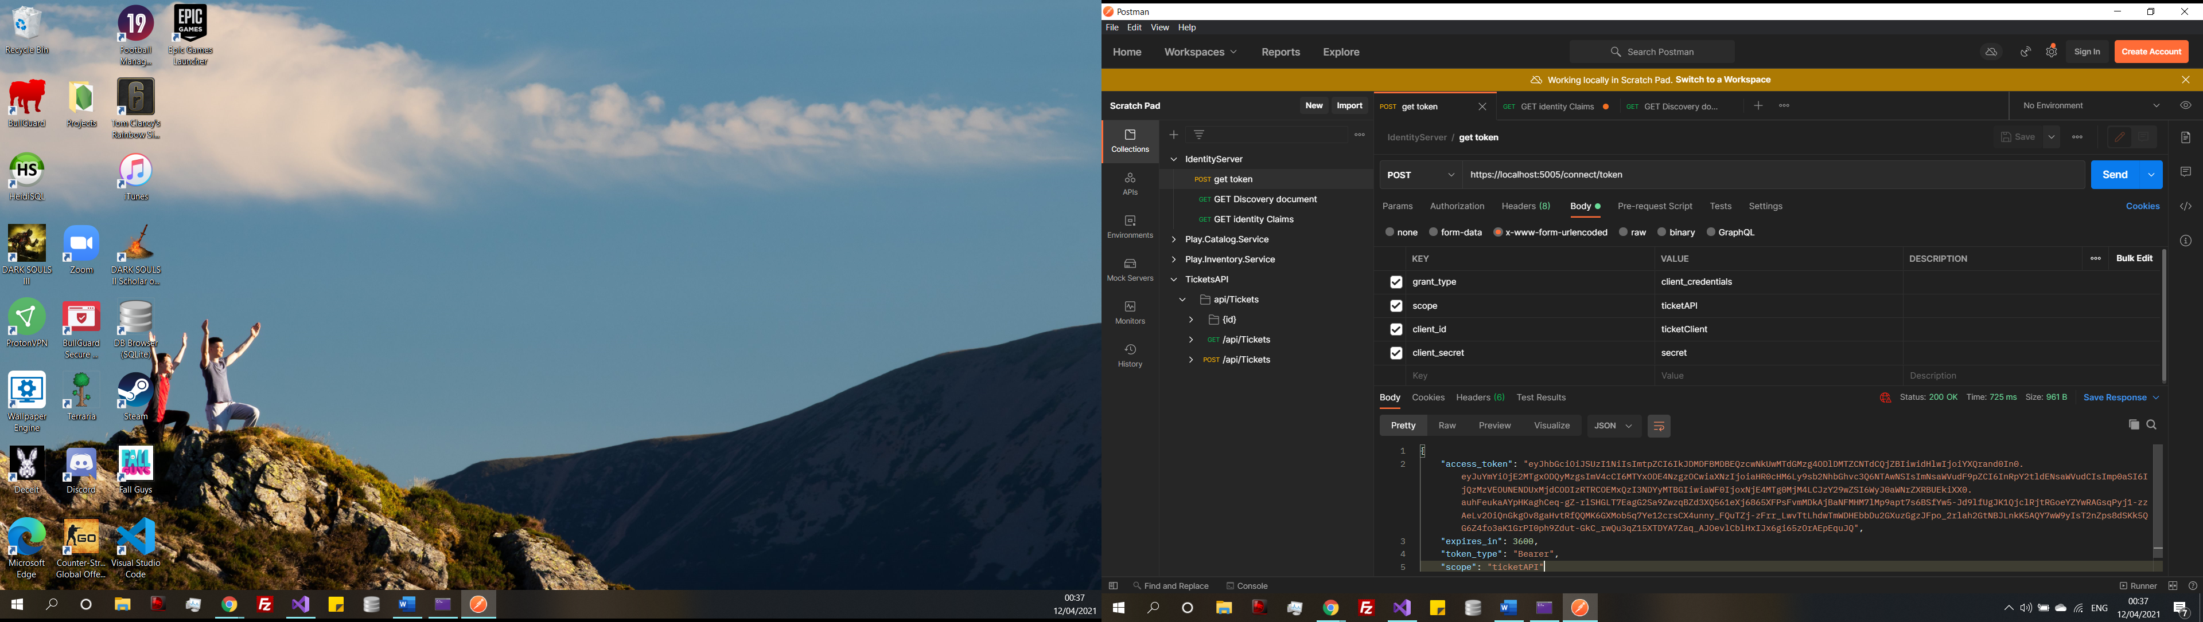

The request was successful, a bearer access token is returned with an expiry date for the ticketAPI scope. To double check by changing the credentials to no longer be correct the token should not be returned.

Add support for JWT bearer tokens in the API start up







Add authentication to the http pipeline to ensure that clients need to be authorized to access the API. Also adding the authorize tag to the controller class ensures secure protection. With the controller class and the service set up with authorization, requests must now have to be verified. Using postman submitting a get request returns an error 401 unauthorized message. Meaning it is working as intended.

**Claim based authorization**

The login system using token-based authorization through identify server and Oauth is now complete and fully functional. However, one of the requirements is to have a user and an admin login and to do this there will need to be a claim-based authorization policy added into the solution to recognize which log in credentials are for user and which are for admins.